In the Garden
Aligned to the following standards:
PS.01; PS.02; PL-A.; PG-J.; CS-M.; CS-N.; AG-PL1; AG-PL2; AGPB01.02; AGPB01.03; CCSS.SL.9-10.1A; CCSS.SL.9-10.4; CCSS.RST.9-10.4; CCSS.WHST.9-10.2; CCSS.WHST.9-10.9; MP1; MP3; MP6; CRP.02; CRP.04; CRP.05; CRP.06; CRP.07; CRP.08
Directions:
Answer the questions below as you watch the video “School Garden SAE | Sydnee Weintraut and Raelyn Butler,” available at https://vimeo.com/379629138.
What were their favorite things about their SAE?
What is Sydnee and Raelyn’s SAE?

What did they plant in the garden?


What steps did Sydnee and Raelyn take to develop their SAE?

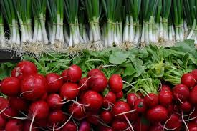

Veggies Everywhere!
Aligned to the following standards:
PS.01; PS.02; PL-A.; PG-J.; CS-M.; CS-N.; AG-PL1; AG-PL2; AGPB01.02; AGPB01.03; CCSS.SL.9-10.1A; CCSS.SL.9-10.4; CCSS.RST.9-10.4; CCSS.WHST.9-10.2; CCSS.WHST.9-10.9; MP1; MP3; MP6; CRP.02; CRP.04; CRP.05; CRP.06; CRP.07; CRP.08
Directions:
Using the resources provided below, plan a vegetable garden for your school or community.

Scenario:
Your school or community has provided you with a 30 foot by 30 foot space to grow a vegetable garden. You will determine what vegetables you can grow, learn how to grow those vegetables and plan your garden space. Your garden must have between five and 10 types of vegetables that are appropriate for your growing zone.

Step 1:
To discover your growing zone, use the Growing Zone Finder, available at https://www.burpee.com/findgrowzone.

What is your growing zone? _______________________

Step 2:
Using the Burpee Growing Calendar, choose what vegetables you want in your garden and learn when to plant them: https://www.burpee.com/growingcalendar. Use this information to help complete the chart in Step 3. If a vegetable is not appropriate for your zone, the growing calendar will indicate this.

Step 3:
Complete the Vegetable Planting Chart below using the vegetables you chose in Step 2, and then use the Burpee seed catalog to choose the variety of vegetable seed you want to purchase. The information to complete the table can be found in the Growing Information and Product Details sections of each seed webpage on https://www.burpee.com/vegetables/.

Vegetable | Planting Time | Start Outdoors Date | Sow Method | Seed Planting Depth | Plant Spread | Distance Between Rows | Plant Height | Sun  Needs | Days to Maturity
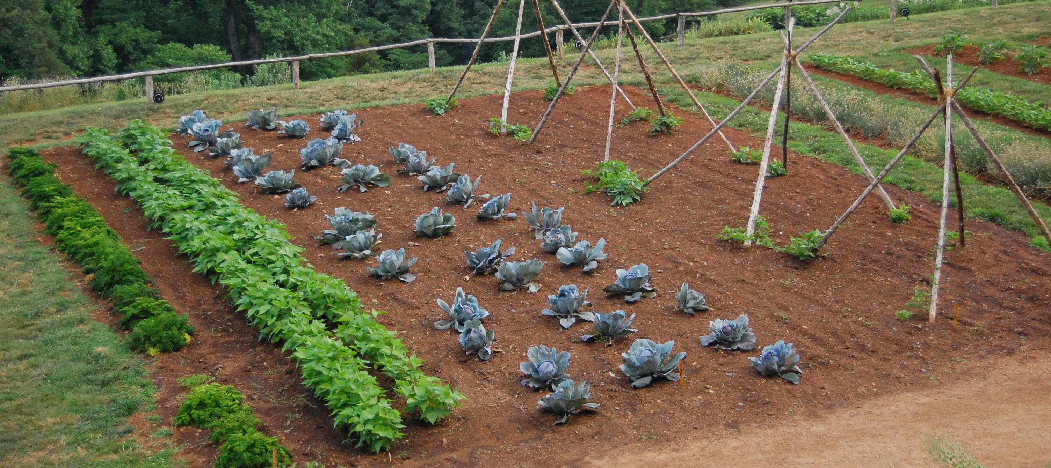

Step 4:
In the space below, “plant” your garden. Be sure to indicate how rows and plants will be spaced and label your rows to indicate which plants are in that row. If one row has more than one type of vegetable in it, then label each plant. Pay attention to the direction in which the sun will move as you plant your garden (the provided compass indicates north for your garden), considering what plants might need shade and the height of each plant. Your plants should be spaced and drawn to scale: 1/4 inch equals 12 inches, so 7.5 inches on the paper is equal to 360 inches or 30 feet of garden in real life.
(Example: If your rows are going to be 3 feet (36 inches) apart in real life, then on the paper, they would be 3/4 inches apart [1/4 X 3 = 3/4])
(How to Plan a Garden with Example Plan: https://agrilifeextension.tamu.edu/library/gardening/planning-a-garden/)

Scale: 1/4 inch = 12 inches/1 foot

7.5 inches = 30 feet
7.5 inches = 30 feet

Vegetable Garden Plan Rubric

 | 25–21 Points | 20–16 Points | 15–11 Points | 10–6 Points | 5–0 Points
Vegetable Planting Chart | Ten vegetables are included.  Table includes all requested information, and it is accurate. | Eight or nine vegetables are included.  Table includes all requested information, and it is accurate. | Six or seven vegetables are included.  Table includes almost all requested information, and it is accurate. | Five vegetables are included.  Table is missing at least three pieces of requested information, or there are factual errors. | Less than five vegetables are included.  Table is incomplete, OR there are several factual errors.
Effort | Garden plot planting sketch shows an excellent amount of time spent and very careful, neat work. | Garden plot planting sketch shows a great amount of time spent and very careful, neat work. | Garden plot planting sketch shows a good amount of time spent and careful, neat work. | Garden plot planting sketch shows some amount of time spent and is slightly lacking neatness. | Garden plot planting sketch shows a minimal amount of time spent and is lacking neatness.
Required Elements in Garden Plot Planting Sketch  Spacing of rows and plants clearly labeled  Rows and/or plants labeled  Direction of sun and shading were considered when laying out plants. | All required elements are included, and student went above and beyond by laying out plants to scale and clearly indicating how shade and plant height differences would be handled. | All required elements are included. Student attempted to lay out plants to scale and indicate how shade and plant height differences would be handled. | All required elements are included. Student did not accurately lay out plants to scale. How shade and plant height differences would be handled was inaccurate or lacking. | Most required elements are included. Student did not lay out plants to scale. There was no attempt to show how shade and plant height differences would be handled. | Several required elements are missing. Student did not lay out plants to scale. There was no attempt to show how shade and plant height differences would be handled.
Overall Effectiveness and Use of Time | Student worked diligently and did not waste time. The plan for the garden plot is well thought out and thorough. | Student worked hard and did not waste time. The plan for the garden plot is well thought out. | Student worked hard and was mostly on task. The plan for the garden plot is mostly thought out. | Student worked hard and was on task about half the time. The plan for the garden plot is weak and some elements are missing or incomplete. | Student wasted time and did not work hard. The plan for the garden plot shows little planning or consideration.

