School Garden
Created: 07/2020 by the National FFA Organization

Sydnee Weintraut and Raelyn Butler’s supervised agricultural experience (SAE) program is a school garden, which is a school-based enterprise. Learn how they planned and implemented the garden and how they use it to serve their community.

Student Learning Objectives:
After completing these activities, students will …
- Research what growing zone they live in and identify vegetables that are suitable for their area.
- Plan a vegetable garden using growing zones and plant requirements.
- Calculate how to space plants in a garden plot and sketch based on a scale.

Time Required: 180 minutes
Resources/References:
- Video: “School Garden SAE | Sydnee Weintraut and Raelyn Butler,” https://vimeo.com/379629138
- Website: Growing Zone Finder, https://www.burpee.com/findgrowzone
- Website: Burpee Growing Calendar, https://www.burpee.com/growingcalendar
- Website: Burpee Vegetable Seeds and Plants, https://www.burpee.com/vegetables/
- Article: “Planning a Garden,” https://agrilifeextension.tamu.edu/library/gardening/planning-a-garden/

Equipment and Supplies Needed:
- A copy of the “In the Garden” worksheet for each student
- A copy of the “Veggies Everywhere!” worksheet for each student
- A copy of the “Vegetable Garden Plan Rubric” for each student
- Internet access to play the video in real time or embed it in a PowerPoint ahead of time

Student activity sheets:
Direct access to student activity sheets without lesson plan or answer key for easy upload to learning management system or printing for classwork.
https://ffa.box.com/s/v6rsqgcxvlpqa6dv9sigkemmsnenc39m (Word)
https://ffa.box.com/s/6xdfn0fx2u1b5o27yf1s98u4dj2fa2qm (PDF)

Cross-Curricular Connections:
Science | Mathematics
Use growing zones and plant requirements to plan a vegetable garden. | Calculate how to space plants in a garden plot and sketch based on a scale.

These activities are aligned to the following standards:

AFNR Performance Element
- PS.01. Develop and implement crop management plan for a given production goal that accounts for environmental factors.
- PS.02. Apply principles of classification, plant anatomy and plant physiology to plant production and management.
FFA Precept
- FFA.PL-A.Action: Assume responsibility and take the necessary steps to achieve the desired results, no matter what the goal or task at hand.
- FFA.PG-J.Mental Growth: Embrace cognitive and intellectual development relative to reasoning, thinking and coping.
- FFA-CS-M.Communication: Effectively interact with others in personal and professional settings.
- FFA.CS-N.Decision Making: Analyze a situation and execute an appropriate course of action.
Common Career Technical Core
- AG-PL1 Develop and implement crop management plan for a given production goal that accounts for environmental factors.
- AG-PL2 Apply the principles of classification, plant anatomy and plant physiology to plant production and management.
NASDCTEc
- AGPB01.02 Examine and explain basic plant anatomy and physiology using taxonomic and other classifications to build a working understanding of functional differences among plant structures.
- AGPB01.03 Examine and apply fundamentals of production and harvesting when producing plants to demonstrate plant management and production techniques.
Common Core – Speaking and Listening
- CCSS.ELA-Literacy.SL.9-10.1.A Come to discussions prepared, having read and researched material under study; explicitly draw on that preparation by referring to evidence from texts and other research on the topic or issue to stimulate a thoughtful, well-reasoned exchange of ideas.
- CCSS.ELA-Literacy.SL.9-10.4 Present information, findings, and supporting evidence clearly, concisely, and logically such that listeners can follow the line of reasoning and the organization, development, substance, and style are appropriate to purpose, audience, and task.
Common Core – Science & Technical Subjects
- CCSS.ELA-Literacy.RST.9-10.4 Determine the meaning of symbols, key terms, and other domain-specific words and phrases as they are used in a specific scientific or technical context relevant to grades 9-10 texts and topics.
- CCSS.ELA-Literacy.RST.9-10.9 Compare and contrast findings presented in a text to those from other sources (including their own experiments), noting when the findings support or contradict previous explanations or accounts.
Common Core – Literacy in Science & Technical Subjects: Writing
- CCSS.ELA-Literacy.WHST.9-10.7 Conduct short as well as more sustained research projects to answer a question (including a self-generated question) or solve a problem; narrow or broaden the inquiry when appropriate; synthesize multiple sources on the subject, demonstrating understanding of the subject under investigation.
- CCSS.ELA-Literacy.WHST.9-10.9 Draw evidence from informational texts to support analysis, reflection, and research.
Common Core – Math Practices
- CCSS.MATH.PRACTICE.MP1 Make sense of problems and persevere in solving them.
- CCSS.MATH.PRACTICE.MP3 Construct viable arguments and critique the reasoning of others.
- CCSS.MATH.PRACTICE.MP6 Attend to precision.
AFNR Career Ready Practices
- CRP.02. Apply appropriate academic and technical skills. Career-ready individuals readily access and use the knowledge and skills acquired through experience and education to be more productive.
- CRP.04. Communicate clearly, effectively, and with reason. Career-ready individuals communicate thoughts, ideas and action plans with clarity, whether using written, verbal and/or visual methods.
- CRP.05. Consider the environmental, social and economic impact of decisions. Career-ready individuals understand the interrelated nature of their actions and regularly make decisions that positively impact and/or mitigate negative impact on other people, organizations and the environment.
- CRP.06. Demonstrate creativity and innovation. Career-ready individuals regularly think of ideas that solve problems in new and different ways, and they contribute those ideas in a useful and productive manner to improve their organization.
- CRP.07. Employ valid and reliable research strategies. Career-ready individuals are discerning in accepting and using new information to make decisions, change practices or inform strategies.
- CRP.08. Utilize critical thinking to make sense of problems and persevere in solving them. Career-ready individuals readily recognize problems in the workplace, understand the nature of the problem, and devise effective plans to solve the problem.
Partnership for 21st Century Skills
- Communication
- Critical Thinking and Problem Solving
- Implement Innovations
- Information Literacy
- Information, Communications, and Technology Literacy
- Initiative and Self-Direction
- Productivity and Accountability
- Think Creatively

Lesson Plan:
- Bell Ringer: Have you ever had your own garden? If yes, did you enjoy working in it? If no, would you like to have your own garden? Why or why not?

- Introduction: Today, we are going to learn about two FFA members who work together in the school garden as part of their school-based enterprise supervised agricultural experience (SAE) program. We’ll discover how they developed the plan for their garden and what they had to learn to be successful.

- Activity: Each student needs a copy of the worksheet “In the Garden.” Have students complete the worksheet as they watch the video “School Garden SAE | Sydnee Weintraut and Raelyn Butler,” available at https://vimeo.com/379629138. When students are finished, hand out copies of the worksheet “Veggies Everywhere!” Students will research the growing zone in which they live and then identify vegetables that would be suitable for their area. Students will then plan their garden and show how they would place their vegetables. The plan should be drawn to scale. It would be beneficial for each student to have a copy of the “Vegetable Garden Plan Rubric” so they know expectations before they begin the assignment.

- Follow-up: Have several students share their garden plans. As a class, discuss what was easy and what was challenging about creating a garden that met all the requirements of the rubric. If there is time, segue this discussion into the challenges of planting and maintaining a real garden plot.

- Optional — Extended Learning Opportunities (Not factored into time requirement):
  - In groups, have students research what they would need to start either a school or a community garden. Then, have students develop a plan for starting a school or community garden within 12 months and have groups present their plans to the class.

- Exit Ticket: What was the most difficult part of designing your garden plot?

In the Garden
Aligned to the following standards:
PS.01; PS.02; PL-A.; PG-J.; CS-M.; CS-N.; AG-PL1; AG-PL2; AGPB01.02; AGPB01.03; CCSS.SL.9-10.1A; CCSS.SL.9-10.4; CCSS.RST.9-10.4; CCSS.WHST.9-10.2; CCSS.WHST.9-10.9; MP1; MP3; MP6; CRP.02; CRP.04; CRP.05; CRP.06; CRP.07; CRP.08
Directions:
Answer the questions below as you watch the video “School Garden SAE | Sydnee Weintraut and Raelyn Butler,” available at https://vimeo.com/379629138.
What were their favorite things about their SAE?
What is Sydnee and Raelyn’s SAE?

What did they plant in the garden?
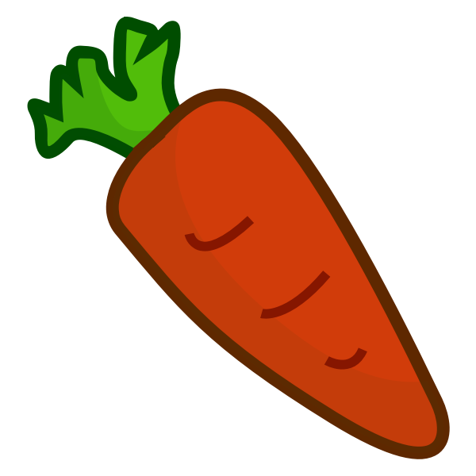

What steps did Sydnee and Raelyn take to develop their SAE?

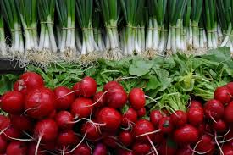

Veggies Everywhere!
Aligned to the following standards:
PS.01; PS.02; PL-A.; PG-J.; CS-M.; CS-N.; AG-PL1; AG-PL2; AGPB01.02; AGPB01.03; CCSS.SL.9-10.1A; CCSS.SL.9-10.4; CCSS.RST.9-10.4; CCSS.WHST.9-10.2; CCSS.WHST.9-10.9; MP1; MP3; MP6; CRP.02; CRP.04; CRP.05; CRP.06; CRP.07; CRP.08
Directions:
Using the resources provided below, plan a vegetable garden for your school or community.

Scenario:
Your school or community has provided you with a 30 foot by 30 foot space to grow a vegetable garden. You will determine what vegetables you can grow, learn how to grow those vegetables and plan your garden space. Your garden must have between five and 10 types of vegetables that are appropriate for your growing zone.

Step 1:
To discover your growing zone, use the Growing Zone Finder, available at https://www.burpee.com/findgrowzone.

What is your growing zone? _______________________

Step 2:
Using the Burpee Growing Calendar, choose what vegetables you want in your garden and learn when to plant them: https://www.burpee.com/growingcalendar. Use this information to help complete the chart in Step 3. If a vegetable is not appropriate for your zone, the growing calendar will indicate this.

Step 3:
Complete the Vegetable Planting Chart below using the vegetables you chose in Step 2, and then use the Burpee seed catalog to choose the variety of vegetable seed you want to purchase. The information to complete the table can be found in the Growing Information and Product Details sections of each seed webpage on https://www.burpee.com/vegetables/.

Vegetable | Planting Time | Start Outdoors Date | Sow Method | Seed Planting Depth | Plant Spread | Distance Between Rows | Plant Height | Sun  Needs | Days to Maturity
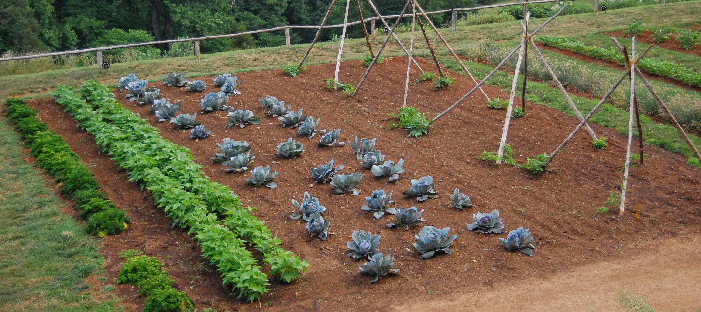

Step 4:
In the space below, “plant” your garden. Be sure to indicate how rows and plants will be spaced and label your rows to indicate which plants are in that row. If one row has more than one type of vegetable in it, then label each plant. Pay attention to the direction in which the sun will move as you plant your garden (the provided compass indicates north for your garden), considering what plants might need shade and the height of each plant. Your plants should be spaced and drawn to scale: 1/4 inch equals 12 inches, so 7.5 inches on the paper is equal to 360 inches or 30 feet of garden in real life.
(Example: If your rows are going to be 3 feet (36 inches) apart in real life, then on the paper, they would be 3/4 inches apart [1/4 X 3 = 3/4])
(How to Plan a Garden with Example Plan: https://agrilifeextension.tamu.edu/library/gardening/planning-a-garden/)

Scale: 1/4 inch = 12 inches/1 foot

7.5 inches = 30 feet
7.5 inches = 30 feet
KEY: In the Garden
Aligned to the following standards:
PS.01; PS.02; PL-A.; PG-J.; CS-M.; CS-N.; AG-PL1; AG-PL2; AGPB01.02; AGPB01.03; CCSS.SL.9-10.1A; CCSS.SL.9-10.4; CCSS.RST.9-10.4; CCSS.WHST.9-10.2; CCSS.WHST.9-10.9; MP1; MP3; MP6; CRP.02; CRP.04; CRP.05; CRP.06; CRP.07; CRP.08
Directions:
Answer the questions below as you watch the video “School Garden SAE | Sydnee Weintraut and Raelyn Butler,” available at https://vimeo.com/379629138.
What were their favorite things about their SAE?

- Working with other students who have the same passion of wanting to learn more about growing plants
- The hands-on experience
- Giving back to the community

What is Sydnee and Raelyn’s SAE?
Working in the school garden, which is classified
as vegetable production

What did they plant in the garden?
beans
peas
sweet corn
pumpkins

What steps did Sydnee and Raelyn take to develop their SAE?

Vegetable Garden Plan Rubric

 | 25–21 Points | 20–16 Points | 15–11 Points | 10–6 Points | 5–0 Points
Vegetable Planting Chart | Ten vegetables are included.  Table includes all requested information, and it is accurate. | Eight or nine vegetables are included.  Table includes all requested information, and it is accurate. | Six or seven vegetables are included.  Table includes almost all requested information, and it is accurate. | Five vegetables are included.  Table is missing at least three pieces of requested information, or there are factual errors. | Less than five vegetables are included.  Table is incomplete, OR there are several factual errors.
Effort | Garden plot planting sketch shows an excellent amount of time spent and very careful, neat work. | Garden plot planting sketch shows a great amount of time spent and very careful, neat work. | Garden plot planting sketch shows a good amount of time spent and careful, neat work. | Garden plot planting sketch shows some amount of time spent and is slightly lacking neatness. | Garden plot planting sketch shows a minimal amount of time spent and is lacking neatness.
Required Elements in Garden Plot Planting Sketch  Spacing of rows and plants clearly labeled  Rows and/or plants labeled  Direction of sun and shading were considered when laying out plants. | All required elements are included, and student went above and beyond by laying out plants to scale and clearly indicating how shade and plant height differences would be handled. | All required elements are included. Student attempted to lay out plants to scale and indicate how shade and plant height differences would be handled. | All required elements are included. Student did not accurately lay out plants to scale. How shade and plant height differences would be handled was inaccurate or lacking. | Most required elements are included. Student did not lay out plants to scale. There was no attempt to show how shade and plant height differences would be handled. | Several required elements are missing. Student did not lay out plants to scale. There was no attempt to show how shade and plant height differences would be handled.
Overall Effectiveness and Use of Time | Student worked diligently and did not waste time. The plan for the garden plot is well thought out and thorough. | Student worked hard and did not waste time. The plan for the garden plot is well thought out. | Student worked hard and was mostly on task. The plan for the garden plot is mostly thought out. | Student worked hard and was on task about half the time. The plan for the garden plot is weak and some elements are missing or incomplete. | Student wasted time and did not work hard. The plan for the garden plot shows little planning or consideration.

