Horse Evaluation Career Development Event
Created: Aug-21
As a team, review the following questions; you will have 10 minutes for this activity. One team member should clearly mark each answer on the team E-scan sheet.

team activity 1-Equine vertebrae

- What is the appropriate term used to describe the section of the spine highlighted in the illustration below?
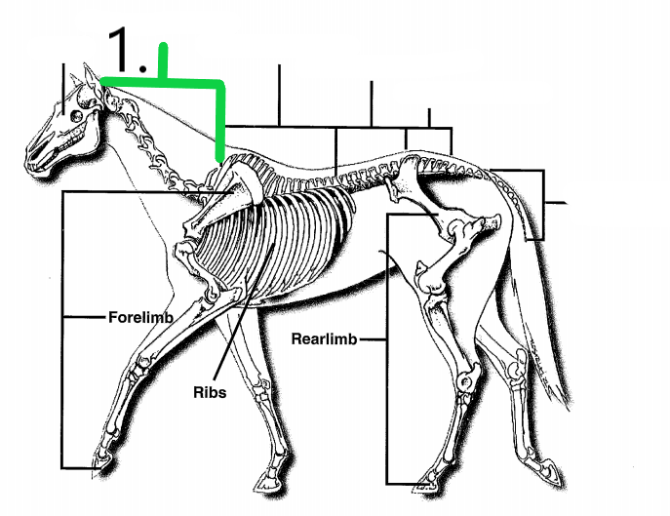
  - Coccygeal vertebrae
  - Lumbar vertebrae
  - Cervical vertebrae
  - Thoracic vertebrae
- What is the appropriate term used to describe the section of the spine highlighted in the illustration below?
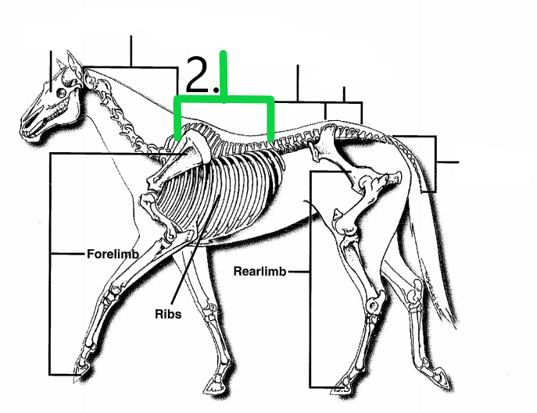
  - Coccygeal vertebrae
  - Lumbar vertebrae
  - Cervical vertebrae
  - Thoracic vertebrae

- What is the appropriate term used to describe the section of the spine highlighted in the illustration below?
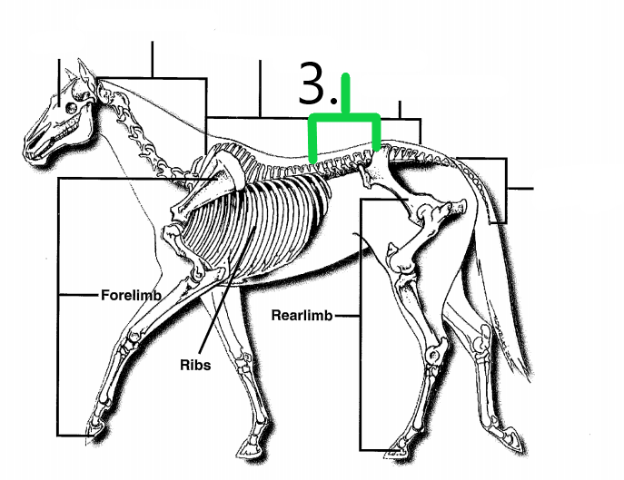
  - Coccygeal vertebrae
  - Lumbar vertebrae
  - Cervical vertebrae
  - Thoracic vertebrae

- What is the appropriate term used to describe the section of the spine highlighted in the illustration below?
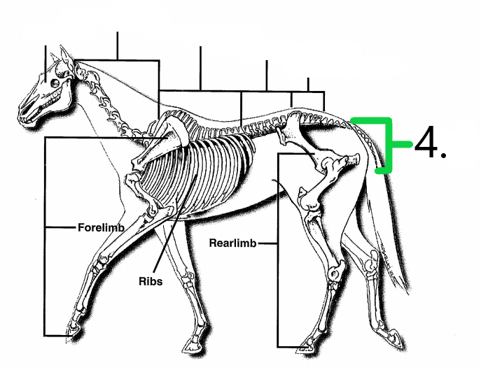
  - Coccygeal vertebrae
  - Lumbar vertebrae
  - Cervical vertebrae
  - Thoracic vertebrae

- Which of the following is NOT a function of the equine vertebrae?
  - Acts as a protective barrier to the spinal cord.
  - Serve as points of muscle attachment.
  - Bear the majority of the weight put on the spine.
  - Supplies motor and sensor perception to the entire body.

