Team Exam-A
Hoof Care-Tools and Uses (5 points per question) 50 points
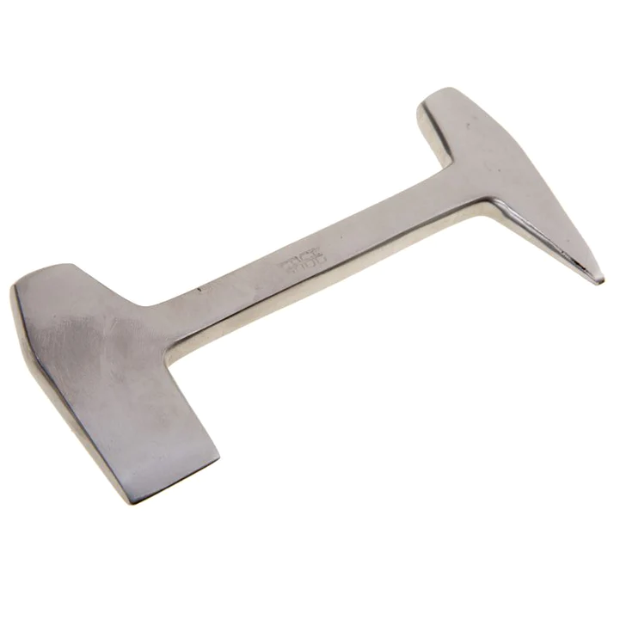
Modern domesticated horses are dependent entirely upon humans for their maintenance and comfort. Proper hoof care including, but limited to, regular trimming and shoeing should be a priority for all horse owners. Select the most appropriate tool name and/or use from the choices below.

- Anvil
- Nail Puller
- Clinch Block
- Clincher
- Clinch Cutter

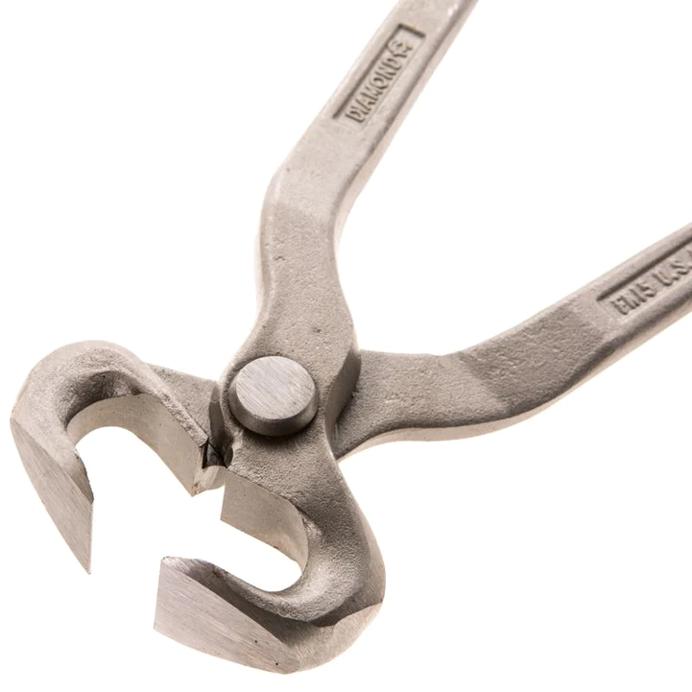

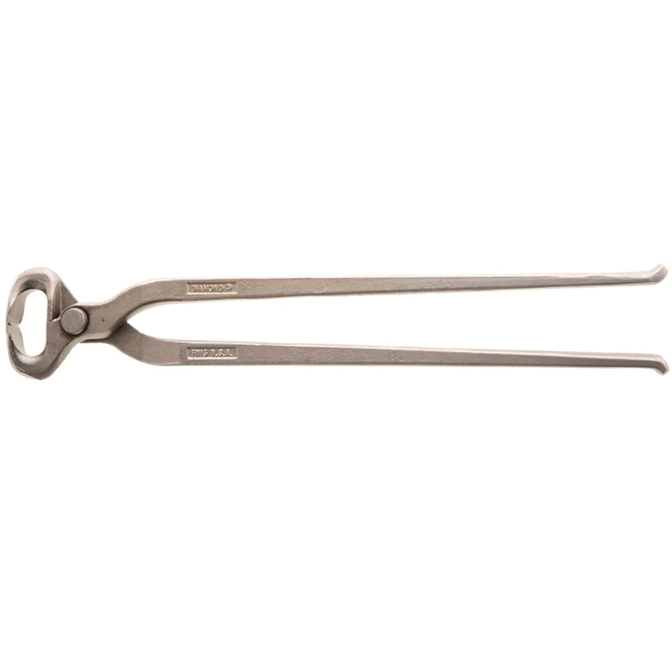

- Clinch Cutter
- Hoof Nipper
- Hoof Pincher
- Clincher
- Hoof Tester

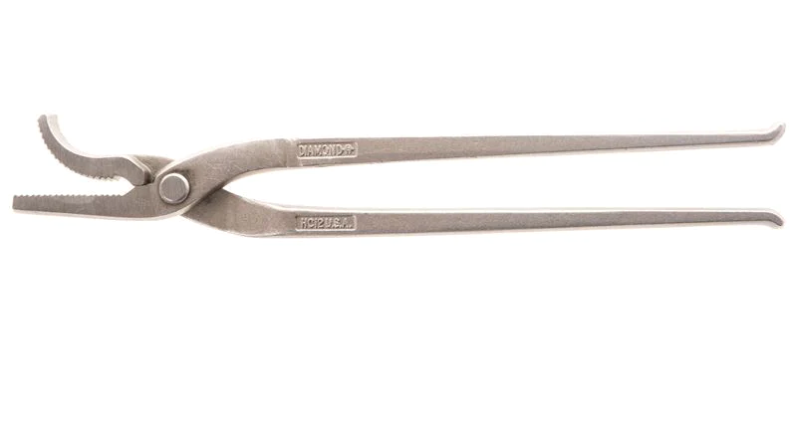
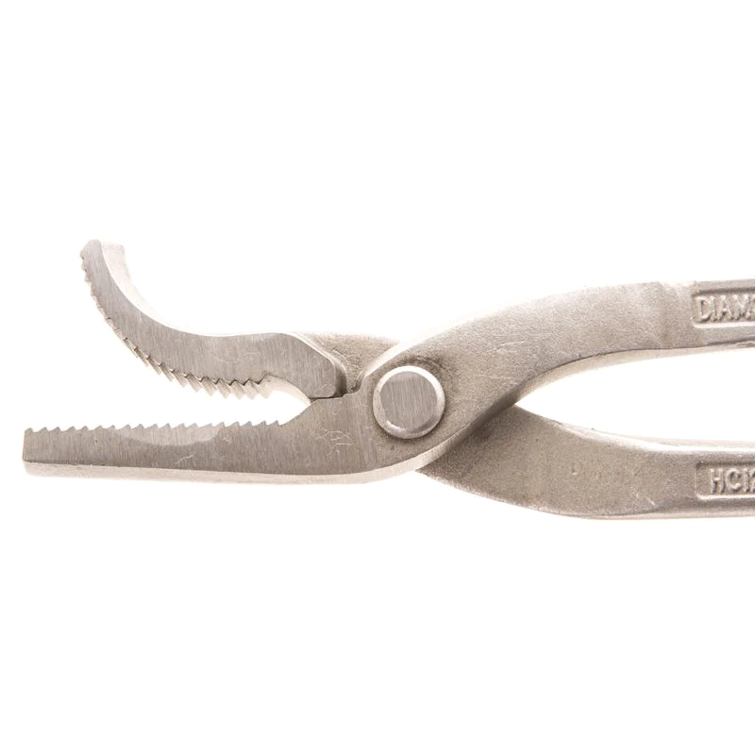

- Nail Puller
- Clinch Cutter
- Hoof Nipper
- Clincher
- Hoof Tester

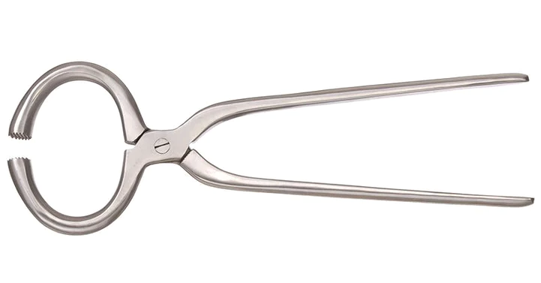

- Clincher
- Hoof Nipper
- Hoof Tester
- Nail Puller
- Hoof Pincher

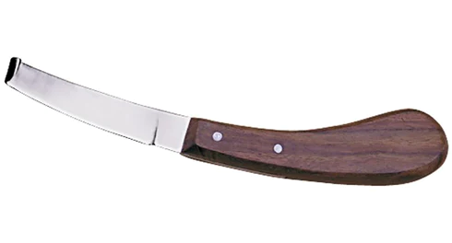

- Nail Puller
- Clincher
- Hoof Tester
- Hoof Knife
- Clinch Cutter

- A ____________________________ allows you to efficiently remove rocks, dirt, manure, and other debris from the sole of the hoof.

- Hoof Knife
- Hoof Pick
- Hoof Tester
- Hoof Pincher
- Hoof Nipper

- A _________________________________ consists of two parts – the blade and the point – and is used in combination with a driving hammer to cut or raise clinches.

- Anvil
- Nail Puller
- Clinch Block
- Clincher
- Clinch Cutter

- A ____________________________________ is used to make a level bearing surface after the hoof has been trimmed with the nippers. This tool has one coarse side for rapid removal of the hoof and one fine side for finishing/shaping.

- Hoof Knife
- Hoof Gauge
- Rasp
- Hoof Tester
- Clincher

- A _____________________________________ is used for simple and quick diagnosis when abscesses, navicular disease or laminitis are suspected.

- Hoof Knife
- Hoof Pick
- Hoof Tester
- Hoof Pincher
- Hoof Nipper

- A ___________________________________ is used to open the nail holes on the shoe to receive the horseshoeing nail.

- Rounding Hammer
- Pritchel
- Driving Hammer
- Clinch Block
- Nail Puller

