Strengthen Agriculture by Telling the FFA Story! 
How can I tell the story of FFA and my chapter? Here are some ideas to help with promotion throughout the community.


Speak on the radio or have the radio station come to an FFA event at your school.

Utilize social media to share fun facts about agriculture or FFA and to talk about the activities your chapter will do during the year.

Share stories of how FFA has positively impacted individual members in your local newspaper.
Interview an FFA Alumni or Supporter member. Put together a video of several interviews to show what FFA has meant to alumni or why they support FFA.

Create and place “FFA Supporter” signs in the windows of partnering businesses. (Yard signs are a great option also!)
Work with local billboard agencies and secure space for an FFA chapter billboard. Ask them if they will donate the space for a month or so. (Some towns have old movie theatre sign space to rent too!)
Have students share their SAE projects in an SAE spotlight each week or month in your local newspaper or on your local radio station.
Write an editorial for your local newspapers. Highlight the many opportunities FFA has to offer.
Work with local newspapers and radio and TV stations to highlight the activities of the chapter and FFA members. Don’t forget about your school newspaper and announcements.

Develop an FFA chapter supplement for the local paper or for the school newsletter. Make it electronic and post it on the websites.

Provide FFA facts for your local media and school newspaper.
Send in ad slicks to area businesses for possible placement in newsletters, magazines, etc. Work with your local newspaper for donated ad space.

Take food or treats to the morning radio/TV stations. (Ex. cookies, candy, cupcakes, etc.)
Hold an open house for the community. Show off your classrooms, facilities and other special chapter areas. You could also do this at an off-site location and not necessarily a farm.
Strengthen Agriculture by Telling the FFA Story!
Now that you are a chapter officer, it is your role to tell the world about FFA! Voices spreading the FFA message across social media elevates awareness of FFA, and that’s where you come in. Your chapter’s story is important in helping others learn who we are, what we do and the diversity of FFA across the country. Use the guide below to help you plan for social media posts throughout the year.
Pick one or two social platforms to concentrate on. Don’t spread yourself too thin. It’s better to be in one place with great stories than everywhere with mediocre stories.
Which social platforms will you concentrate on?
- _______________________________
- _______________________________



Social platform 1: __________________________________

1.

2.
Social platform 2: _________________________________

1.

2.
Before your FFA activities or events, plan your posts. You can even write some of them ahead of time. Planning ahead will save time during the year. Just leave some room for spontaneity. In the boxes below, choose an event or activity you want to highlight, and compose two posts for each social platform you selected above.

Use this space to brainstorm a list of photos and videos that could be used. Don’t have any that will work? Brainstorm pictures and videos that can be taken!
In your posts, use the highest-quality photos and videos you have access to. These tell the best stories and generate the most engagement.


If someone is being vulgar, bullying or posting unrelated comments on your posts, hide them. It’s good practice to have user guidelines on your page in the About section. Ours is on the National FFA website: FFA.org/social-media-user-policy/.
Compose some guidelines that you could include to help avoid vulgarity, bullying or posting of unrelated comments.


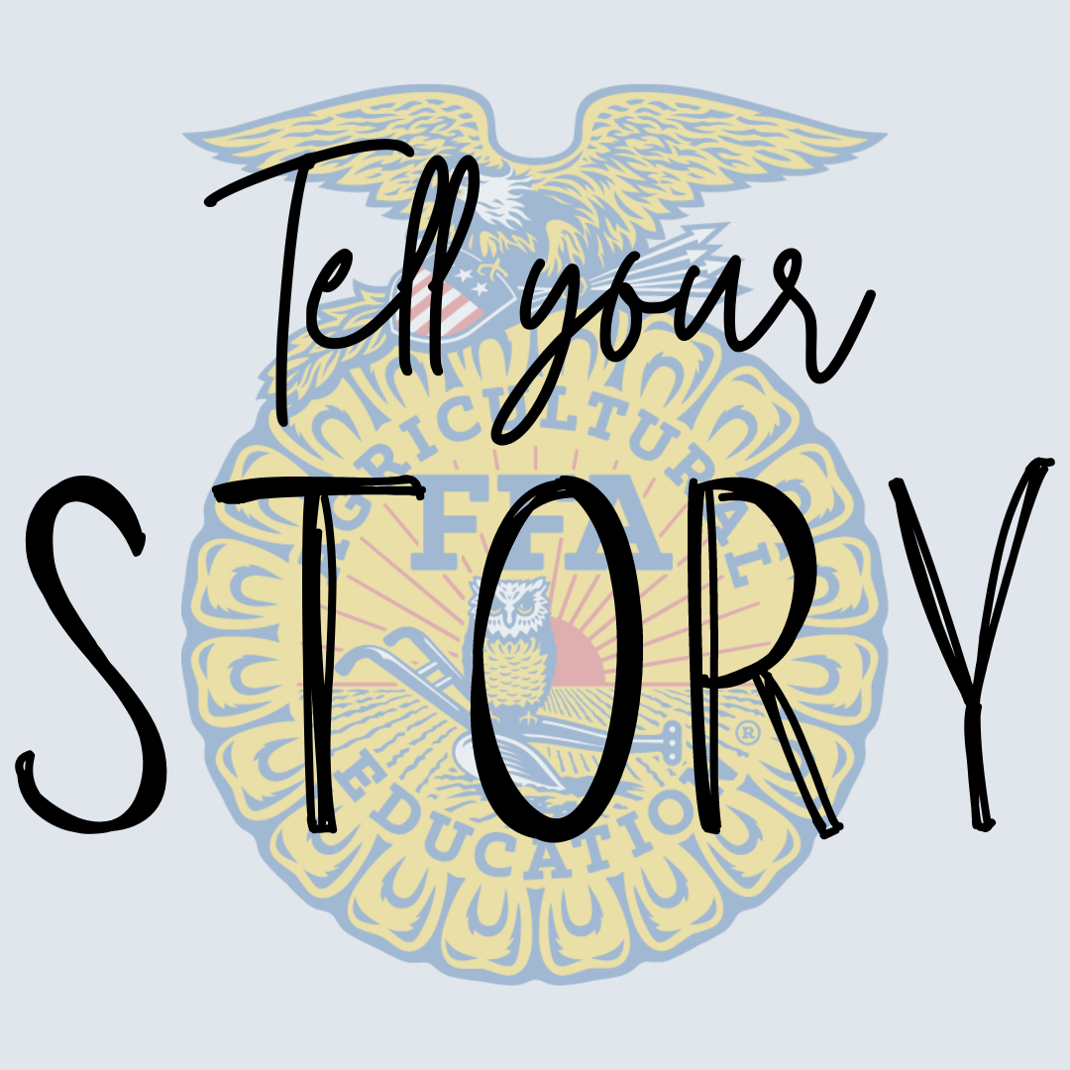

MOST importantly, every member and every chapter have an important FFA story.
Don’t be afraid to share yours — we know it will be interesting!

