Thank-You Note Writing 
The Necessities of a GREAT Thank You Note
***Create a draft directly on this worksheet, then copy to your card.***
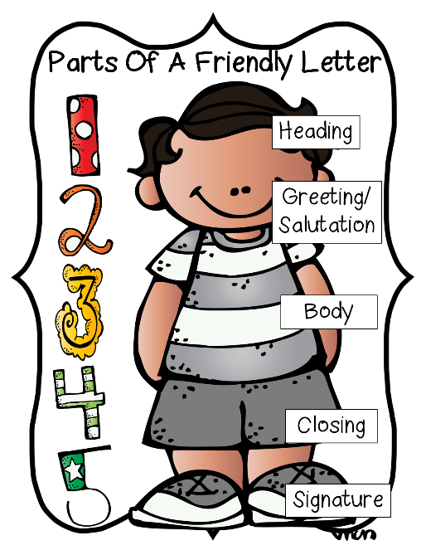
1. Greeting Don’t forget to make sure you’re using the correct form and spelling of the person’s name.
Be Specific!
- Dear Aunt Sharon,
- Dear Mr. Ed Myers,
________________________________

2. Express your thanks. Begin with the two most important words: Thank you. Avoid, “I’m writing to let you know …” Express the specific reason for thanking them.
- Thank you so much for …
Be Sincere!
- It made my day when I opened …
- I’m so grateful you were there when …
____________________________________________________________________________________________________________________________________________________________________________

3. Add specific details. Tell them how you plan to use or display their gift. It shows them you really appreciate the thought that went into it. You can also describe how you’ll spend a monetary gift.
- Here’s a picture of me with my new briefcase. I look so professional!
Be Informative!
- I can’t wait to use the birthday money you sent to decorate my dorm room.
- The going-away party meant so much to me. Having all my friends and family in one place was something I’ll never forget.
____________________________________________________________________________________________________________________________________________________________________________
4. Look ahead. Mention the next time you might see them, or just let them know you’re thinking of them.
- We look forward to seeing you next month at Lucy’s party.
Be Enthusiastic!
- I’ll always think of you when I use the new briefcase you gave me.

____________________________________________________________________________________________________________________________________________________________________________
5. Restate your thanks. Add details to thank them in a different way.
- Again, thank you for your generosity. I’m so excited about college. I’ll let you know all about it when I get settled.
- We felt so blessed that you made the trip to be with us on our wedding day. We can’t wait to see you again soon!
____________________________________________________________________________________________________________________________________________________________________________
6. End with your regards. “Sincerely” is a safe standby, but for closer relationships, you might choose a warmer option.
- With love,
- Many thanks,
- Yours truly,
________________________________

EXAMPLE

Dear Mr. Jacob Haagen,

Thank you so much for your partnership during the recent ACES Leadership Conference. Because of your generosity, over 1,500 FFA members have experienced a life-changing weekend! We were able to learn many leadership and career-readiness skills such as time management, public speaking and teamwork. These attributes will be very valuable as we proceed to college and the workforce.
FFA has opened my eyes to a vast array of careers in the agriculture industry. I’m so thankful for my own personal growth and look forward to the day I can work for a company like AgChoice Farm Credit! Again, thank you so much for your support of this conference and FFA.


Sincerely,
Sarah Sparks
FFA Chapter

