The Creation of the FFA Jacket
Created: 04/2016 by the National FFA Organization

Student Learning Objectives
After completing these activities students will…
- Identify where FFA jackets are created and why.
- Illustrate the path the jacket takes from start to finish.
- Discover the impact global sourcing has on goods.

Time Required: 30 minutes
Resources: FFA.org
Equipment and Supplies Needed:
- A copy of the “Track the FFA Jacket” worksheet for each student.
- Article: “The FFA Jacket: A Global Effect” https://www.ffa.org/the-feed/the-ffa-jacket-a-global-effort/
This quick lesson plan would work well as:
- As a portion of a FFA unit.
- As a portion of an FFA history lesson.
- As a portion of a global agriculture lesson.

These activities are aligned to the following standards:

FFA Precept
- FFA.PL-A. Action: Assume responsibility for life and take the necessary steps to achieve the desired results, no matter what the goal or task at hand.
- FFA.PL-E. Awareness: Understanding where you are with regard to personal vision, mission, and goals.
- FFA.CS-M. Communication: Effectively interact with others in personal and professional settings.
Common Core- Writing
- CCSS.ELA-Literacy.W.9-10.2 Write informative/explanatory texts to examine and convey complex ideas, concepts, and information clearly and accurately through the effective selection, organization, and analysis of content.
Common Core- Speaking and Listening
- CCSS.ELA-LITERACY.SL.9-10.1 Initiate and participate effectively in a range of collaborative discussions (one-on-one, in groups, and teacher-led) with diverse partners on grades 9-10 topics, texts, and issues, building on others' ideas and expressing their own clearly and persuasively.
- CCSS.ELA-LITERACY.SL.9-10.2 Integrate multiple sources of information presented in diverse media or formats (e.g., visually, quantitatively, orally) evaluating the credibility and accuracy of each source.
AFNR Career Ready Practices
- CRP.04. Communicate clearly, effectively, and with reason. Career-ready individuals communicate thoughts, ideas and action plans with clarity, whether using written, verbal and/or visual methods.
Partnership for 21st Century Skills
- Communication
- Information Literacy
- Collaboration

Lesson Plan:
- Introduction: The FFA jacket is a key distinguishing piece of our Official Dress, and gives members a great sense of pride in our organization. Have you ever thought about how or where the FFA jacket is made? Today, you will be discovering just that, the creation of the FFA Jacket.
  - Have students identify where the clothes they are currently wearing are made.
  - Brainstorm: Why are so many products made outside of the United States?

- Activity: Each student needs a copy of the handout “Track the FFA Jacket.”
  - Students will read the article “The FFA Jacket: A Global Effect” and complete the handout. The direct URL is https://www.ffa.org/the-feed/the-ffa-jacket-a-global-effort/.

- Follow-up: At the conclusion of the activity have a discussion about why we source globally and the location of the place on the map.
  - Guiding Questions: What would happen if we didn’t source globally? What would happen to the cost of products? Would it be possible to make all of the products we use on a daily basis in the United States?

- Leveling Up: To take this activity one step farther, that the students identify a different commoditiy that is imported to the United States (i.e. flowers, coffee, etc.). After students identify this commodity have them identify on the map the path it takes to get to the United States and the mode(s) of transportation.

Track the FFA Jacket
Directions:
Read the article The FFA Jacket: A Global Effect. The direct URL is https://www.ffa.org/the-feed/the-ffa-jacket-a-global-effort/. Complete the questions below.

- a. Identify, shade in and label where the cotton is woven and dyed in yellow on the map below:
b. Identify, shade in and label where the FFA Jackets are manufactured in blue on the map below:

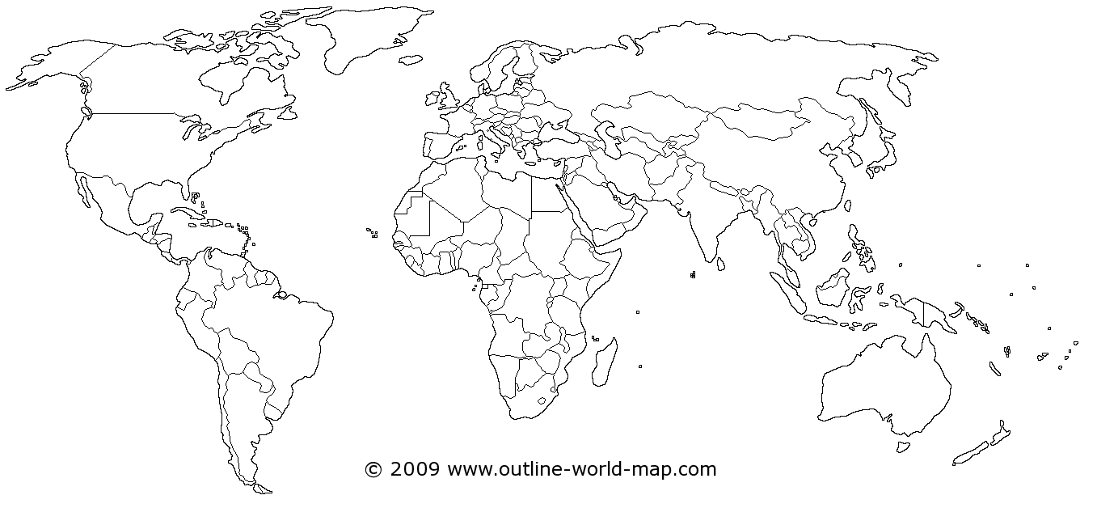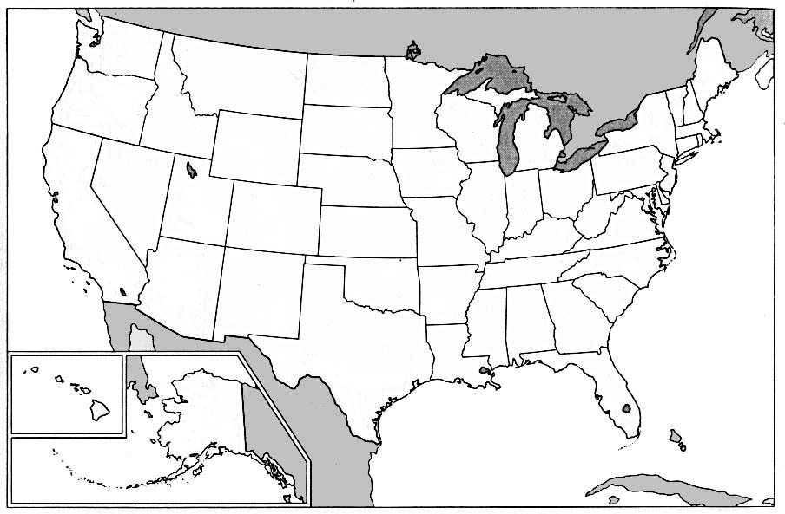

- Where are the names of states, chapters and FFA members emroidered?

- Utilizing the maps below illustrate the entire process from start to finish.

Why do we source products globally? What would happen if we didn’t?

- What is global sourcing?

Aligned to the following standards:
FFA.PL-A; FFA.PL-E; FFA.CS-M, CCSS.W.9-10.2; CCSS.SL.9-10.1; CCSS.SL.9-10.2; CRP.04
KEY: Track the FFA Jacket
Directions:
Read the article The FFA Jacket: A Global Effect. The direct URL is https://www.ffa.org/the-feed/the-ffa-jacket-a-global-effort/. Complete the questions below.

- a. Identify(shade in) and label where the cotton is woven and dyed in yellow on the map below:
b. Identify(shade in) and label where the FFA Jackets are manufactured in blue on the map below:
Ohio: shaded blue

Vietnam: shaded blue
China: shaded yellow

- Where are the names of states, chapters, and FFA members embroidered?

Universsal Lettering Company in Ohio

- Utilizing the maps below illustrate the entire process from start to finish.

4
3
2
1

- Cotton is sent to Chine to be woven and dyed
- Woven and dyed cotton is sent to manufacturing facilities in Vietnam and Ohio
- All Jackets are sent to Universal Lettering Company in Ohio to be personalized
- Finished Jackets are sent to custumers

Why do we source products globally? What would happen if we didn’t?

- What is global sourcing?

Global sourcing is when you have products made outside the country of origin and then imported.

Aligned to the following standards:
FFA.PL-A; FFA.PL-E; FFA.CS-M, CCSS.W.9-10.2; CCSS.SL.9-10.1; CCSS.SL.9-10.2; CRP.04

