The Future of Agriculture: Critical Challenges
Created: 11/2018 by the National FFA Organization

The Blue 365 lesson series is intended to bring innovative technology, science, research and entrepreneurship to the classroom. These lessons are designed to highlight the innovations and technologies transforming agriculture. This lesson focuses on the broader challenges in agriculture to set context for future lessons regarding specific technologies and innovations designed to meet these challenges.

Student Learning Objectives:
After completing these activities, students will …
- Describe critical challenges facing the agriculture industry by the year 2050.
- Identify two to three statistics facing agriculture sustainability.
- Design an infographic illustrating ways to respect our planet.
- Create an innovation or product to improve lives and feed the world.
- Analyze current challenges faced by the agriculture industry and develop potential solutions.

Time REQUIRED: 90 minutes
Resources:

- Website: Organisation for Economic Co-operation and Development’s http://www.oecd.org/env/indicators-modelling-outlooks/oecdenvironmentaloutlookto2050theconsequencesofinaction-keyfactsandfigures.htm
- Video: Factnomenal’s (2017) “15 Amazing Statistics for 2050!”, https://www.youtube.com/watch?v=sw2qBtnrQxQ
- Website: American Farm Bureau (2017), https://www.fb.org/newsroom/fast-facts
- Website: Food and Agriculture Organization’s (FAO, 2018), http://www.fao.org/nr/sustainability/food-loss-and-waste/en/
- Infographic generation tools:
  - Piktochart (2018), https://piktochart.com/formats/infographics/
  - Canva (2018), https://www.canva.com
- Video: “One Hungry Planet” (BASFAgProducts, 2010), https://www.youtube.com/watch?v=Jd-48Zw0Tr4
- Website: “Innovations at Work in Agriculture” (USDA, 2017), https://newfarmers.usda.gov/innovations-work-agriculture
- Website: “27 Industrial Revolution Inventions that Changed the World” (McFaddin, 2018), https://interestingengineering.com/27-inventions-of-the-industrial-revolution-that-changed-the-world
- AgExplorer, AgExplorer.ffa.org
- National FFA Living to Serve Grant Program, FFA.org/livingtoserve/grants/

Equipment and Supplies Needed:
- Internet access to play the videos in real time or embed them in a PowerPoint
- A copy of the “Critical Challenges 2050” worksheet for each student
- A copy of the “Critical Challenges — Infographic” worksheet for each student
- A copy of the “Innovations for a Changing Globe” worksheet for each student
- A copy of the “Brainstorming Solutions for Critical Challenges” worksheet for each student
- A copy of the “Agricultural Careers Exploration” worksheet for each student
- A copy of the “What Is My Role?” worksheet for each student
- Colored pens/markers
- Blank paper

This quick lesson plan would work well as An:
- Introduction to critical issues in agriculture.
- Introduction to technology in agriculture.
- Introduction to innovations in agriculture.
- Introduction to global food security.

student activity sheets
https://ffa.box.com/s/4n867k32bk35at1gukwea737vw2ar1ty (Word)
https://ffa.box.com/s/8dnw8vg513z07u4ro0rwv7av1j8clntn (PDF)
These activities are aligned to the following standards:
AFNR Performance Element
- CS.01. Analyze how issues, trends, technologies and public policies impact systems in the Agriculture, Food & Natural Resources Career Cluster
- CS.05. Describe career opportunities and means to achieve those opportunities in each of the Agriculture, Food & Natural Resources career pathways.
- CS.06. Analyze the interaction among AFNR systems in the production, processing and management of food, fiber and fuel and the sustainable use of natural resources.

FFA Precept
- FFA.CS-M.Communication. Effectively interact with others in personal and professional settings.
- FFA.CS-N.Decision Making. Analyze a situation and execute an appropriate course of action.

Common Career Technical Core
- AG1. Analyze how issues, trends, technologies and public policies impact systems in the Agriculture, Food & Natural Resources Career Cluster.
- AG5. Describe career opportunities and means to achieve those opportunities in each of the Agriculture, Food & Natural Resources Career Pathways.
- AG6. Analyze the interaction among AFNR systems in the production, processing, and management of food, fiber, and fuel and the sustainable use of natural resources.

NASDCTEc
- AGC10.03. Compare and contrast issues affecting the AFNR industry including biotechnology, employment, safety, environmental and animal welfare to demonstrate an understanding of the trends and issues important to careers in this industry.
- AGC10.04. Envision emerging technology and globalization and project its influence on widespread markets to demonstrate an understanding of technologies and trends that will impact the AFNR industry.

Common Core – Reading: Informational Text
- CCSS.ELA-Literacy.RI.9-10.3. Analyze how the author unfolds an analysis or series of ideas or events, including the order in which the points are made, how they are introduced and developed, and the connections that are drawn between them.

Common Core – Writing
- CCSS.ELA-Literacy.W.9-10.2. Write informative/explanatory texts to examine and convey complex ideas, concepts, and information clearly and accurately through the effective selection, organization, and analysis of content.

Common Core – Speaking and Listening
- CCSS.ELA-Literacy.SL.9-10.4. Present information, findings, and supporting evidence clearly, concisely, and logically such that listeners can follow the line of reasoning and the organization, development, substance, and style are appropriate to purpose, audience, and task.

Common Core – Science & Technical Subjects
- CCSS.ELA-Literacy.RST.9-10.7. Translate quantitative or technical information expressed in words in a text into visual form (e.g., a table or chart) and translate information expressed visually or mathematically (e.g., in an equation) into words.

Common Core – Literacy in Science & Technical Subjects: Writing
- CCSS.ELA-Literacy.WHST.9.10.6. Use technology, including the Internet, to produce, publish, and update individual or shared writing products, taking advantage of technology's capacity to link to other information and to display information flexibly and dynamically.

Next Generation Science
- HS-ETS1-3. Evaluate a solution to a complex real-world problem based on prioritized criteria and trade-offs that account for a range of constraints, including cost, safety, reliability, and aesthetics as well as possible social, cultural, and environmental impacts.

Green/Sustainability Knowledge and Skill Statements
- AFNR Career Cluster, Statement 3. Communicate the impact of green and sustainability principles on agriculture, food and natural resource systems.
- AFNR Career Cluster, Statement 7. Demonstrate an understanding of green and sustainability trends that are impacting processes and markets in AFNR.

AFNR Career Ready Practices
- CRP.05. Consider the environmental, social and economic impact of decisions. Career-ready individuals understand the interrelated nature of their actions and regularly make decisions that positively impact and/or mitigate negative impact on other people, organizations and the environment.
- CRP.06. Demonstrate creativity and innovation. Career-ready individuals regularly think of ideas that solve problems in new and different ways, and they contribute those ideas in a useful and productive manner to improve their organization.

Partnership for 21st Century Skills
- Communication
- Critical Thinking and Problem Solving
- Environmental Literacy
- Implement Innovations
- Think Creatively

Lesson Plan:
- Bell Ringer: What the world will look like in 50 years? In 100 years?
  - Using the “Critical Challenges 2050” worksheet, draw a scene of how the world might look in 2050. Use your imagination and be as descriptive as possible. Consider what the scenery might look like. What might the people be doing? What are their jobs? How do they travel to and from their destinations? Use pictures, illustrations and words to capture your thoughts.
  - Share illustrations with the class.

- Introduction: The year 2050 provides some unique challenges for agriculturists and scientists as we prepare to feed and clothe a growing population. However, with such critical challenges and issues ahead of us, agriculturists also have a great opportunity to make a positive difference for food and fiber production while maintaining sustainable natural resources by discovering new innovations, engaging advanced technology and collaborating with other key players in the industry of agriculture.
  - Students should visit the Organisation for Economic Co-operation and Development’s website on 2050 projections. The URL is http://www.oecd.NFFA66org/env/indicators-modelling-outlooks/oecdenvironmentaloutlookto2050theconsequencesofinaction-keyfactsandfigures.htm.
    - With a partner, have students discuss two to three projections that were the most surprising/alarming. They should list their projections on the “Critical Challenges 2050” worksheet.
  - Optional: Have students watch Factnomenal’s (2017) video on statistics about 2050. The video is available at https://www.youtube.com/watch?v=sw2qBtnrQxQ.
    - With a partner, have students discuss two to three projections for 2050 that were the most surprising/alarming. Have students share one projection with the class when finished.

- Part 1 — Respecting our Planet:
  - The first step to addressing critical challenges faced by the industry of agriculture is understanding how to respect the planet’s land, air, water and natural resources.
    - With a partner, have students research current statistics about respecting our planet and sustainability by visiting:
      - The American Farm Bureau (2017) website at https://www.fb.org/newsroom/fast-facts.
      - The Food and Agriculture Organization’s (FAO) website on food waste and loss. The URL is
http://www.fao.org/nr/sustainability/food-loss-and-waste/en/.
      - Other resources from valid, scientific sources.
    - Students should select two to three statistics about respecting our planet to design an infographic using the “Critical Challenges — Infographic” worksheet and share with the class.
      - Provide colored pens/markers for students to get creative with their infographics.
    - If time permits or as an optional “leveling up” exercise (see below), encourage students to use an infographic generation tool:
      - Piktochart — https://piktochart.com/formats/infographics/
      - Canva — https://www.canva.com

- Part 2 — Feeding the World:
  - Feeding the world requires thinking creatively about new technologies and innovations.
    - Have students watch “One Hungry Planet” (BASFAgProducts, 2010). The video is available at https://www.youtube.com/watch?v=Jd-48Zw0Tr4.
      - Optional: If watching YouTube is not an option, have students visit the U.S. Department of Agriculture’s (2017) “Innovations at Work in Agriculture” website. The URL is
https://newfarmers.usda.gov/innovations-work-agriculture.
      - As a class, discuss current issues and trends in agriculture that need innovative and creative ideas to solve.
      - Begin thinking of creative ways to help solve issues.
    - With a partner, have students think through possible solutions to increase food production to feed the world. If you were to invent something new (a product, method, technology, etc.) to help feed the world, what would it look like? What would it do? Who could use it? Is it affordable for producers to buy?
      - For additional inspiration and context for students, have students consider innovations and products that revolutionized agriculture throughout history. Students can use “27 Industrial Revolution Inventions that Changed the World” on Interesting Engineering’s (McFaddin, 2018) website as a resource. The URL is https://interestingengineering.com/27-inventions-of-the-industrial-revolution-that-changed-the-world.
    - Have students create a diagram of the innovation or product they designed on the “Innovations for a Changing Globe” worksheet.
    - Students should address what need it is meeting within the industry and describe how it can connect future food production needs with people who are currently working within the agriculture industry.

- Part 3 — Improving Lives:
  - Improving lives starts by critically analyzing solutions that can help overcome critical challenges.
    - As a class, discuss what improving lives means. How can we improve someone’s life around us? What about improving lives through agriculture?
    - Have students review notes from the lesson and, if time allows, research additional challenges the agriculture industry will face in the next 50 to 100 years. Discuss which challenges emerge as the most critical to respecting our planet, feeding the world and improving lives.
    - Have students diagram a concept map by using the “Brainstorming Solutions for Critical Challenges” worksheet to expand on at least five key challenges faced by the agriculture industry in the next 50 to 100 years.
      - If time permits, draw a large concept map diagram on the board or tape a template on the floor for the whole class to create a visual representation of challenges and solutions.
    - Encourage students to critically analyze realistic solutions to these challenges that can help improve lives. List steps to the solutions within the concept/mind map.

- Follow-up: As a class, review and discuss the concept maps, focusing on the proposed solutions to the challenges. If time allows, divide students into groups of two or three to discuss challenges and solutions.

- Leveling Up:
  - Respecting the planet infographics and advocacy platform:
    - Using the infographics created in the lesson, have students develop an advocacy platform that can be used as an agricultural issues topic to debate in class.
    - Encourage students to develop an infographic that displays another side of their issue or topic that could be debated by other students in their class.
    - Discuss how illustrating multiple sides of an issue forms a more well-rounded viewpoint of the issue.
  - Oral presentations or written reports:
    - Visit the American Farm Bureau website to review teacher resources.
    - The Food and Farm Facts annual publication can be ordered for $2.50 (https://www.dmsfulfillment.com/FarmBureau/DMSStore/Product/ProductDetail/26095).
    - After reviewing statistics, develop a five- to seven-minute presentation or a three- to five-page written report on a selected topic.
  - Apply for a “Living to Serve” Grant:
    - Using students’ “Brainstorming Solutions for Critical Change” worksheets, have the class select one winner for the most innovative idea or product to resolve a challenge within agriculture.
    - As a class, revise the proposed solution to address one of the key focus areas for the National FFA Living to Serve Grant Program (FFA.org/livingtoserve/grants/).
    - Develop an implementation plan, and complete a grant application to apply for chapter funding.
  - Career exploration:
    - Have students visit AgExplorer (AgExplorer.ffa.org).
    - Using the “Agricultural Careers Exploration” worksheet, have students select one career for each critical challenge area (respecting the planet, feeding the world and improving lives) that they think will have a significant role in addressing the challenge.
    - Students should explain the connection of the career choice and challenge area.
  - School or community service project:
    - Discuss steps to be taken within the agricultural education classroom, school or community to raise awareness on critical challenges faced by food, water or natural resources.

- Exit Ticket: What is my role in addressing the critical challenges?
Agriculture has a role in everyone’s life that goes far beyond providing food and clothing. Agriculture encompasses scientists, engineers, computer programmers, mathematicians, artists, communicators, educators and many other careers, and they all play a role in respecting our planet, feeding the world and improving lives. What will be your role in helping the agriculture industry address critical challenges? Complete the “What Is My Role?” worksheet.
Critical Challenges 2050
Aligned to the following standards:
CS.01; CS.05; CS.06; FFA.CS-M; FFA.CS-N; AG1; AG5; AG6; AGC10.03; AGC10.04; CCSS.ELA-RI.9-10.3; CCSS.ELA-W.9-10.2; CCSS.ELA.SL.9-10.4; CCSS.ELA.RST.9-10.7; CCSS.ELA.WHST.9.10.6; HS-ETS1-3; AFNR.CC.S.3; AFNR.CC.S.7; CRP.05; CRP.06
Directions:
Visit the Organisation for Economic Co-operation and Development’s website on 2050 projections, available at http://www.oecd.NFFA66org/env/indicators-modelling-outlooks/oecdenvironmentaloutlookto2050theconsequencesofinaction-keyfactsandfigures.htm. Draw a scene of how the world might look in 2050. Include what the scenery might look like. What might the people be doing? What are their jobs? How do they travel to and from their destinations? Use pictures, illustrations and words to capture your thoughts.

Watch Factnomenal’s “15 Amazing Statistics for 2050!” video, available at https://www.youtube.com/watch?v=sw2qBtnrQxQ. List 2 to 3 projections about the year 2050 that were the most surprising/alarming and explain why. What critical area(s) did the projections best align with? How?
Surprising projection:

Critical Area:
Surprising projection:

Critical Area:
Surprising projection:

Critical Area:


Critical Challenges — Infographic
Aligned to the following standards:
CS.01; CS.05; CS.06; FFA.CS-M; FFA.CS-N; AG1; AG5; AG6; AGC10.03; AGC10.04; CCSS.ELA-RI.9-10.3; CCSS.ELA-W.9-10.2; CCSS.ELA.SL.9-10.4; CCSS.ELA.RST.9-10.7; CCSS.ELA.WHST.9.10.6; HS-ETS1-3; AFNR.CC.S.3; AFNR.CC.S.7; CRP.05; CRP.06
Directions:
The first step in addressing critical challenges is understanding how to respect the planet’s land, air, water and natural resources. Answer the brainstorming questions in the section below.

1) What issue(s) are you most passionate about solving?

2) What do you currently know about the topic?

3) What would it take to communicate that issue to a non-scientific audience or one that might not be thinking about the future of the planet?

Directions:
Research current statistics about respecting our planet and sustainability by visiting the American Farm Bureau website (https://www.fb.org/newsroom/fast-facts) or the Food and Agriculture Organization’s website (http://www.fao.org/nr/sustainability/food-loss-and-waste/en/).

List 2 to 3 statistics you find the most interesting.

1) | 2) | 3)

Directions:
Design an infographic illustrating 2 to 3 statistics about respecting the planet and how agriculture can help improve sustainability. Sketch your ideas and thoughts in the space below. Then, use a clean piece of paper or an online infographic design system to create the final product.

Innovations for a Changing Globe
Aligned to the following standards:
CS.01; CS.05; CS.06; FFA.CS-M; FFA.CS-N; AG1; AG5; AG6; AGC10.03; AGC10.04; CCSS.ELA-RI.9-10.3; CCSS.ELA-W.9-10.2; CCSS.ELA.SL.9-10.4; CCSS.ELA.RST.9-10.7; CCSS.ELA.WHST.9.10.6; HS-ETS1-3; AFNR.CC.S.3; AFNR.CC.S.7; CRP.05; CRP.06
Directions:
Using a global issue you are passionate about (see the Critical Challenges — Infographic worksheet), describe one possible solution that could help to resolve the issue. Do any innovations/products currently exist to address this need? If so, what are they?

The issue: One possible solution: Solutions that exist:

Directions:
Create a business plan for an innovation or product to address this issue.

  - Name of the innovation/product:

  - What need does it address?

  - Describe the environmental, social and economic impact of the innovation/product.

  - How will it be accessed by or provided to agricultural producers? How will it benefit agricultural producers?

  - Projected cost of the innovation/product:

  - Projected release timeline:

  - Diagram of the innovation/product (provide labels and description):

Brainstorming Solutions for Critical Challenges
Aligned to the following standards:
CS.01; CS.05; CS.06; FFA.CS-M; FFA.CS-N; AG1; AG5; AG6; AGC10.03; AGC10.04; CCSS.ELA-RI.9-10.3; CCSS.ELA-W.9-10.2; CCSS.ELA.SL.9-10.4; CCSS.ELA.RST.9-10.7; CCSS.ELA.WHST.9.10.6; HS-ETS1-3; AFNR.CC.S.3; AFNR.CC.S.7; CRP.05; CRP.06
Directions:
Complete the concept map by listing at least five challenges that will be faced by the agriculture industry in the next 50 to 100 years, and research solutions to be practiced by individuals, businesses and/or communities.
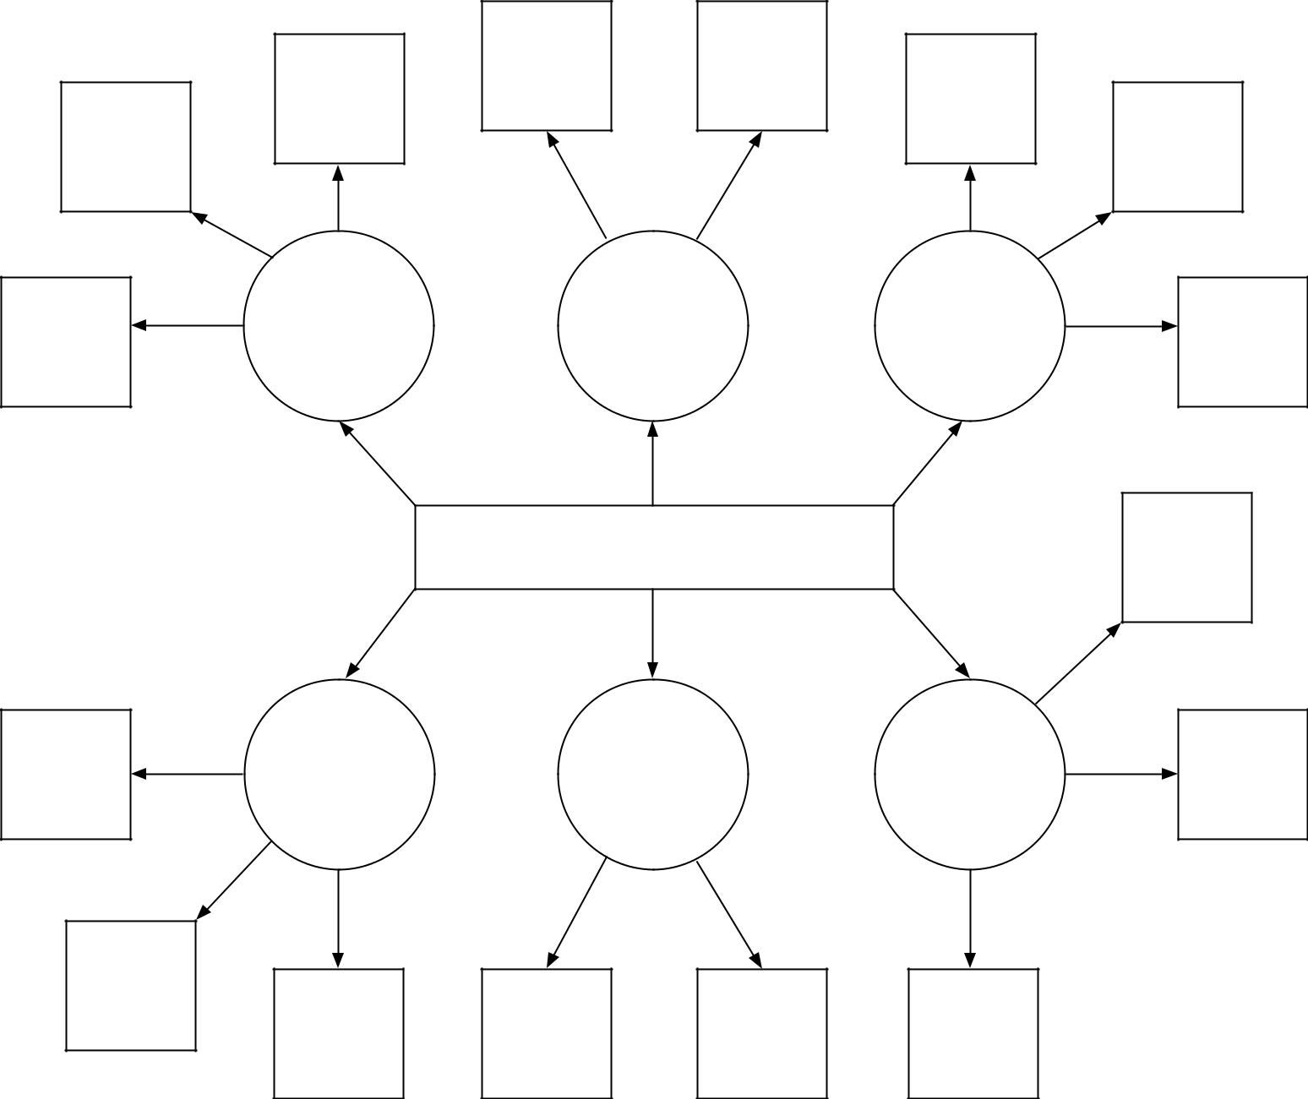
Critical Challenges and Solutions
Example Challenge:
Clean Water Shortage
Recycle
(i.e., gray water collection; rain water; recycle)
Reduce
(i.e., turn water off when brushing teeth; xeriscape)
Conserve
(i.e., drip irrigation; use mulch landscaping)

Agricultural Careers Exploration
Aligned to the following standards:
CS.01; CS.05; CS.06; FFA.CS-M; FFA.CS-N; AG1; AG5; AG6; AGC10.03; AGC10.04; CCSS.ELA-RI.9-10.3; CCSS.ELA-W.9-10.2; CCSS.ELA.SL.9-10.4; CCSS.ELA.RST.9-10.7; CCSS.ELA.WHST.9.10.6; HS-ETS1-3; AFNR.CC.S.3; AFNR.CC.S.7; CRP.05; CRP.06
Directions:
Visit AgExplorer (AgExplorer.ffa.org) to find different careers that interest you. Select one career for each critical challenge area (respecting the planet, feeding the world and improving lives) that you think will have a significant role in addressing the challenge. Explain the connection between the career and the challenge area in the second column on the handout.

Respecting the Planet
Career Interest: | Connection to Challenge Area:
Feeding the World
Career Interest: | Connection to Challenge Area:
Improving Lives
Career Interest: | Connection to Challenge Area:

What Is My Role?
Aligned to the following standards:
CS.01; CS.05; CS.06; FFA.CS-M; FFA.CS-N; AG1; AG5; AG6; AGC10.03; AGC10.04; CCSS.ELA-RI.9-10.3; CCSS.ELA-W.9-10.2; CCSS.ELA.SL.9-10.4; CCSS.ELA.RST.9-10.7; CCSS.ELA.WHST.9.10.6; HS-ETS1-3; AFNR.CC.S.3; AFNR.CC.S.7; CRP.05; CRP.06
Directions:
Agriculture has a role in everyone’s life that goes far beyond providing food and clothing. Agriculture encompasses scientists, engineers, computer programmers, mathematicians, artists, communicators, educators and many other careers, and everyone plays a role in respecting our planet, feeding the world and improving lives.

Describe your role or what you can do to help the agriculture industry address critical challenges. Use pictures, words, phrases, etc. to illustrate your role in each area.

Respecting the Planet
Feeding the World
Improving Lives

