Tough Work for Tender Meats
Created: 02/2021 by the National FFA Organization
Description of Lesson: Being able to experience the farm-to-fork process for foods that we consume is a valuable learning experience. In this lesson, we will explore what one FFA chapter does to make this experience a reality while learning what part of the animal different cuts of beef, pork and lamb come from.

Student Learning Objectives:
After completing these activities, students will …
- Identify the cuts of meat from beef.
- Identify the cuts of meat from pork.
- Identify the cuts of meat from lamb.
- Develop recipes that incorporate different cuts of meat.
- Explain the importance of the meat science industry.

Time Required: 60 minutes
Resources/References:
- Website: University of Nebraska-Lincoln Animal Science, https://animalscience.unl.edu/meat-cut-identification/
Related Resources:
- Meats Evaluation and Technology CDE, FFA.org/participate/cdes/meats-evaluation-and-technology/

Equipment and Supplies Needed:
- A copy of the “Tough Work for Tender Meats” worksheet for each student
- A copy of or online access to the article “Tough Work for Tender Meats,” FFA.org/the-feed/tough-work-for-tender-meats/

Vocabulary:
- Chop
- Loin
- Meat cut
- Roast

Cross-Curricular Connections:
Science | English/Language Arts
Identify different cuts of meats and their uses. | Write a recipe using one of the cuts of meat that were identified.

Student Activity Sheets:
Direct access to student activity sheets without lesson plan or answer key for easy upload to a learning management system or printing for classwork.

https://ffa.box.com/s/n3124uq5iovjs3x58szljb99nem4p2db (Word)
https://ffa.box.com/s/51ggxdlrcq1hruenpr10nuw540j2ezzd (PDF)

These Activities are Aligned to the Following Standards:
FFA Precept
- FFA.PL-A.Action: Assume responsibility and take the necessary steps to achieve the desired results, no matter what the goal or task at hand.
- FFA.PL-F.Continuous Improvement: Accept responsibility for learning and personal growth.
- FFA.PG-I.Professional Growth: Assume responsibility for attaining and improving upon the skills needed for career success.
- FFA.PG-J.Mental Growth: Embrace cognitive and intellectual development relative to reasoning, thinking and coping.
- FFA.CS-N.Decision Making: Analyze a situation and execute an appropriate course of action.
- FFA.CS-P.Technical/Function Skills in Agriculture: Obtain knowledge and skills needed for a career in agriculture and related industries.
Common Core – Reading: Informational Text
- CCSS.ELA-Literacy.RI.9-10.4 Determine the meaning of words and phrases as they are used in a text, including figurative, connotative, and technical meanings; analyze the cumulative impact of specific word choices on meaning and tone (e.g., how the language of a court opinion differs from that of a newspaper).
Common Core – Writing
- CCSS.ELA-Literacy.W.9-10.1: Write arguments to support claims in an analysis of substantive topics or texts, using valid reasoning and relevant and sufficient evidence.
- CCSS.ELA-Literacy.W.9-10.2: Write informative/explanatory texts to examine and convey complex ideas, concepts, and information clearly and accurately through the effective selection, organization, and analysis of content.
Partnership for 21st Century Skills
- Critical Thinking and Problem Solving
- Flexibility and Adaptability
- Initiative and Self-Direction
- Leadership and Responsibility
- Think Creatively

Lesson Plan:
- Bellringer: What is your favorite meal? This can be breakfast, lunch or dinner. List all the ingredients needed for this meal. Example: Lasagna would need mozzarella cheese, ricotta cheese, noodles, Italian sausage, tomato sauce, basil, oregano, garlic powder, salt and pepper.

- Introduction: Many of the foods that people enjoy have a meat component. Today, we are going to learn about where different cuts of meat come from and how they are utilized in the meals and snacks we enjoy.

- Activity: Each student needs a copy of the worksheet “Tough Work for Tender Meats.”
  - Part 1: Have students read the article “Tough Work for Tender Meats” found at FFA.org/the-feed/tough-work-for-tender-meats/. Students will complete the activities to learn more about different cuts of meat.
  - Part 2: Knowing the different cuts of meat is important to understand the way those cuts can be used. Have students use the images of each species (cattle, swine, lamb) and the resource from University of Nebraska-Lincoln (https://animalscience.unl.edu/meat-cut-identification/) to complete the following:
    - Take each species (cattle, swine, lamb) and draw lines to identify the different cuts on each image. Then label each cut. One cut has been completed for students as an example. Students should note that there are multiple cuts and labels for each species.
    - Identify three specific cuts that come from each area. There is an example for students to reference. Students will need two more examples from the Beef Round area.
  - Part 3: The ultimate goal of the different cuts of meat is to be able to create meals. Have students take one specific cut of meat (Ex. eye round roast) and develop a recipe for a main course of a meal. If a student is vegetarian or vegan, have them develop a recipe with a meat alternative.

- Follow-up: Gather all the recipes and develop a class cookbook that can be shared. You could also consider selling the cookbook to gain funds for projects in your classroom or FFA chapter.

- Optional – Extended Learning Opportunities (Not factored into time requirement):
  - Have students vote on their favorite recipe. Then have students record themselves preparing the meal at home and sharing their thoughts on the process.

- Exit Ticket: Why is it important to understand the meat fabrication industry?

Tough Work for Tender Meats
Aligned to the following standards:
FFA.PL-A; FFA.PL-F; FFA.PG-I; FFA.PG-J; FFA.CS-N; FFA.CS-P; CCSS.ELA.RI.9-10.4; CCAA.ELA.W.9-10.1; CCSS.ELA.W.9-10.2
Directions:
Read the article “Tough Work for Tender Meats” found at FFA.org/the-feed/tough-work-for-tender-meats/. Complete the following activities to learn more.

Part 1
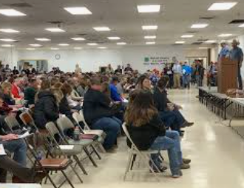
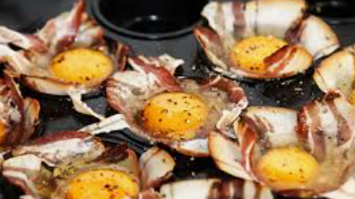
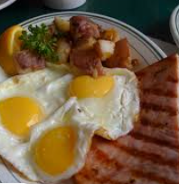
What role does the meat science industry play in our economy?
What skills can be gained from learning about meat science?
A school having a meat lab can be seen as a community service/support. What role do you think a school-based meat lab has/can have on the community?

Do you think a meat lab would work well in your school and community? Why or why not?
What skills can be learned from a Ham, Bacon and Egg show?
What is the purpose of the Ham, Bacon and Egg shows?

In what state did Makayla gain experience in a school meat lab?
- Virginia
- Minnesota
- West Virginia
- Maine
Why do you think schools have meat labs as part of their school programs?
Part 2
Directions:
Knowing the different cuts of meat is important to understand the way those cuts can be used. Use the images of each species (cattle, swine, lamb) and the resource identified below to complete the following:
- Take each species (cattle, swine, lamb) and draw lines to identify the different cuts on each image. Then label each cut. One cut has been completed for you as an example. Note that there are multiple cuts and labels for each species.
- Identify three specific cuts that comes from each area. There is an example below for you to reference. You will need two more examples from the Beef Round area.
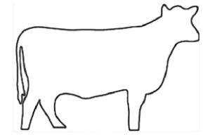
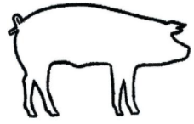
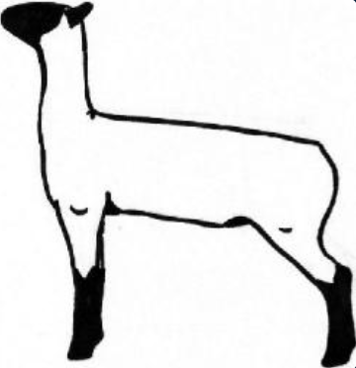
Resource: University of Nebraska-Lincoln, https://animalscience.unl.edu/meat-cut-identification/
Beef Round
Eye Round Roast
Part 3
Directions:
The ultimate goal of the different cuts of meat is to be able to create meals. Take one specific cut of meat (Ex. eye round roast) and develop a recipe for a main course of a meal.
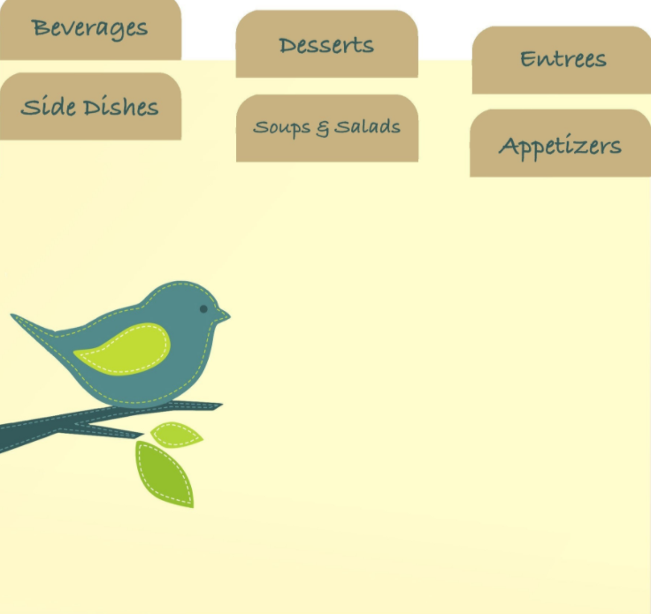
Why is understanding where the different cuts of meat come from important?
How will you use what you have learned about meat cuts?
Summarize what you have learned in this lesson in one sentence.
Directions:
Ingredients:
KEY: Tough Work for Tender Meats
Aligned to the following standards:
FFA.PL-A; FFA.PL-F; FFA.PG-I; FFA.PG-J; FFA.CS-N; FFA.CS-P; CCSS.ELA.RI.9-10.4; CCAA.ELA.W.9-10.1; CCSS.ELA.W.9-10.2
Directions:
Read the article “Tough Work for Tender Meats” found at FFA.org/the-feed/tough-work-for-tender-meats/. Complete the following activities to learn more.
Part 1
What role does the meat science industry play in our economy? The meat science industry is responsible for providing a safe and nutritional food for consumption and providing money to the economy.
What skills can be gained from learning about meat science? Answers will vary. Example: Understanding the meat science industry can make you a more conscientious consumer.
In what state did Makayla gain experience in a school meat lab?
- Virginia
- Minnesota
- West Virginia
- Maine
Why do you think schools have meat labs as part of their school programs? Answers will vary.
A school having a meat lab can be seen as a community service/support. What role do you think a school-based meat lab has/can have on the community? Answers will vary.

Do you think a meat lab would work well in your school and community? Why or why not? Answers will vary.
What skills can be learned from a Ham, Bacon and Egg show? Answers will vary. Examples include showmanship, communication, personal presentation, etc.
What is the purpose of the Ham, Bacon and Egg shows? Allows students to showcase what they have learned and practice their showmanship skills as well as how to present themselves to an audience

Part 2
Directions:
Knowing the different cuts of meat is important to understand the way those cuts can be used. Use the images of each species (cattle, swine, lamb) and the resource highlighted below to complete the following:
- Take each species (cattle, swine, lamb) and draw lines to identify the different cuts on each image. Then label each cut. One cut has been completed for you as an example. Note that there are multiple cuts and labels for each species.
- Identify three specific cuts that comes from each area. There is an example below for you to reference. You will need two more examples from the Beef Round area.
Beef Round
Eye Round Roast
Beef Round
- Tip Steak-Cap Off
- Round Steak
- Tip Roast-Cap Off
- Bottom Round Rump Roast, Boneless
- Eye Round Steak
- Bottom Round Steak
- Top Round Steak

Brisket
- Brisket, Corned, Boneless
- Brisket, Flat Half, Boneless
- Brisket, Whole, Boneless

Beef Chuck
- Top Blade Steak (Flat Iron)
- Chuck Eye Roast, Boneless
- Arm Pot Roast, Boneless
- Mock Tender Roast
- Mock Tender Steak
- 7-Bone Pot Roast
- Arm Pot Roast
- Blade Roast

Beef Rib
- Ribeye Steak, Boneless
- Rib Eye Steak, Lip-On
- Rib Roast

Beef Loin
- Top Sirloin Steak, Boneless
- Tenderloin Steak
- Porterhouse Steak
- Top Loin Steak, Boneless
- T-Bone Steak
- Top Loin Steak

Plate
- Skirt Steak, Boneless
- Short Ribs
- Flank
Flank
- Skirt Steak, Boneless
- Short Ribs
- Flank
Resource: University of Nebraska-Lincoln, https://animalscience.unl.edu/meat-cut-identification/
Flank
Plate
Head
Pork Shoulder
Pork Shoulder
Pork Loin
Pork Side/Belly
Pork Ham/ Leg
Pork Ham/Leg
- Smoked Ham Center Slice
- Smoked Ham Shank Portion
- Smoked Ham Rump Portion
- Smoked Ham, Boneless
- Fresh Ham Shank Portion
- Fresh Ham Rump Portion
- Fresh Ham Center Slice
Pork Loin
- Tenderloin, Whole
- Sirloin Cutlets
- Top Loin Chop, Boneless
- Rib Chop
- Center Rib Roast
- Back Ribs
- Country Style Ribs
- Tri-Tip Roast
- Smoke Loin Chop
- Sirloin Roast
- Sirloin Chops
- Center Loin Roast
- Loin Chop
- Blade Roast
- Blade Chop
Pork Shoulder
- Arm Roast
- Smoked Shoulder Picnic, Whole
- Arm Picnic, Whole
- Shoulder Arm Steak
- Blade Boston Roast
- Blade Steak
Pork Side/Belly
- Slice Bacon
- Slab Bacon
- Fresh Side
Lamb Shoulder
Lamb Breast
Lamb Rib
Lamb Loin
Lamb Leg
Lamb Shoulder
- Arm Chop
- Blade Chop
- Square Cut
Lamb Shoulder
- Rib Roast, Frenched
- Rib Chops, Frenched
- Rib Chops
- Rib Roast
Lamb Loin
- Loin Roast
- Loin Chops
Lamb Leg
- Sirloin Chop
- American Style Roast
Lamb Breast
- Breast Ribs (Denver Style)
Head
Beef Chuck
Brisket
Beef Rib
Beef Loin

