Smart Irrigation
Aligned to the following standards:
NRS.02; FFA.PL-A; FFA.PG-J; AG-NR2; AGPE01.03; CS.06; CCSS.RI.9-10.3; CCSS.RST.9.10.1; CCSS.RST.9.10.2; CCSS.RST.9.10.5; CCSS.RST.9.10.8; CCSS.WHST.9.10.4; CCSS.WHST.9.10.7; CCSS.WHST.9.10.8; CCSS.WHST.9.10.9; MP3; MP6; AFNR Career Cluster, Statement 7; CRP.02; CRP.05; CRP.07; CRP.08
Directions:
Read over and answer the questions below while you watch the video “Turfgrass Management-Irrigation SAE | Tyler Hewitt,” available at https://vimeo.com/368438143.
Describe Tyler’s SAE.

List the tasks Tyler does at work on a typical day.

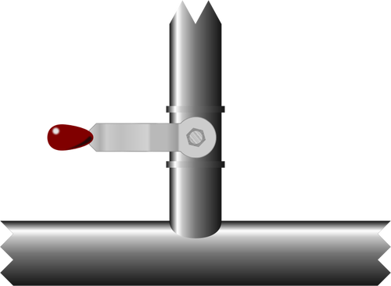

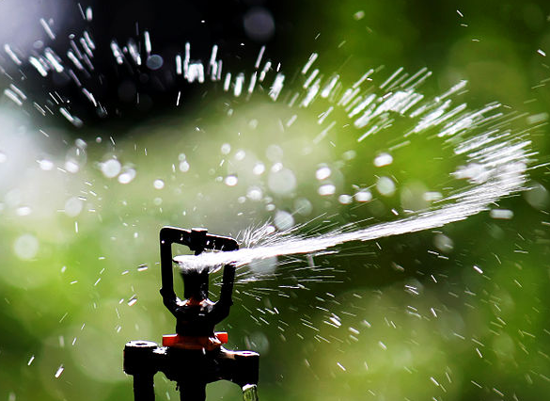
What is Tyler’s claim to fame? (Hint: It’s related to his certification.)
What did Tyler do to become a certified irrigation expert?

How does his SAE help his community?


Water Conservation Through Technology
Aligned to the following standards:
NRS.02; FFA.PL-A; FFA.PG-J; AG-NR2; AGPE01.03; CS.06; CCSS.RI.9-10.3; CCSS.RST.9.10.1; CCSS.RST.9.10.2; CCSS.RST.9.10.5; CCSS.RST.9.10.8; CCSS.WHST.9.10.4; CCSS.WHST.9.10.7; CCSS.WHST.9.10.8; CCSS.WHST.9.10.9; MP3; MP6; AFNR Career Cluster, Statement 7; CRP.02; CRP.05; CRP.07; CRP.08
Directions:
Through Tyler Hewitt’s work in his SAE, he has learned that water conservation and technology are closely linked. Answer the questions below by researching water conservation and technology. Then, create an infographic that shows how technology can assist with water conservation efforts. Create your infographic using paper and colored pencils or pens. If your teacher approves, you can also use digital resources to create your infographic.
Suggested Resources:
Water Conservation: https://www.epa.gov/environmental-topics/water-topics
Water Availability: https://www.ars.usda.gov/natural-resources-and-sustainable-agricultural-systems/water-availability-and-watershed-management/
Water Conservation: https://www.nal.usda.gov/waic/water-conservation
Water Scarcity: http://www.fao.org/3/a-i6459e.pdf

Find four facts about the importance of water conservation.


Research water scarcity and agriculture, and list three things you learned.



Describe three technologies that could help with water conservation.
Technology 1
Technology 2
Technology 3

What are steps you can take each day to practice water conservation?

Irrigation-Related Careers
Aligned to the following standards:
NRS.02; FFA.PL-A; FFA.PG-J; AG-NR2; AGPE01.03; CS.06; CCSS.RI.9-10.3; CCSS.RST.9.10.1; CCSS.RST.9.10.2; CCSS.RST.9.10.5; CCSS.RST.9.10.8; CCSS.WHST.9.10.4; CCSS.WHST.9.10.7; CCSS.WHST.9.10.8; CCSS.WHST.9.10.9; MP3; MP6; AFNR Career Cluster, Statement 7; CRP.02; CRP.05; CRP.07; CRP.08

- Using AgExplorer.ffa.org, research three careers that require knowledge of irrigation systems. Compare and contrast the job responsibilities of the three careers in this Venn diagram.

- Summarize what you learned about the similarities and differences between job responsibilities in careers that require knowledge of irrigation systems.

 | 25–21 Points | 20–16 Points | 15–11 Points | 10–6 Points | 5–0 Points
Design  Layout  Color Scheme  Fonts | Layout is organized and uses consistent style.  Color scheme has visual appeal and works with content.  Fonts are legible and consistent. | Generally good layout  Has minor inconsistency or one distracting element  Color scheme clashes | Layout could use improvement  Two or more inconsistent elements  Hard to read fonts  Layout distracts from content | Layout is disorganized, no obvious organization  Layout distracts from content  Color scheme is confusing. | No layout or scheme— just random elements, colors and fonts
Content  Terms, Facts  Quantity of data  Quality of data | Appropriate terms, vocab, jargon defined and used  More than enough data to make claims  Data clearly demonstrate trend, claim, etc.  Data from good source | One or two terms or jargon used incorrectly or without explanation.  Adequate amount of data  Data demonstrate trend, claim, etc.  Data from good source | Not enough terms, vocab, jargon  Data is sparse.  Data might not demonstrate the trend or claim.  Data from good source | Lacking in appropriate terminology  Not enough facts or data  Data is from poor or questionable source. | No real data or facts are present.
Clarity  Makes a claim  Efficiency  Makes clear impression | Claim or main idea is obvious and easy to understand.  No unnecessary graphics or visuals  Infographic makes a good initial impression. | Claim or main idea is understandable.  No unnecessary graphics or visuals | Claim or main idea is made.  Some graphics or visuals are unneeded. | Infographic makes a poor initial impression.  Confusing | Claim or main idea is missing.
Representation  Design complements content  Careful choice of visuals  Data visualization matches content and claim | Design elements are clearly informed by content.  Visuals show connection to content and create a visual flow.  Visualizations fit the data and the claim. | Design elements are clearly informed by content.  Visualizations fit the data and the claim. | Visualizations fit the data and the claim. | Design and visuals are at odds with the content or claims being made. | Design elements and visuals convey a meaning contrary to the intent.
Infographic Rubric

Modified from “General Infographic” created by Jim White and available at http://science-infographics.org/general-infographic-rubric/.

