Tyson: Anatomy of a Logo
Created: 11/2016 by the National FFA Organization

Student Learning Objectives:
After completing these activities, students will…
- Discover how Tyson Foods has evolved throughout its existence.
- Create personalized logos.

Time Required: 30 minutes
Resources:
- FFA.org
- Website: Tyson Logo Timeline, http://www.tysonfoods.com/our-story/heritage/logo-timeline
Equipment and Supplies Needed:
- A copy of the “Logo Match” worksheet for each student.
- A copy of the “Tyson Foods: Logos Throughout the Years” worksheet for each student.
- A copy of the “My Logos” worksheet for each student.
- Internet access for students.

This quick lesson plan would work well as:
- A portion of an agriculture companies lesson/unit.
- A personal development lesson.

These activities are aligned to the following standards:

FFA Precept
- FFA.PL-A.Action: Assume responsibility and take the necessary steps to achieve the desired results, no matter what the goal or task at hand.
- FFA.PL-E. Awareness: Understanding where you are with regard to personal vision, mission, and goals.
- FFA.CS-M.Communication: Effectively interact with others in personal and professional settings.
Common Core - Speaking and Listening
- CCSS.ELA-Literacy.SL.9-10.1 Initiate and participate effectively in a range of collaborative discussions (one-on-one, in groups, and teacher-led) with diverse partners on grades 9-10 topics, texts, and issues, building on others' ideas and expressing their own clearly and persuasively.
- CCSS.ELA-Literacy.SL.9-10.2 Integrate multiple sources of information presented in diverse media or formats (e.g., visually, quantitatively, orally) evaluating the credibility and accuracy of each source.
AFNR Career Ready Practices
- CRP.04. Communicate clearly, effectively, and with reason. Career-ready individuals communicate thoughts, ideas and action plans with clarity, whether using written, verbal and/or visual methods.
Partnership for 21st Century Skills
- Communication
- Initiative and Self-direction
- Leadership and Responsibility

Lesson Plan:
- Introduction: Each student needs a copy of the handout, “Logo Game.” Have students complete the handout as fast as they can. When everyone is finish, have a conversation about why it was easy to identify the logos of well-known companies.

Transition: Today we are going to learn about the evolution of the Tyson Foods logo throughout their history.

- Activity: Each student needs a copy of the handout, “Tyson Foods: Logos Throughout the Years.”
  - Have the students utilize the Tyson Foods website to complete the handout. The direct URL is http://www.tysonfoods.com/our-story/heritage/logo-timeline.

- Follow Up: At the completion of the activity, have the students share what they discovered about the Tyson Foods logo with a partner, then have the pair share with the entire class.

- Leveling Up: To take this lesson one step further, have students create personal logos using the handout, “My Logos.” After completing their logos, have students share their logos with the class.

Logo Game
Aligned to the following standards:
FFA.PL-A; FFA.PL-E; FFA.CS-M; CCSS.SL.9-12.1; CCSS.SL.9-12.2; CRP.04

Directions:
Write the correct company name with their logo.

- 

- 

- 

- 

- 

- 

- 

- 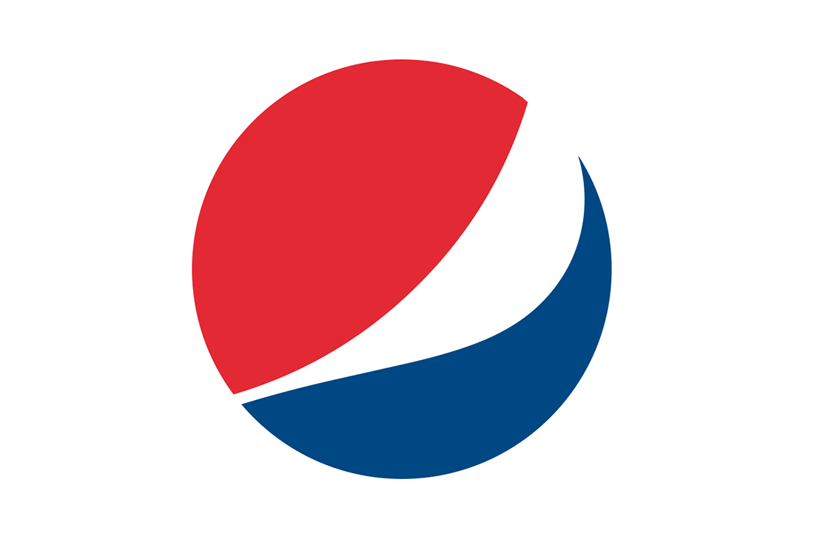

- 

- 

- 

- 

- 

- 

- 

- 
- 
- 
- 

- 

KEY: Logo Game
Aligned to the following standards:
FFA.PL-A; FFA.PL-E; FFA.CS-M; CCSS.SL.9-12.1; CCSS.SL.9-12.2; CRP.04

Directions:
Write the correct company name with their logo.

- Nike

- McDonald’s

- Apple

- Olympics

- NBC

- Snapchat

- Target

- Pepsi

- Starbucks

- Instagram

- Amazon

- Facebook

- Adidas

- Google Chrome

- Jordan

- Disney
- AT&T
- NASA
- Wendy’s

- Lays

Tyson Foods: Logos Throughout the Years
Aligned to the following standards:
FFA.PL-A; FFA.PL-E; FFA.CS-M; CCSS.SL.9-12.1; CCSS.SL.9-12.2; CRP.04

Directions:
Utilize the Tyson Foods website to complete the handout. The direct URL is http://www.tysonfoods.com/our-story/heritage/logo-timeline.

- Draw and color the major progressions of the Tyson Foods logo.

- List the progression of the Tyson Foods name changes.

- The first oval logo was designed to fit the _____________ packaging.

- Why did Tyson Foods change the logo colors between 1975 and 1978?

- What is Tyson Foods’ tagline, and why was it created?

Why would a logo need to be changed or updated over time?

KEY: Tyson Foods: Logos Throughout the Years
Aligned to the following standards:
FFA.PL-A; FFA.PL-E; FFA.CS-M; CCSS.SL.9-12.1; CCSS.SL.9-12.2; CRP.04

Directions:
Utilize the Tyson Foods website to complete the handout. The direct URL is http://www.tysonfoods.com/our-story/heritage/logo-timeline
- Draw and color the major progressions of the Tyson Foods logo.

- List the progression of the Tyson Foods name changes.

John W. Tyson Tyson Feed & Hatchery Tyson Pride Tyson Foods

- The first oval logo was designed to fit the ____Cornish Hen_________ packaging.

- Why did Tyson Foods change the logo colors between 1975 and 1978?
To be more attractive in grocers’ display cases.

- What is Tyson Foods’ tagline and why was it created?
To reflect the company’s purpose
Making Great Food. Making A Difference

Why would a logo need to be changed or updated over time?

My Logos
Aligned to the following standards:
FFA.PL-A; FFA.PL-E; FFA.CS-M; CCSS.SL.9-12.1; CCSS.SL.9-12.2; CRP.04

Directions:
Utilize the boxes below to create a logo that represents you for the specified time periods.

Elementary School

Today

Five Years in the Future

