Companion Guide
Created: 07/2019 by the National FFA Organization

This guide is designed to help high school students, who have completed the poultry curriculum, bring content relevant to the poultry industry into elementary classrooms.

All About Poultry
In this section, you will guide students through activities that will introduce the basics of the poultry industry. This section is comprised of four activities: Poultry Body Parts, Types of Poultry, Turkey Numbers and History — Then vs. Now. Under each activity you will find a facilitation guide as well as the materials needed for the activity.

- Poultry Body Parts
- Materials needed:
  - A copy of the “Poultry Body Parts” worksheet for each student
  - A copy of the “You and a Chicken” worksheet for each student
  - PowerPoint or flip chart of chicken image

- Facilitation Guide
  - Activity:
    - Part 1: Play a short game of “Simon Says.” Most students have probably played, but to ensure everyone is on the same page, explain the rules of the games. This game will be all about body parts. You can utilize the prompts below or you can create your own. (While one person is “Simon” the other facilitators will roam around the room observing the students, ensuring they are following the rules.)
      - “Simon says touch your ears.”
      - “Simon says wiggle your fingers.”
      - “Simon says close your eyes.”
      - “Touch your nose.”

After a few minutes of play, or when you are down to the last person, wrap up the game and congratulate those that made it to the end. If possible, give candy or a small prize to those that made it to the end of the game.

- Part 2: Ask the class “Who can tell me the topic of our game of Simon Says?” (You are looking for “body parts” as the answer.) “That’s right! It was all about our body parts. Today we are going to look at the similarities and differences in our bodies and chickens.”

Hand out the “Poultry Body Parts” worksheet to each student and have them identify and label the parts of the human in the box titled “YOU.” They will utilize the word bank to add labels to the diagram. Have students put their pencils down when they are finished. (While students are working, make sure you walk around the room helping students if they need it.)

When all students have completed the “YOU” box on their worksheets, utilize the PowerPoint or a flip chart to teach the students about the location and function of the parts of the chicken listed below:
- Wattle: The red skin underneath the beak. Blood circulates between this and the comb to regulate body temperature.
- Comb: The red skin located on top of the head. Blood circulates between this and the wattle to regulate body temperature.
- Plumage: The outer covering of the bird’s body.
- Beak: Used for eating, drinking and self-defense
- Shank: Bones in the foot that are fused together causing the birds to walk upright.

After instruction, have students complete the “Chicken” box on their worksheets just as they completed the box for “YOU.”

- Part 3: Upon completion of the “Poultry Body Parts” worksheet, hand out the “You and a Chicken” worksheet to each student. Provide the instructions for the worksheet. (On this worksheet you will compare and contrast the parts and functions of humans and those we identified for the chicken.)

  - Wrap-Up: After the students have completed the “You and a Chicken” worksheet, review the answers as a class by completing a large Venn diagram on the board or on a flip chart. 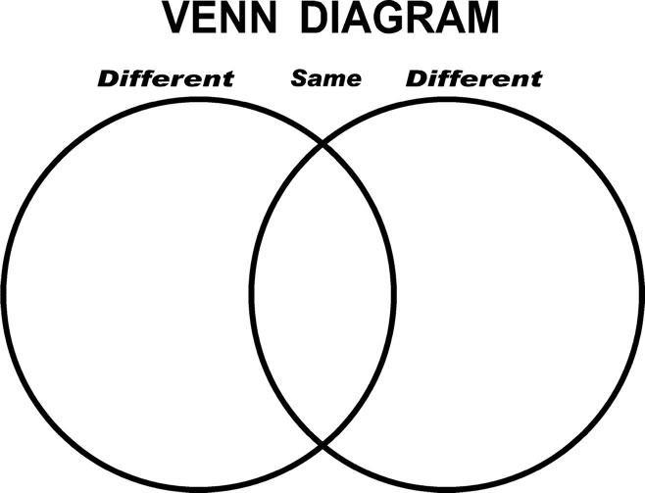

- Types of Poultry
- Materials needed:
  - A copy of the “Guess Who?” worksheet for each student
  - A set of “Matching Game Pieces” for each group
  - PowerPoint or flip chart

- Facilitation Guide
  - Activity:
    - Part 1: Ask the students the following questions:
      - How many types or categories of poultry are there?
      - Name as may types of poultry as you can in one minute. (Have them use a scrap piece of paper to complete this task.)

Utilize the PowerPoint or flip chart to teach the students about the types of poultry.
- Broiler Chicken: Chickens raised for their meat.
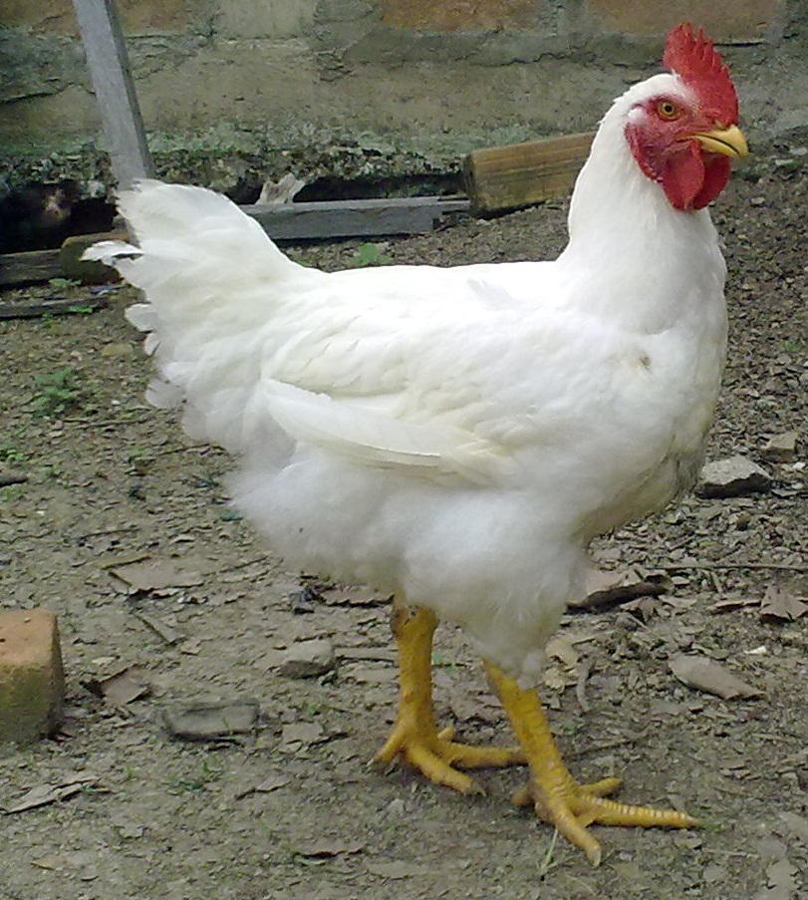
- Layer Chicken: Chickens raised to lay eggs.
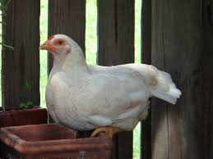
- Rooster: Male chicken, fertilizes eggs
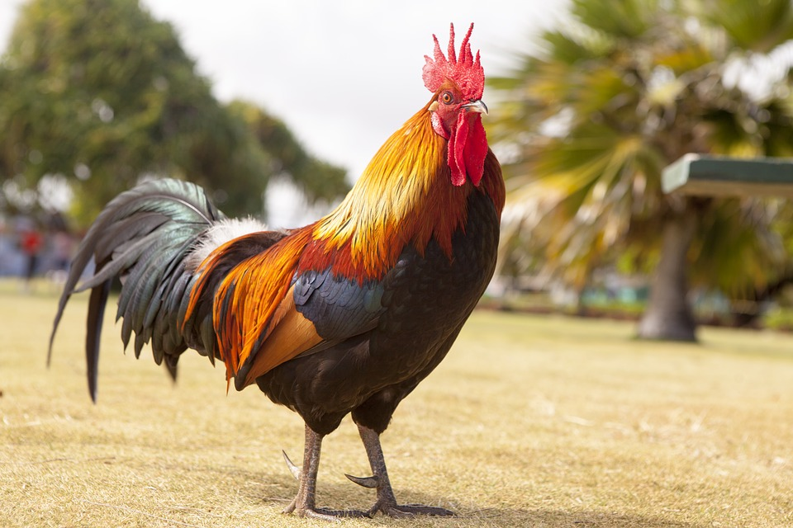
- Chick: Baby chickens (can be layers or broilers)
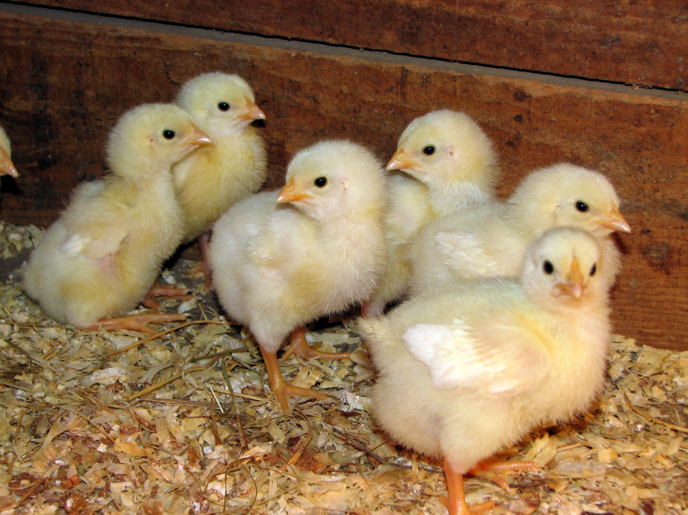

- Hen (Turkey): Female
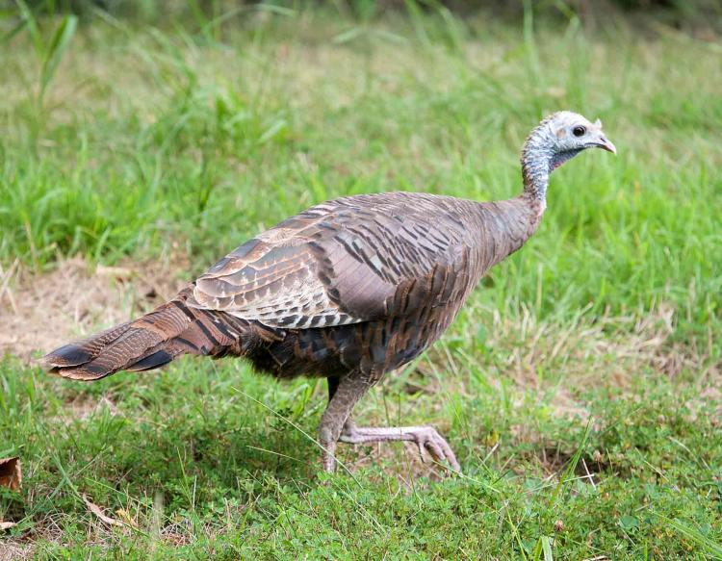
- Tom (Turkey): Male
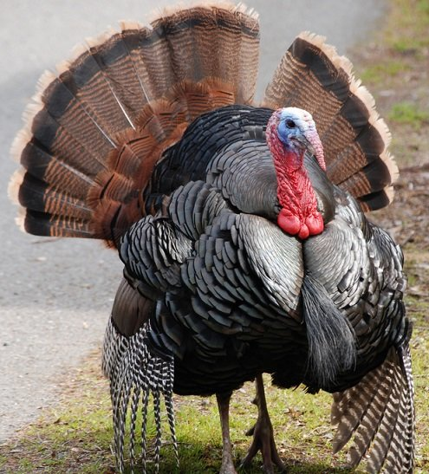

    - Part 2: Hand out the “Guess Who?” worksheet to each student. Provide the instructions for the worksheet. (On this worksheet, you will match the image of the poultry type to its name. Draw a line from the name to the image.)

  - Wrap-Up: Have students create groups of three to four depending on the size of the class. Hand out the set of pre-cut “Matching Game Pieces” to each group. Have them work in their groups to match the image of the poultry type to its name.

- Turkey Numbers
  - Materials needed:
    - A copy of the “Give It Your Best Guess!” worksheet for each student
    - PowerPoint or flip chart

  - Facilitation Guide
    - Activity:
      - Part 1: Each student needs a copy of “Give It Your Best Guess!” worksheet. Have students work individually to give their best guess to the questions on the worksheet. Give them three minutes to complete this activity. Once they are finished have students pair up with a partner and compare their guesses. Record the highest and lowest guesses for each question on the board or flip chart. You will reference these during the instruction.

      - Part 2: Using the information (high and low numbers) recorded during Part 1, talk students through the actual number for each of the turkey facts. Students will record the “actual” numbers in a different color than they did their best guess.

    - Wrap-Up: Have a discussion with the class about what the students found to be the most surprising about the numbers they learned today. Ensure they explain their answers.
      - Guiding questions:
        - Which fact did you find the most interesting? Why?
        - Which fact were you most surprised by? Why?

- History — Then vs. Now
  - Materials needed:
- A copy of the “Poultry History: Then vs. Now” worksheet for each student
  - Markers, crayons and/or colored pencils

  - Facilitation Guide
    - Activity:
    - Part 1: Hand out the “Poultry History: Then vs. Now” worksheet to each student and have them complete Part 1. They will utilize their markers, crayons or colored pencils to draw a picture of what they looked like in kindergarten in the first box and a picture of what they look like now in the second box. Make sure they remember to label the second box with their current grade in school. Once students have finished their drawings, have them answer the question at the bottom of the page. Have students put their pencils down when they are finished. (While students are working, make sure you walk around the room helping students if they need it.)

    - Part 2: Have a few students share how they have changed between being in kindergarten and now. (Thanks for those great answers.) Have students complete Part 2 of the “Poultry History: Then vs. Now” worksheet. (Now that you have compared how you have changed over the years, let’s take a look at how the poultry industry has changed. Look at the pictures on the worksheet. Identify and describe five differences and/or changes that have occurred. Record you answers in the space provided.)

    - Wrap-Up: Have students share the differences they found between the two photos of the poultry industry.

Eggs
In this section, you will guide students through activities that will introduce the basics of eggs. This section is comprised of five activities: Egg Colors, Egg Sizes, Egg Freshness, Egg Parts and Egg Hatching (fertilized vs. unfertilized eggs). Under each activity, you will find a facilitation guide as well as the materials needed for the activity.

- Egg Colors
- Materials needed:
  - A copy of the “Egg Colors” worksheet for each student
  - Markers, crayons and/or colored pencils

- Facilitation Guide
  - Activity:
    - Part 1: Ask the students the following questions:
      - How many different color eggs are there?
      - What colors are they?
      - How do we get different colored eggs?

    - Part 2: In Part 1, you discussed how the color of eggs is determined. Utilize the images in the PowerPoint to show students which colored earlobes produce which colored eggs.

After instruction, hand out the “Egg Colors” worksheet. Provide students instructions to complete the worksheet. (Color the earlobe of the chicken that determines the color of the egg. See the example provided on your worksheet. Please note that it is just an example and purple eggs do not exist.)

  - Wrap-Up: Ask the class “Are brown eggs better for you than white eggs? Explain your answer.” Have a class discussion around their responses and the correct answer.

- Egg Sizes
- Materials needed:
  - A copy of the “Egg Sizes” worksheet for each student
  - A scale for each group
  - Various objects from the classroom

- Facilitation Guide
  - Activity:
    - Part 1: Divide students into groups of three or four. You can choose to group students in different ways: let them choose the individuals they work with, have their teacher help you group students or, after you determine the number of groups needed, you can use playing cards to divide the students. Hand out the “Egg Sizes” worksheet to each student and a scale to each group.

As a group, students will identify items around the classroom that are the same “size” or weight as the sizes of eggs. For example: A pee wee egg weighs 15oz.; a soccer ball also weighs 15 oz. so they are the same "size." Groups will continue through a trial and error process until they have identified items for all six sizes.

  - Wrap-Up: Ask the students the following questions:
      - What size comparison was the most surprising to you? Why?
      - Which size was the hardest to find a matching item for? Why do you think that is?

- Egg Freshness
  - Materials needed:
    - A copy of the “Is It Fresh?” worksheet for each student
    - Five eggs of varying freshness levels for each group
    - Bowl with cold water for each group
    - Paper towels

  - Facilitation Guide
    - Activity:
    - Part 1: Ask the students “Have you ever wondered if your eggs are fresh?”
      - If they respond “Yes” (There is a test you can do to see the freshness. We will do the test today!)
      - If they respond “No” (Did you know there is test you can do to check for the freshness? We will get do the test today.)

    - Part 2: Divide students into groups of five. You can choose to group students in different ways: let them choose the individuals they work with, have their teacher help you group students or, after you determine the number of groups needed, you can use playing cards to divide the students. Hand out the “Is It Fresh?” worksheet to each student. Each group will need a bowl of cold water and five eggs of varying freshness. If possible, number the eggs beforehand to make it easier for the students to record their results.

Have students complete Part 1 of their worksheet. Review the answers as a class. (If an egg is fresh, will it sink or float in the bowl of water? SINK! This means if an egg is not fresh it will FLOAT.)

In their groups, students will take turn placing their eggs in the water. They will observe whether the egg sinks and stays on the bottom of the bowl or if it floats to the top. Students will record “Fresh” or “Not Fresh” for the eggs in Part 2 of their worksheet.

    - Wrap-Up: Review with the class the results of their “Freshness” tests. Ask the students “What should be done with the eggs that are not fresh?”

- Parts of an Egg
  - Materials needed:
    - A copy of the “Parts of an Egg” worksheet for each student
    - Eggs: raw and hard boiled (enough for each student or pair of students)
    - Paper plates
    - Toothpicks
    - Mini sticky notes
    - Paper towels
    - Trashcans

  - Facilitation Guide
    - Activity:
    - Part 1: Ask the students the following questions:
      - How many of us have eaten eggs before? (Have students raise their hands.)
      - What are some ways we have eaten eggs?
(Have you ever really looked at the inside of an egg? Today we will. But first, let’s learn about the different parts of an egg.)

    - Part 2: Hand out the “Parts of an Egg” worksheet. Utilize the PowerPoint to identify and explain the parts of an egg:
      - Yolk: yellow portion of the egg; major source of vitamins, minerals and fat
      - Egg White: it’s the clear, liquid portion when the egg is raw and is white when cooked; major source of protein
      - Shell: outer covering of the egg; different colors depending on the breed of hen
      - Shell membrane: provides a secondary barrier after the shell.
      - Air cell: pocket of air at the large end of the egg.

Have students complete the “Parts of an Egg” worksheet utilizing the word bank at the bottom of the page.

    - Part 3: Crack/Peel the Egg activity
Depending on the number of eggs you have, pair students up if needed. Pass out materials (plates, mini sticky notes or paper to label, toothpicks and paper towels).

We’ve looked at what the inside of an egg looks like on paper, but let’s crack open some eggs ourselves. We will label the parts of our eggs using toothpicks and sticky notes like flags. In a moment, we will each receive one egg. When you receive your egg, crack it on the table and gently (very important that this is done gently or else some of the pieces of the egg will be ruined) place it onto the plate. (Wait for everyone to crack his or her egg. Have trashcans ready.)

Once students have cracked their eggs on their plates, have them identify the parts of the egg we discussed earlier. When they see a part of the egg they recognize, they will write that term on a sticky note and wrap the sticky part around the toothpick like a flag. When we have made our label flag, we will gently place it in the Styrofoam plate where it will stand up. Do not pop the yolk; be sure to label the yolk by putting the toothpick beside the yolk. (Remember, use your diagram as a reference, but recognize that some pieces may look differently on paper than in real life.)

Once students have labeled their eggs, have them raise their hands to ensure their labels are correct. Once checked by a facilitator, individual students or pairs will receive a hard-boiled egg to do the same activity with. As they are looking at the parts of a hard-boiled egg, have them identify the differences between the two. (Tips: Have multiple trashcans ready and have students throw away their eggs as soon as their diagram is deemed correct.)

    - Wrap-Up: Have students share the differences they saw between the raw egg and hard-boiled egg.

- Hatching
- Materials needed:
  - A copy of the “Am I Eating a Baby Chick?” worksheet for each student
  - A copy of the “Baby Chicks” worksheet for each student
  - A copy of the “Hatching Eggs” handout
  - A copy of the “3-2-1 Activity Sheet” for each student

- Facilitation Guide
  - Activity:
    - Part 1: Ask the students the following questions:
      - “What is the difference between the eggs you buy at the grocery store and eggs you hatch?”

Hand out the “Am I Eating a Baby Chick?” worksheet to each student and have them look at the two images at the top of the page. Utilize the PowerPoint to teach the students the difference between a fertilized and unfertilized egg.

After instruction, have students complete the Venn diagram on the worksheet, identifying the similarities and differences between the types of eggs.

- Part 2: Show the video “Chick Embryo Development.” The video URL is https://youtu.be/PedajVADLGw. Have students write down things they find interesting while watching. After the video is over, have students choose six days out of the development process to learn more about. Have the students draw a picture that represents what is happening in the development process in the boxes provided. Make sure you label which day it is in the process.
    - Part 3: If you have the resources to hatch eggs, incubate and hatch eggs. Utilize the “Hatching Eggs” handout to guide you. (This activity is optional.)

  - Wrap-Up: Hand out the “3-2-1 Activity Sheet” to each student and have them complete the prompts.
      - 3 things you learned …
      - 2 things you found interesting …
      - 1 question you still have …

Production/Welfare
In this section, you will guide students through an activity that will introduce the basic care and welfare of chickens. Under the activity, you will find a facilitation guide as well as the materials needed for the activity.

- Care

- Materials needed:
  - A copy of the “Needs for Survival” worksheet for each student
  - A copy of the “Chicken Habitats” worksheet for each student

- Facilitation Guide
  - Activity:
    - Part 1: Hand out the “Needs for Survival” worksheet to each student and have them identify the items needed for us (humans) and chickens to survive. Students will draw a picture to represent each item and place it in the corresponding box.

- Part 2: Discuss with the students what the term habitat means.
        - Webster’s Dictionary defines it as “the place or environment where a plant or animal naturally or normally lives and grows.”

        - Hand out the “Chicken Habitats” worksheet to each student and have them record the definition of habitat in the space provided. Have the students complete Part 2 of the worksheet. They will match animals to their habitats. Have them draw a line from the animal to their habitat. After all students have completed this section, review the correct answers.

    - Part 3: Have students complete Part 3 of the worksheet. Have them draw and label a habitat for their chickens that will fulfill their basic needs. Once they have completed this for chickens, they will do the same thing for their own habitat.

    - Part 4: If your agriculture program has the capability to raise chickens, have the elementary students pair up with high school students to ensure the chickens are getting their basic needs (food, water, shelter) met.

  - Wrap-Up: Have students share their chicken habitats with the class. (Take volunteer — not every student needs to share.) Have them identify the items they included and why they are needed.

Standards
This is a document that can be given to the elementary school teacher to show what general standards the activities are aligned to.

Common Core Anchor Standards:
- CCSS.ELA-LITERACY.CCRA.W.2
Write informative/explanatory texts to examine and convey complex ideas and information clearly and accurately through the effective selection, organization, and analysis of content.
- CCSS.ELA-LITERACY.CCRA.W.3
Write narratives to develop real or imagined experiences or events using effective technique, well-chosen details and well-structured event sequences.
- CCSS.ELA-LITERACY.CCRA.SL.1
Prepare for and participate effectively in a range of conversations and collaborations with diverse partners, building on others' ideas and expressing their own clearly and persuasively.
- CCSS.ELA-LITERACY.CCRA.SL.2
Integrate and evaluate information presented in diverse media and formats, including visually, quantitatively, and orally.
- CCSS.ELA-LITERACY.CCRA.SL.4
Present information, findings, and supporting evidence such that listeners can follow the line of reasoning and the organization, development, and style are appropriate to task, purpose, and audience.
- CCSS.ELA-LITERACY.CCRA.L.6
Acquire and use accurately a range of general academic and domain-specific words and phrases sufficient for reading, writing, speaking, and listening at the college and career readiness level; demonstrate independence in gathering vocabulary knowledge when encountering an unknown term important to comprehension or expression.

Next Gen Science:
Hatching and Habitat Lesson:
- 3-LS4-3 Biological Evolution: Unity and Diversity
Construct an argument with evidence that in a particular habitat some organisms can survive well, some survive less well, and some cannot survive at all.
- 4-LS1-1 From Molecules to Organisms: Structures and Processes
Construct an argument that plants and animals have internal and external structures that function to support survival, growth, behavior, and reproduction.

Poultry Body Parts
Aligned to the following standards:
CCSS.ELA.CCRA.W.2; CCSS.ELA.CCRA.W.3; CCSS.ELA.CCRA.SL.1; CCSS.ELA.CCRA.SL.2; CCSS.ELA.CCRA.SL.4; CCSS.ELA.CCRA.L.4

Directions:
Identify the body parts of humans (you) and chickens using the pictures below. Describe each chicken part next to your label.

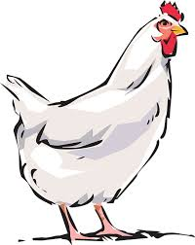
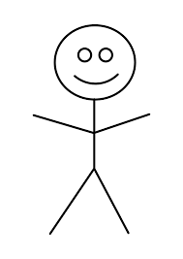
CHICKEN
YOU

WORD BANK

WATTLE SHANK BEAK

COMB PLUMAGE
WORD BANK

EYE MOUTH HAND

FEET BODY/SKIN

You and a Chicken
Aligned to the following standards:
CCSS.ELA.CCRA.W.2; CCSS.ELA.CCRA.W.3; CCSS.ELA.CCRA.SL.1; CCSS.ELA.CCRA.SL.2; CCSS.ELA.CCRA.SL.4; CCSS.ELA.CCRA.L.4

Directions:
Compare and contrast humans (you) and chickens using the chart below.
You
Chicken
How are you the same?
How are you different?
A chicken is different from me because …
I am different from a chicken because …

I am the same as a chicken because …

Guess Who?
Aligned to the following standards:
CCSS.ELA.CCRA.W.2; CCSS.ELA.CCRA.W.3; CCSS.ELA.CCRA.SL.1; CCSS.ELA.CCRA.SL.2; CCSS.ELA.CCRA.SL.4; CCSS.ELA.CCRA.L.4

Directions:
Match the name of the poultry type to the corresponding picture. Next to each image describe the type of poultry.

Broiler Chicken

Layer Chicken

Rooster

Chick

Hen (Turkey)

Tom (Turkey)

Matching Game Pieces
Aligned to the following standards:
CCSS.ELA.CCRA.W.2; CCSS.ELA.CCRA.W.3; CCSS.ELA.CCRA.SL.1; CCSS.ELA.CCRA.SL.2; CCSS.ELA.CCRA.SL.4; CCSS.ELA.CCRA.L.4

Hen (Turkey)
Chicks
Layer Chicken
Rooster
Broiler Chicken
Tom (Turkey)

Give It Your Best Guess!
Aligned to the following standards:
CCSS.ELA.CCRA.W.2; CCSS.ELA.CCRA.W.3; CCSS.ELA.CCRA.SL.1; CCSS.ELA.CCRA.SL.2; CCSS.ELA.CCRA.SL.4; CCSS.ELA.CCRA.L.4

Directions:
Provide your best guess for the turkey facts within each feather for turkey production numbers in the United States. Color in the top 5 turkey-producing states.
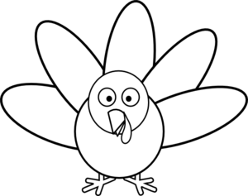
Pounds of turkeys produced
Pounds per person consumed
# of turkeys produced
% consumed during holidays
Top 5 producing states

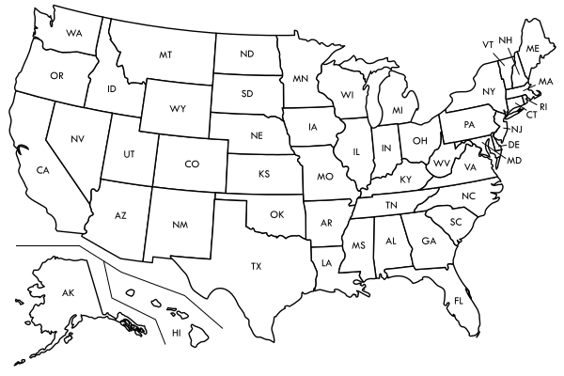

Poultry History: Then vs. Now
Aligned to the following standards:
CCSS.ELA.CCRA.W.2; CCSS.ELA.CCRA.W.3; CCSS.ELA.CCRA.SL.1; CCSS.ELA.CCRA.SL.2; CCSS.ELA.CCRA.SL.4; CCSS.ELA.CCRA.L.4

Directions:
Part 1: Draw a picture of you when you were in kindergarten and then a picture of what you look like now. In the box below, describe how you have changed between kindergarten and now.
THEN
NOW

KINDERGARTEN
______ GRADE

How have you changed between kindergarten and now?

Part 2: Now that you have compared how you have changed over the years, let’s take a look at how the poultry industry has changed. Look at the pictures below. Identify and describe five differences and/or changes that have occurred. Record you answers in the bubbles below.
Aligned to the following standards:
CCSS.ELA.CCRA.W.2; CCSS.ELA.CCRA.W.3; CCSS.ELA.CCRA.SL.1; CCSS.ELA.CCRA.SL.2; CCSS.ELA.CCRA.SL.4; CCSS.ELA.CCRA.L.4

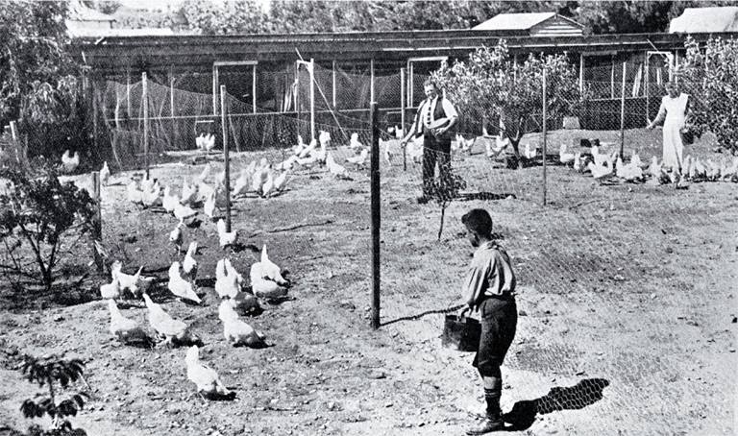
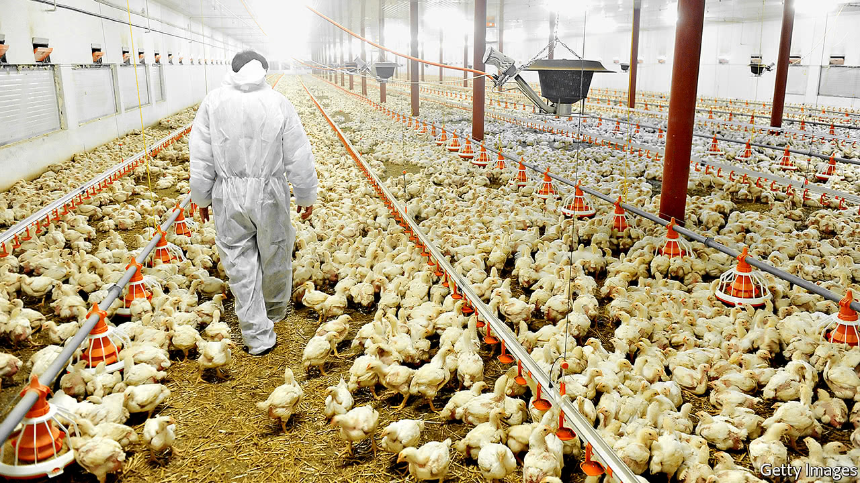
THEN
NOW

Changes/Differences

Egg Colors
Aligned to the following standards:
CCSS.ELA.CCRA.W.2; CCSS.ELA.CCRA.W.3; CCSS.ELA.CCRA.SL.1; CCSS.ELA.CCRA.SL.2; CCSS.ELA.CCRA.SL.4; CCSS.ELA.CCRA.L.4

Directions:
Color the ear lobe of the chicken the correct color so that it will produce the egg color shown. An example is provided below. (Please note that purple is not a natural color of egg; it is just being used as an example.)

Example:
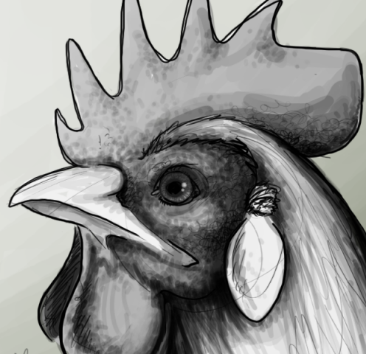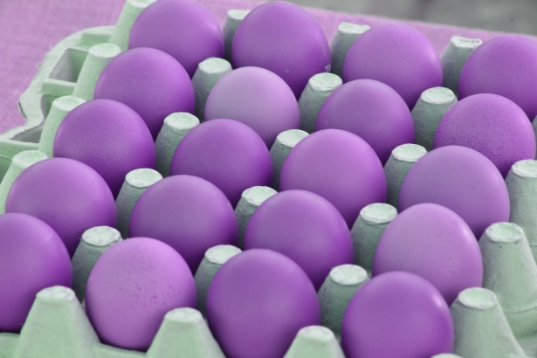

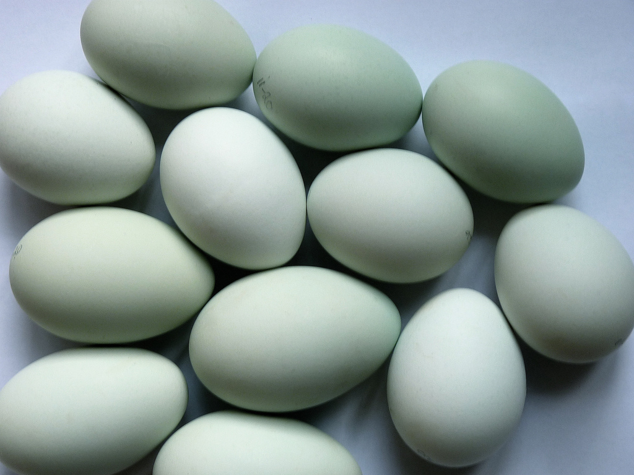

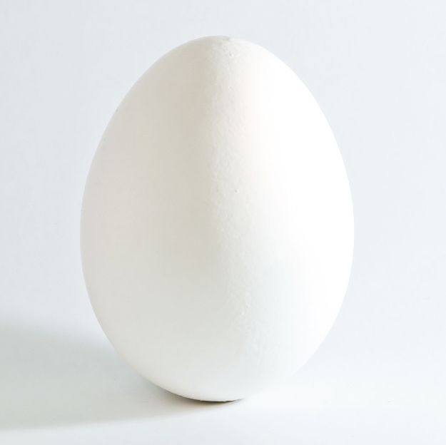

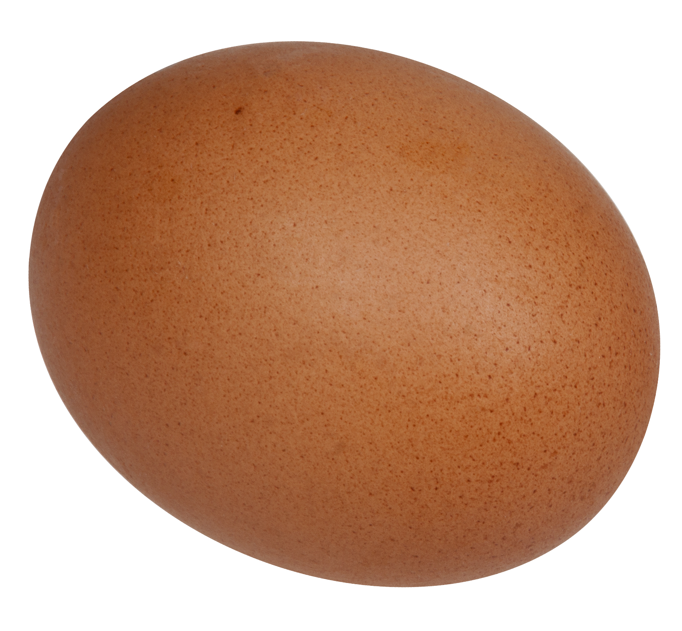
Egg Sizes
Aligned to the following standards:
CCSS.ELA.CCRA.W.2; CCSS.ELA.CCRA.W.3; CCSS.ELA.CCRA.SL.1; CCSS.ELA.CCRA.SL.2; CCSS.ELA.CCRA.SL.4; CCSS.ELA.CCRA.L.4

Directions:
Work with your group members to find objects in the classroom that match the various egg sizes. Use scales to weigh the objects and record your findings in the corresponding boxes.

Peewee
15 ounces
Small
18 ounces
Medium
21 ounces
Large
24 ounces
Extra Large
27 ounces
Jumbo
30 ounces

Is It Fresh?
Aligned to the following standards:
CCSS.ELA.CCRA.W.2; CCSS.ELA.CCRA.W.3; CCSS.ELA.CCRA.SL.1; CCSS.ELA.CCRA.SL.2; CCSS.ELA.CCRA.SL.4; CCSS.ELA.CCRA.L.4

Directions:
Part 1: Circle the result below that indicates the result of a fresh and not fresh egg.
NOT FRESH

FLOAT SINK

FRESH

FLOAT SINK

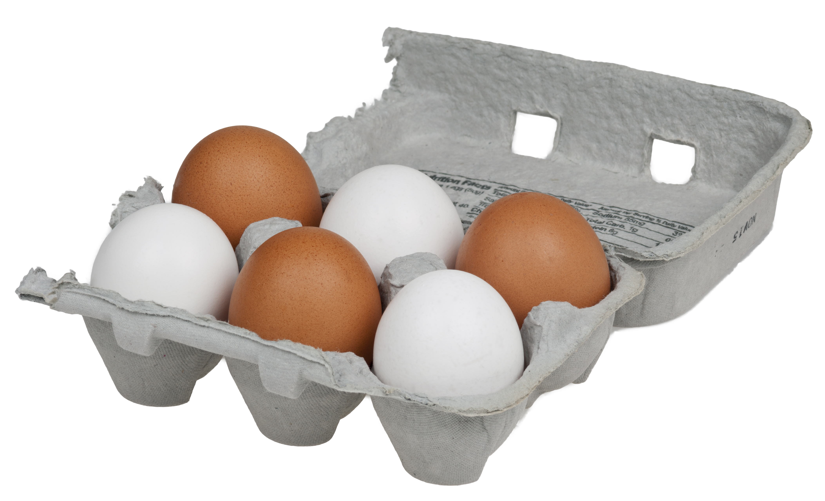

Part 2: Determine if the five eggs are fresh by putting them into a bowl of water. Label each egg below as “Fresh” or “Not Fresh.”

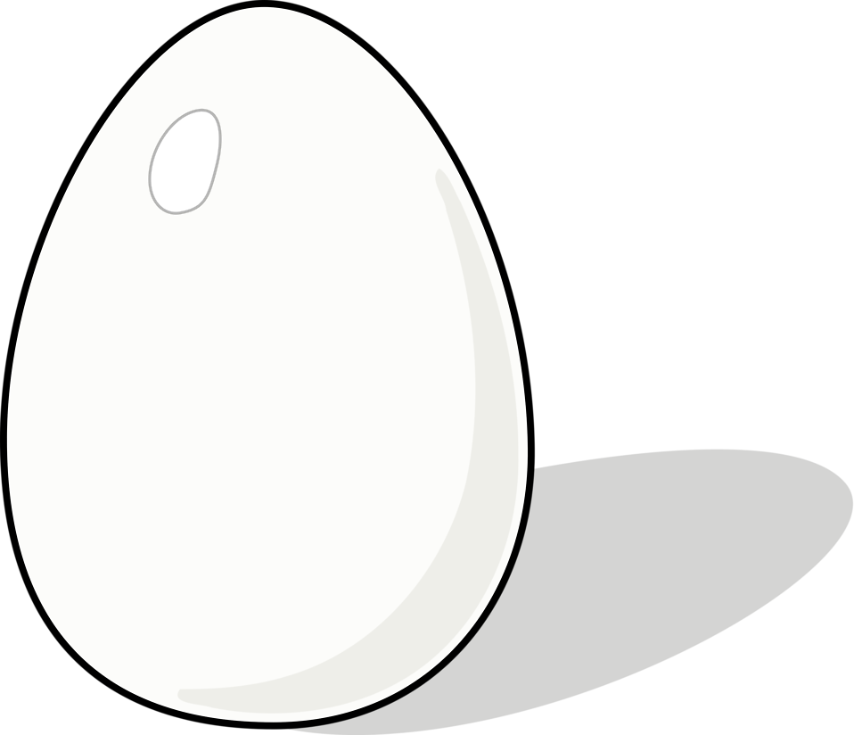
Parts of an Egg
Aligned to the following standards:
CCSS.ELA.CCRA.W.2; CCSS.ELA.CCRA.W.3; CCSS.ELA.CCRA.SL.1; CCSS.ELA.CCRA.SL.2; CCSS.ELA.CCRA.SL.4; CCSS.ELA.CCRA.L.4

Directions:
Label the parts of the egg on the diagram below.

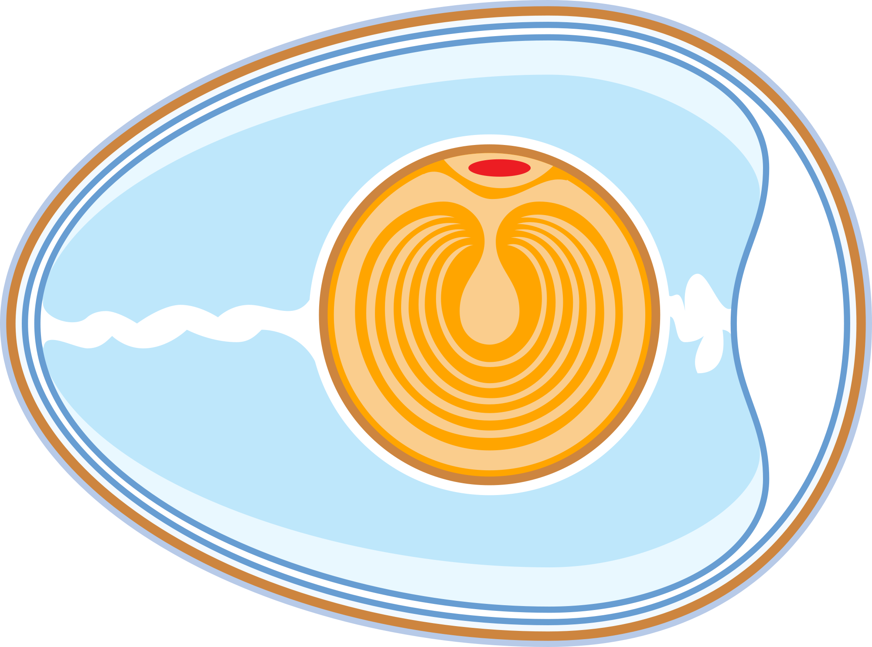

WORD BANK

Yolk Egg White Shell

Air Cell Shell Membrane

Am I Eating a Baby Chick?
Aligned to the following standards:
CCSS.ELA.CCRA.W.2; CCSS.ELA.CCRA.W.3; CCSS.ELA.CCRA.SL.1; CCSS.ELA.CCRA.SL.2; CCSS.ELA.CCRA.SL.4; CCSS.ELA.CCRA.L.4; 3-LS4-3; 4-LS1-1

Directions:
Identify the similarities and differences between the fertilized and unfertilized eggs below. Record your answers in the Venn Diagram.

Fertilized Unfertilized

Fertilized
Unfertilized

Baby Chicks
Aligned to the following standards:
CCSS.ELA.CCRA.W.2; CCSS.ELA.CCRA.W.3; CCSS.ELA.CCRA.SL.1; CCSS.ELA.CCRA.SL.2; CCSS.ELA.CCRA.SL.4; CCSS.ELA.CCRA.L.4; 3-LS4-3; 4-LS1-1

Directions:
Watch the “Chick Embryo Development” video, available at https://youtu.be/PedajVADLGw. Choose six days out of the development process and draw a picture that represents what is happening. Make sure you label which day it is in the process.
Day
Day
Day
Day
Day
Day

Hatching Eggs
Aligned to the following standards:
CCSS.ELA.CCRA.W.2; CCSS.ELA.CCRA.W.3; CCSS.ELA.CCRA.SL.1; CCSS.ELA.CCRA.SL.2; CCSS.ELA.CCRA.SL.4; CCSS.ELA.CCRA.L.4; 3-LS4-3; 4-LS1-1

Preparing to Hatch Eggs

Step 1: Order fertilized eggs from a hatchery or from poultry farmers. The eggs should be medium-sized and free from holes or cracks. If you are breeding chickens, the best way for the eggs to hatch is to allow the hens to sit on them. This is called setting.

Step 2: Choose an incubator. A forced-air incubator is large, great for large numbers of eggs and has a fan. A still-air incubator is smaller, hatches a fewer number of eggs and does not have a fan. Most experts prefer a forced-air incubator. Speak to a veterinarian or a poultry farmer to find out which incubator is best for your needs.

Step 3: Test the incubator before putting eggs into it for about twenty-four hours to make sure the temperature and humidity stays consistent within the incubator. The incubator should be placed indoors, and the room should have proper ventilation.

The Eggs and the Incubator

Step 1: Place the eggs into an incubator. The temperature will naturally go down in the incubator for the first few hours. Do not adjust the temperature for the first 48 hours after setting the eggs. The incubation period is about 21 days for chickens and 28 days for turkeys.

Step 2: Keep the temperature steady at about 100 degrees Fahrenheit in a forced-air incubator. In a still-air incubator, the temperature should be kept at about 102 degrees Fahrenheit.

Step 3: Set the humidity at 58 to 60 percent and then increase it to 65 percent when the eggs start hatching.

Step 4: Turn the eggs about half a turn four to six times a day. However, do not turn the eggs within three days of hatching. Never set eggs with the small ends pointing upward. All the eggs should hatch within about twenty-four hours.

Step 5: Do not help any of the chicks out of the shells once the eggs start hatching. Chicks need to work their own way out of the egg for proper maturity.

Step 6: Clean the incubator after the eggs have hatched and before reusing the incubator.

3-2-1 Activity Sheet
Aligned to the following standards:
CCSS.ELA.CCRA.W.2; CCSS.ELA.CCRA.W.3; CCSS.ELA.CCRA.SL.1; CCSS.ELA.CCRA.SL.2; CCSS.ELA.CCRA.SL.4; CCSS.ELA.CCRA.L.4

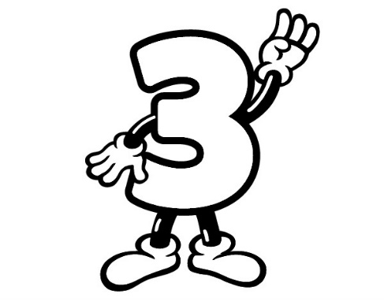 | Three things I learned:
 | Two things I found interesting:
 | One question I still have:

Needs for Survival
Aligned to the following standards:
CCSS.ELA.CCRA.W.2; CCSS.ELA.CCRA.W.3; CCSS.ELA.CCRA.SL.1; CCSS.ELA.CCRA.SL.2; CCSS.ELA.CCRA.SL.4; CCSS.ELA.CCRA.L.4; 3-LS4-3; 4-LS1-1

Directions:
List the items needed for survival by humans (you) and chickens. Draw a picture the represents each item in the boxes below.
What do YOU need on a daily basis to survive?
What do CHICKENS need on a daily basis to survive?

Chicken Habitats
Aligned to the following standards:
CCSS.ELA.CCRA.W.2; CCSS.ELA.CCRA.W.3; CCSS.ELA.CCRA.SL.1; CCSS.ELA.CCRA.SL.2; CCSS.ELA.CCRA.SL.4; CCSS.ELA.CCRA.L.4; 3-LS4-3; 4-LS1-1

Directions:
Part 1: Define the word “habitat” in the box below.
A habitat is …

Part 2: Draw a line from the animal to its habitat.

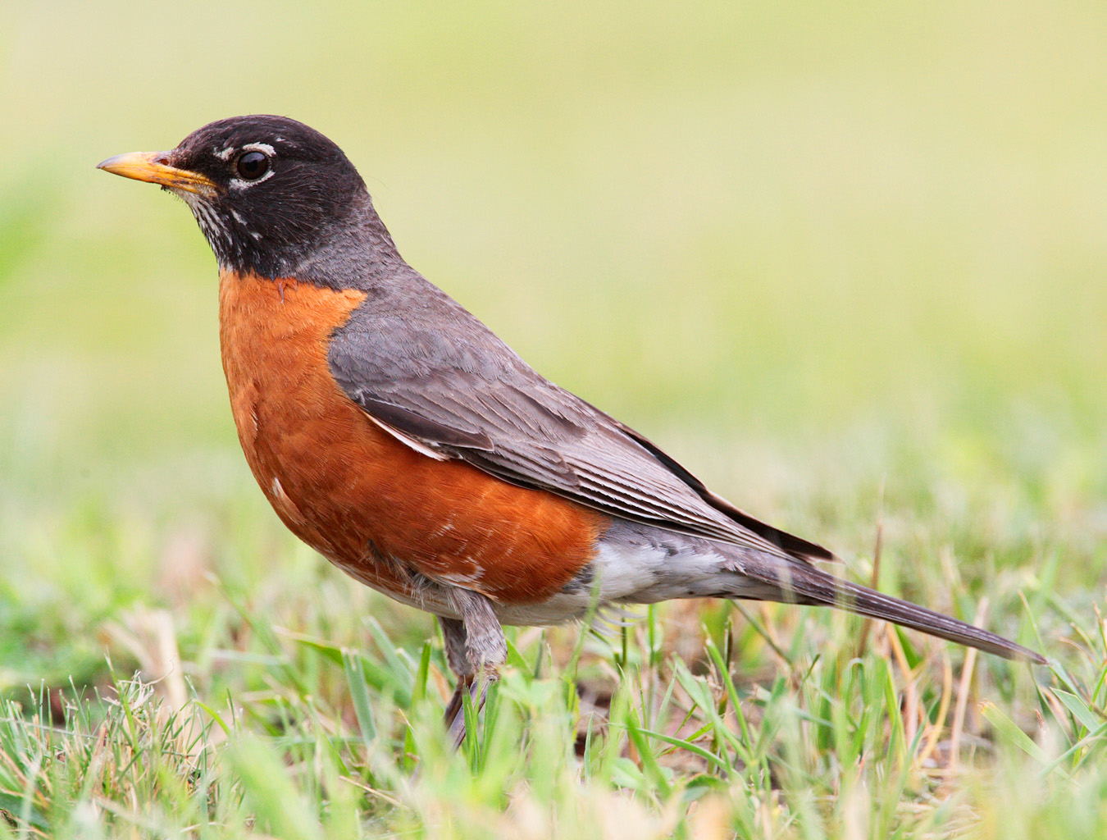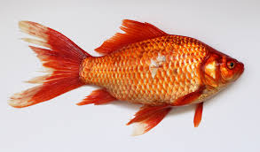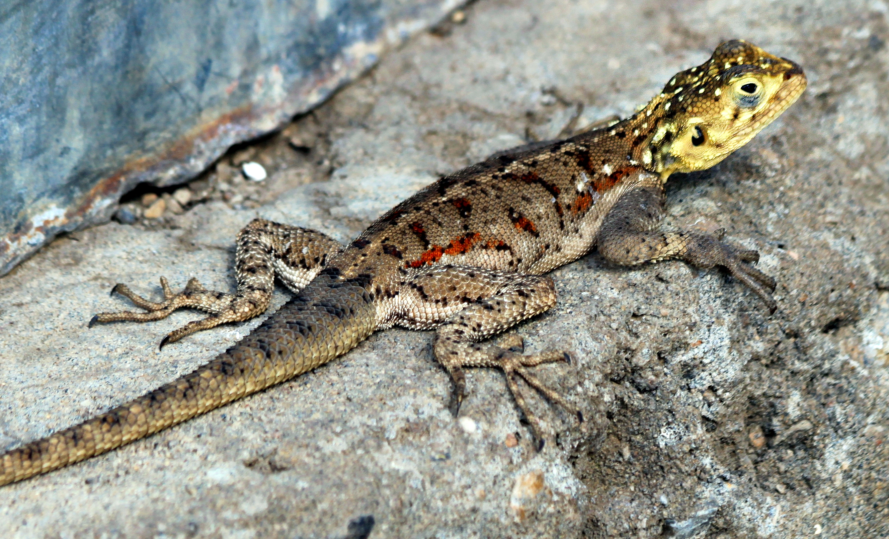

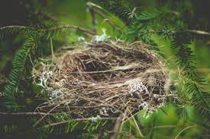
Aligned to the following standards:
CCSS.ELA.CCRA.W.2; CCSS.ELA.CCRA.W.3; CCSS.ELA.CCRA.SL.1; CCSS.ELA.CCRA.SL.2; CCSS.ELA.CCRA.SL.4; CCSS.ELA.CCRA.L.4; 3-LS4-3; 4-LS1-1

Part 3: Create a habitat for your chickens to live in that will meet their daily needs for survival. Draw and label your habitat in the “chicken habitat” box. After you create your chicken habitat, draw and label your habitat in the “my habitat” box.
Chicken Habitat
My Habitat

KEY: Poultry Body Parts
Aligned to the following standards:
CCSS.ELA.CCRA.W.2; CCSS.ELA.CCRA.W.3; CCSS.ELA.CCRA.SL.1; CCSS.ELA.CCRA.SL.2; CCSS.ELA.CCRA.SL.4; CCSS.ELA.CCRA.L.4

Directions:
Identify the body parts of humans (you) and chickens using the pictures below.

CHICKEN
YOU

Comb
Beak
Eye

Plumage

Mouth

Wattle

Body/Skin
Hand

Feet
Shank

WORD BANK

WATTLE SHANK BEAK

COMB PLUMAGE
WORD BANK

EYE MOUTH HAND

FEET BODY/SKIN

KEY: You and a Chicken
Aligned to the following standards:
CCSS.ELA.CCRA.W.2; CCSS.ELA.CCRA.W.3; CCSS.ELA.CCRA.SL.1; CCSS.ELA.CCRA.SL.2; CCSS.ELA.CCRA.SL.4; CCSS.ELA.CCRA.L.4

Directions:
Compare and contrast humans (you) and chickens using the chart below.
You
Chicken
How are you the same?
How are you different?
A chicken is different from me because …

They have a wattle and comb that regulates their body temperature.
I am different from a chicken because …

I have hands that help me accomplish tasks like eating.

I am the same as a chicken because …

We have parts that accomplish the same tasks but are called different things:
- mouth and beak (eat)
- skin and plumage (covering for our body)

KEY: Guess Who?
Aligned to the following standards:
CCSS.ELA.CCRA.W.2; CCSS.ELA.CCRA.W.3; CCSS.ELA.CCRA.SL.1; CCSS.ELA.CCRA.SL.2; CCSS.ELA.CCRA.SL.4; CCSS.ELA.CCRA.L.4

Directions:
Match the name of the poultry type to the corresponding picture.

Broiler Chicken

Layer Chicken

Rooster

Chick

Hen (Turkey)

Tom (Turkey)

KEY: Give It Your Best Guess!
Aligned to the following standards:
CCSS.ELA.CCRA.W.2; CCSS.ELA.CCRA.W.3; CCSS.ELA.CCRA.SL.1; CCSS.ELA.CCRA.SL.2; CCSS.ELA.CCRA.SL.4; CCSS.ELA.CCRA.L.4

Directions:
Provide your best guess for the turkey facts within each feather for turkey production numbers in the United States. Color in the top 5 turkey-producing states.
Pounds of turkeys produced
Pounds per person consumed
# of turkeys produced
% consumed during holidays
Top 5 producing states

16.4

7.5 billion
28.5

Minnesota
North Carolina
Arkansas
Indiana
Missouri
243 million

KEY — Poultry History: Then vs. Now
Aligned to the following standards:
CCSS.ELA.CCRA.W.2; CCSS.ELA.CCRA.W.3; CCSS.ELA.CCRA.SL.1; CCSS.ELA.CCRA.SL.2; CCSS.ELA.CCRA.SL.4; CCSS.ELA.CCRA.L.4

Directions:
Part 1: Draw a picture of you when you were in kindergarten and then a picture of what you look like now. In the box below, describe how you have changed between kindergarten and now.
THEN
NOW

KINDERGARTEN
______ GRADE

How have you changed between kindergarten and now?

Part 2: Now that you have compared how you have changed over the years, let’s take a look at how the poultry industry has changed. Look at the pictures below. Identify and describe five differences and/or changes that have occurred. Record you answers in the bubbles below.
Aligned to the following standards:
CCSS.ELA.CCRA.W.2; CCSS.ELA.CCRA.W.3; CCSS.ELA.CCRA.SL.1; CCSS.ELA.CCRA.SL.2; CCSS.ELA.CCRA.SL.4; CCSS.ELA.CCRA.L.4

THEN
NOW

Clothes of producer: has changed to be more biosecure and prevent illness

Lighting: is no longer only natural light but artificial light is used to imitate seasons and daylight hours

Outdoor environment: chickens are prevented from being around trees, other animals or outdoor contaminants

Changes/Differences

Shelter: is not open and made of natural materials, but is locked down to prevent disease

Feed distribution: Feed is no longer scattered on the ground but is delivered by clean, safe feeders.

KEY: Egg Colors
Aligned to the following standards:
CCSS.ELA.CCRA.W.2; CCSS.ELA.CCRA.W.3; CCSS.ELA.CCRA.SL.1; CCSS.ELA.CCRA.SL.2; CCSS.ELA.CCRA.SL.4; CCSS.ELA.CCRA.L.4

Directions:
Color the ear lobe of the chicken the correct color so that it will produce the egg color shown. An example is provided below.

Example:

KEY: Egg Sizes
Aligned to the following standards:
CCSS.ELA.CCRA.W.2; CCSS.ELA.CCRA.W.3; CCSS.ELA.CCRA.SL.1; CCSS.ELA.CCRA.SL.2; CCSS.ELA.CCRA.SL.4; CCSS.ELA.CCRA.L.4

Directions:
Work with your group members to find objects in the classroom that match the various egg sizes. Use scales to weigh the objects and record your findings in the corresponding boxes.
Answers will vary.
Peewee
15 ounces
Small
18 ounces
Medium
21 ounces
Large
24 ounces
Extra Large
27 ounces
Jumbo
30 ounces

KEY: Is It Fresh?
Aligned to the following standards:
CCSS.ELA.CCRA.W.2; CCSS.ELA.CCRA.W.3; CCSS.ELA.CCRA.SL.1; CCSS.ELA.CCRA.SL.2; CCSS.ELA.CCRA.SL.4; CCSS.ELA.CCRA.L.4

Directions:
Part 1: Circle the result below that indicates the result of a fresh and not fresh egg.
NOT FRESH

FLOAT SINK

FRESH

FLOAT SINK

Part 2: Determine if the five eggs are fresh by putting them into a bowl of water. Label each egg below as “Fresh” or “Not Fresh.” Answers will vary depending on the eggs provided to the group.

KEY: Parts of an Egg
Aligned to the following standards:
CCSS.ELA.CCRA.W.2; CCSS.ELA.CCRA.W.3; CCSS.ELA.CCRA.SL.1; CCSS.ELA.CCRA.SL.2; CCSS.ELA.CCRA.SL.4; CCSS.ELA.CCRA.L.4

Directions:
Label the parts of the egg on the diagram below.
Shell

Shell Membrane
Air Cell
Yolk
Egg White

WORD BANK

Yolk Egg White Shell

Air Cell Shell Membrane

KEY: Am I Eating a Baby Chick?
Aligned to the following standards:
CCSS.ELA.CCRA.W.2; CCSS.ELA.CCRA.W.3; CCSS.ELA.CCRA.SL.1; CCSS.ELA.CCRA.SL.2; CCSS.ELA.CCRA.SL.4; CCSS.ELA.CCRA.L.4; 3-LS4-3; 4-LS1-1

Directions:
Identify the similarities and differences between the fertilized and unfertilized eggs below. Record your answers in the Venn Diagram.

Fertilized Unfertilized

Fertilized
-both
start the
same
-Turns into baby chick
-Yolk is the food for the baby
chick
Unfertilized

-type of egg we eat

KEY: Baby Chicks
Aligned to the following standards:
CCSS.ELA.CCRA.W.2; CCSS.ELA.CCRA.W.3; CCSS.ELA.CCRA.SL.1; CCSS.ELA.CCRA.SL.2; CCSS.ELA.CCRA.SL.4; CCSS.ELA.CCRA.L.4; 3-LS4-3; 4-LS1-1

Directions:
Watch the “Chick Embryo Development” video, available at https://youtu.be/PedajVADLGw. Choose six days out of the development process to draw a picture that represents what is happening. Make sure you label which day it is in the process. For a visual representation of each day go to https://www.poultryhub.org/wp-content/uploads/2012/05/Poster_Chick_Embryo_Dev_English.pdf.
Day
Day
Day
Day
Day
Day

KEY: Needs for Survival
Aligned to the following standards:
CCSS.ELA.CCRA.W.2; CCSS.ELA.CCRA.W.3; CCSS.ELA.CCRA.SL.1; CCSS.ELA.CCRA.SL.2; CCSS.ELA.CCRA.SL.4; CCSS.ELA.CCRA.L.4; 3-LS4-3; 4-LS1-1

Directions:
List the items needed for survival by humans (you) and chickens. Draw a picture the represents each item in the boxes below.
What do YOU need on a daily basis to survive?

Food
Water
Shelter
Care
What do CHICKENS need on a daily basis to survive?

Food
Water
Shelter
Care

KEY: Chicken Habitats
Aligned to the following standards:
CCSS.ELA.CCRA.W.2; CCSS.ELA.CCRA.W.3; CCSS.ELA.CCRA.SL.1; CCSS.ELA.CCRA.SL.2; CCSS.ELA.CCRA.SL.4; CCSS.ELA.CCRA.L.4; 3-LS4-3; 4-LS1-1

Directions:
Part 1: Define the word “habitat” in the box below.
A habitat is …

The place or environment where a plant or animal naturally or normally lives and grows.

Part 2: Draw a line from the animal to its habitat.

Aligned to the following standards:
CCSS.ELA.CCRA.W.2; CCSS.ELA.CCRA.W.3; CCSS.ELA.CCRA.SL.1; CCSS.ELA.CCRA.SL.2; CCSS.ELA.CCRA.SL.4; CCSS.ELA.CCRA.L.4; 3-LS4-3; 4-LS1-1

Part 3: Create a habitat for your chickens to live in that will meet their daily needs for survival. Draw and label your habitat in the “chicken habitat” box. After you create your chicken habitat, draw and label your habitat in the “my habitat” box.
Chicken Habitat

Answers will vary
My Habitat

Answers will vary

