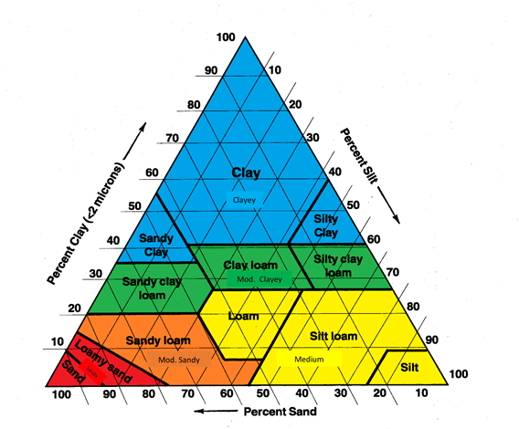
Soil Texture Triangle - USDA

