Unit One Assessment:
Greenhouse Care and Maintenance
Created: 05/2017 by the National FFA Organization
Identification:
Using the description or the photo below name the item that is being described in the blank.

- Biodegradable paper containers made from cellulose
_________________________
_________________________
_________________________
_________________________

that can be transplanted directly into a new container.

- Full-body suit with a hood; made of a chemical resistant material and can be flame retardant.

- Very fine plastic tubing used in drip irrigation, typically in
gardens and greenhouses, with a small inside diameter.

- Derived from heat-treated mica ore and is very lightweight with a neutral pH; commonly used in media for seedlings.

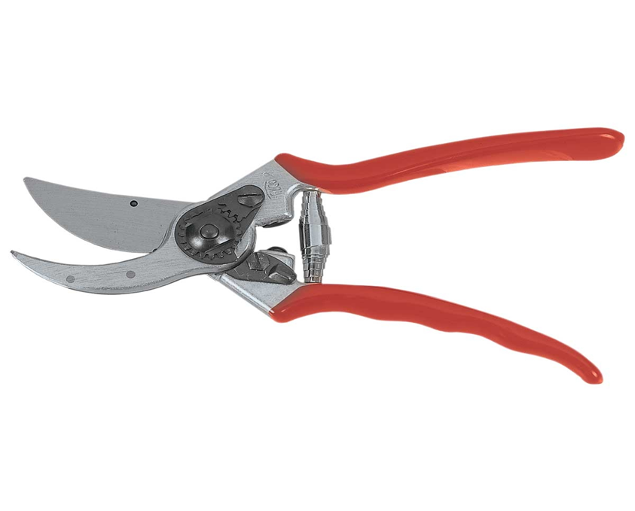

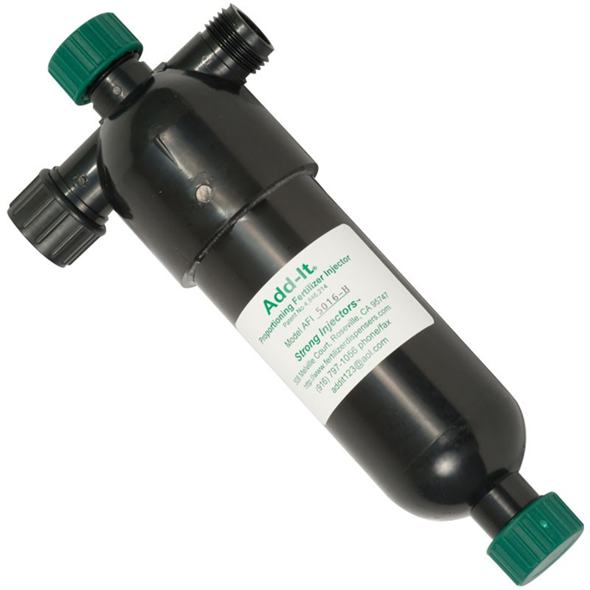
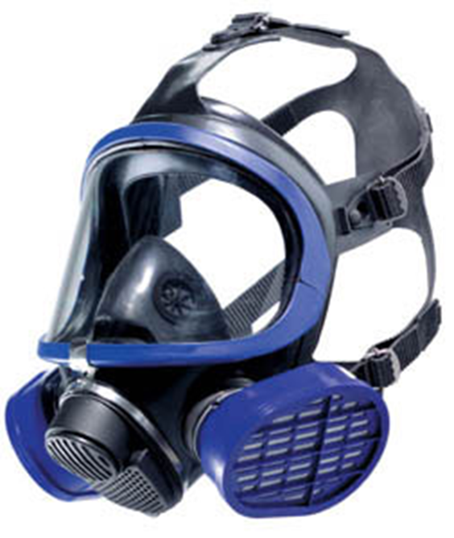

5.___________________ 6. ______________________ 7.___________________

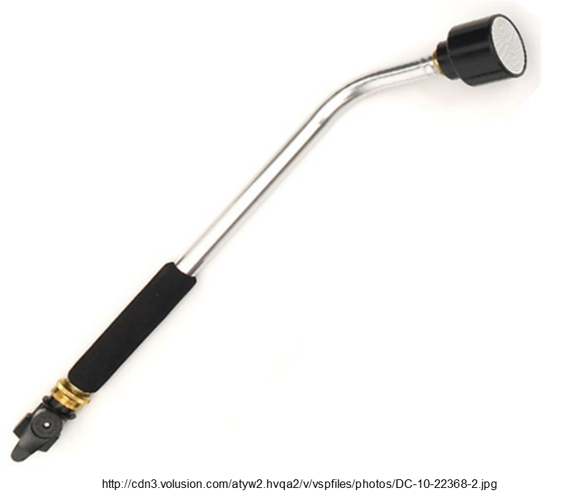
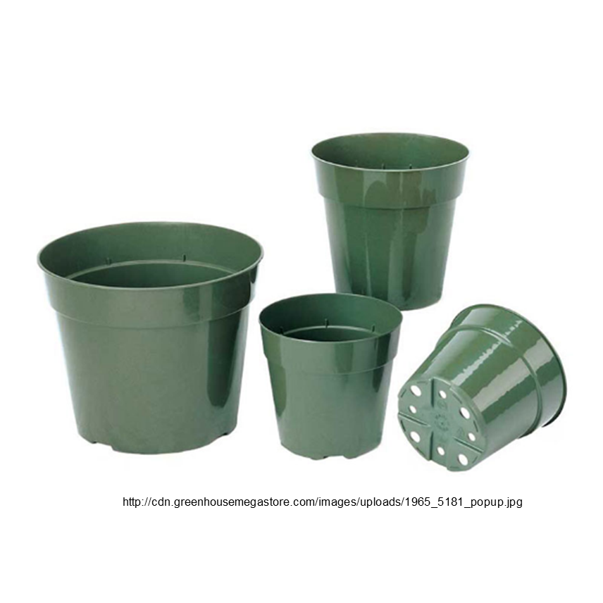
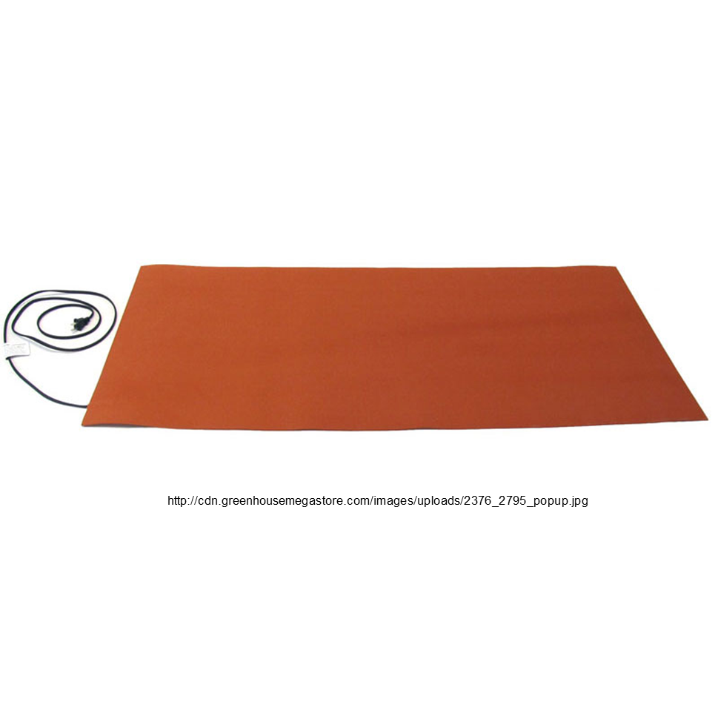

8.___________________ 9._____________________ 10.____________________

Short Answer:
- Explain the difference between sexual and asexual reproduction.

- How and why are rooting hormones used?

- What are some benefits of propagating plants instead of germinating them from seeds?

- What are the two ways to apply fertilizers? Describe the process for each type of application.

- How do you properly control a chemical spill?

multiple choice:
- Which of the following is an example of a pesticide?
  - Fungicide
  - Herbicide
  - Insecticide
  - All of the above

- What makes a complete fertilizer?
  - Made up of only organic material
  - Includes N, P and K in its fertilizer grade
  - Only available as a water-soluble fertilizer
  - All of the above

- The process of pinching reduces what hormone from the upper part of the plant?
  - Auxin
  - Abscisic acid
  - Cytokinins
  - Gibberellin
- What is the term for the application of water-soluble fertilizers through a water irrigation system?
  - Fertigation
  - Irrigation
  - Pre-plant fertilization
  - Water, motor-controlled injection

- What information can you find on a pesticide label?
  - Directions for use
  - Storage and disposal
  - Recommended use
  - All of the above

KEY Unit One Assessment
Identification:
Using the description or the photo below name the item that is being described in the blank.

- Biodegradable paper containers made from cellulose
Elle pots
Spray suit
Spaghetti tubing
Vermiculite

that can be transplanted directly into a new container.

- Full-body suit with a hood; made of a chemical resistant material and can be flame retardant.

- Very fine plastic tubing used in drip irrigation, typically in
gardens and greenhouses, with a small inside diameter.

- Derived from heat-treated mica ore and is very lightweight with a neutral pH; commonly used in media for seedlings.

5. Hook and blade pruners 6. Fertilizer injector 7. Respirator

- Nursery containers 9. Propagation mat 10. Water breaker

Short Answer:
- Explain the difference between sexual and asexual reproduction.
Sexual reproduction involves germination through a pollinated seed. Asexual reproduction involves the propagation of a plant’s stem, leaf or root to create an identical offspring.

- How and why are rooting hormones used?
Hormones or plant growth regulators are naturally found in plants and affect their growth rate. Rooting hormone products are used during propagation and contain the hormone auxin, which increases growth through cell enlargement and helps the plant take root.

- What are some benefits of propagating plants instead of germinating them from seeds?
Propagation is more beneficial in greenhouse production because a single parent plant can produce an identical offspring in greater quantities and in less time. Whereas germination requires time for pollination of the sperm and egg and each seed produces only one plant.

- What are the two ways to apply fertilizers? Describe the process for each type of application.
Dry application is done with granular fertilizer and is mixed into the soil or growing medium before planting. Liquid application is done with water-soluble fertilizers and can be applied more frequently and through an irrigation system.

- How do you properly control a chemical spill?
First, clean any spills that occurred using a cleaning detergent and water. Once the area has been cleaned, transfer the remaining non-contaminated chemicals into a new container. Once the new container has been filled, seal it and label it with the chemical’s information. To do this, remove the entire label off the old container and fasten it to the new container. Dispose of the old container properly.

multiple choice:
- Which of the following is an example of a pesticide?
  - Fungicide
  - Herbicide
  - Insecticide
  - All of the above

- What makes a complete fertilizer?
  - Made up of only organic material
  - Includes N, P and K in its fertilizer grade
  - Only available as a water-soluble fertilizer
  - All of the above

- The process of pinching reduces what hormone from the upper part of the plant?
  - Auxin
  - Abscisic acid
  - Cytokinins
  - Gibberellin
- What is the term for the application of water-soluble fertilizers through a water irrigation system?
  - Fertigation
  - Irrigation
  - Pre-plant fertilization
  - Water motor-controlled injection

- What information can you find on a pesticide label?
  - Directions for use
  - Storage and disposal
  - Recommended use
  - All of the above

