Controlling Poison Ivy in the Home Landscape

Understanding Poison Ivy
Poison ivy (Toxicodendron radicans) is a common, noxious plant known for causing skin irritation and allergic reactions upon contact. Recognizable by its characteristic "leaves of three," poison ivy can grow as a vine or shrub and is found in various environments, including woodlands, fields, and urban areas. Controlling poison ivy is essential to maintaining a safe and pleasant home landscape.
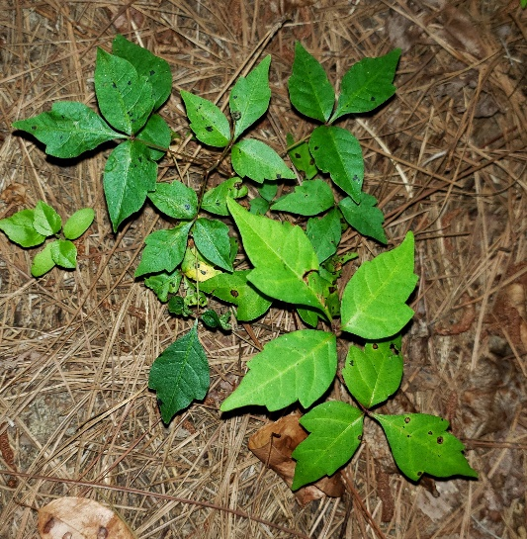
Figure 1 The most distinctive characteristic of poison ivy is the leaf arrangement.
Identification
To effectively manage poison ivy, it is crucial to identify it correctly. Here are some key features:
- Leaves: Compound leaves with three leaflets. The edges can be smooth, toothed, or lobed.
- Color: Leaves are typically green in the summer and can turn red, yellow, or orange in the fall.
- Growth Form: Can appear as a ground cover, shrub, or climbing vine with aerial rootlets.
- Berries: Small, white to greenish-white clusters visible in late summer and fall.

Prevention
Preventing poison ivy from establishing in your landscape is the best control strategy. Here are some tips:
Figure 2 Some other plants also have leaf arrangements similar to poison ivy, such as blackberry.

- Regular Monitoring: Inspect your yard regularly, especially in areas near woods or fields.
- Mulching: Apply a thick layer of mulch in garden beds and around trees to suppress seed germination.
- Ground Covers: Plant dense ground covers to outcompete poison ivy seedlings.
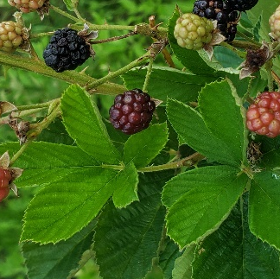
Removal Methods
If poison ivy is already present, several removal methods can be employed:

Manual Removal
Manual removal is effective for small infestations but requires caution.

- Protective Gear: Wear long sleeves, long pants, gloves, and eye protection to avoid skin contact.
- Uprooting: Carefully dig out the plants, ensuring you remove all roots to prevent regrowth.
- Disposal: Do not burn poison ivy. Bag it in plastic and dispose of it with household trash. Burning releases toxic oils that can cause severe respiratory issues.

Chemical Control
Herbicides can be used for larger infestations or where manual removal is impractical.

- Herbicides: Use products containing glyphosate or triclopyr (pronounced tri–clo–peer), which are effective against poison ivy.
- Application: Follow the manufacturer's instructions carefully. Apply on a dry, calm day to minimize drift and avoid affecting desirable plants.
- Repeated Treatments: Multiple applications may be necessary to eradicate established plants.

Safety Precautions
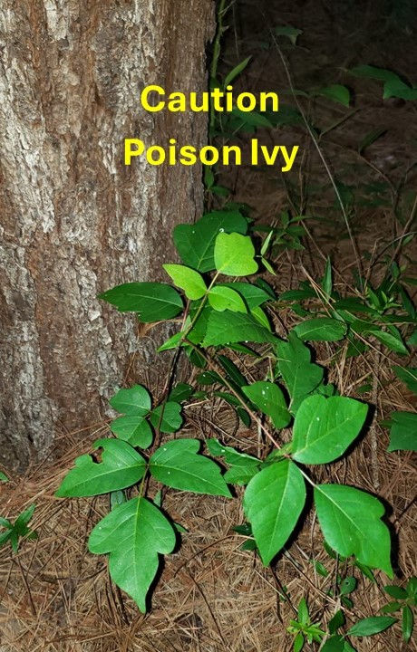
Handling poison ivy requires special care to avoid exposure to urushiol, the oily compound causing allergic reactions.
Figure 3: Poison ivy should be avoided or handled with caution. Urushiol, the irritant oil from the plant, can spread by direct contact or via tools, clothing, and other objects that have touched the plant.

- Cleaning Tools and Clothing: Wash tools, gloves, and clothing with soap and water immediately after use.
- Skin Decontamination: If you suspect contact with poison ivy, wash the affected skin with soap and water as soon as possible.
- Pets: Keep pets away from poison ivy as they can transfer urushiol to you.

Long-Term Management
After initial removal, ongoing management is essential to prevent re-infestation.

- Regular Inspections: Periodically check for and promptly remove new growth.
- Landscape Maintenance: Maintain a healthy, well-maintained landscape to reduce the likelihood of poison ivy returning.
- Education: Educate family members and neighbors about identifying and avoiding poison ivy to minimize accidental exposure.

Contacting Professionals
For extensive infestations or if you are unsure about handling poison ivy, consider contacting a professional landscaper or pest control service. Professionals have the expertise and equipment to safely and effectively manage poison ivy.

Conclusion
Controlling poison ivy is essential for maintaining a safe and enjoyable home landscape. By accurately identifying, preventing, and removing poison ivy, and taking necessary safety precautions, you can protect yourself, your family, and your pets from this troublesome plant. With diligence and proper management, you can keep your outdoor spaces poison ivy-free.

For more information or assistance, please contact your local cooperative extension office or a professional landscaping service.

