What Is BASF?
Created: 06/2017 by the National FFA Organization

Student Learning Objectives:
After completing these activities, students will…
- Discover what BASF is and how the company impacts agriculture.
- Design and develop a project for the agriscience fair.
- Deliver a presentation of their agriscience fair project.

Time Required: 90 minutes (potentially a multi-day/month project)
Resources:
- FFA.org
- Video: “Agriculture Products Recruiting” https://www.youtube.com/watch?v=BNOSoxx2r8c
- Agriscience Fair Handbook

Equipment and Supplies Needed:
- A copy of the “Discovering BASF,” “Career Profile” and “Agriscience Fair Research Project” handouts for each student.
- Internet access to play the video in real time or embed it in a PowerPoint ahead of time
- Internet access for students

This quick lesson plan would work well as A Portion Of:
- A careers unit.
- An agricultural company’s lesson/unit.
- A marketing lesson.

These activities are aligned to the following standards:
FFA Precept
- FFA.PL-A.Action: Assume responsibility and take the necessary steps to achieve the desired results, no matter what the goal or task at hand.
- FFA.PL-E. Awareness: Understanding where you are with regard to personal vision, mission and goals.
- FFA.CS-M.Communication: Effectively interact with others in personal and professional settings.
AFNR Cluster Skills
- CS.01. Analyze how issues, trends, technologies and public policies impact systems in the Agriculture, Food & Natural Resources Career Cluster.
- CS.02. Evaluate the nature and scope of the Agriculture, Food, and Natural Resources Career Cluster and the role of agriculture, food, and natural resources (AFNR) in society and the economy.
Common Core- Writing
- CCSS.ELA-Literacy.W.9-10.2 Write informative/explanatory texts to examine and convey complex ideas, concepts, and information clearly and accurately through the effective selection, organization, and analysis of content.
Common Core - Speaking and Listening
- CCSS.ELA-Literacy.SL.9-10.1 Initiate and participate effectively in a range of collaborative discussions (one-on-one, in groups, and teacher-led) with diverse partners on grades 9-10 topics, texts, and issues, building on others' ideas and expressing their own clearly and persuasively.
- CCSS.ELA-Literacy.SL.9-10.2 Integrate multiple sources of information presented in diverse media or formats (e.g., visually, quantitatively, orally) evaluating the credibility and accuracy of each source.
AFNR Career Ready Practices
- CRP.04. Communicate clearly, effectively, and with reason. Career-ready individuals communicate thoughts, ideas and action plans with clarity, whether using written, verbal and/or visual methods.
Partnership for 21st Century Skills
- Communication
- Initiative and Self-direction
- Leadership and Responsibility

Lesson Plan:
- Introduction: Ask the students the following questions using the Think-Pair-Share method (students identify their answer, discuss their answer with a partner and then the pair shares with the class).
  - “What is your favorite product?”
  - “Who makes that product?”
  - “How and why did that company decide to make that product?”
    - Have students share their responses.

Transition: “Today we are going to learn about BASF and some of its careers.”

- Activity: Each student needs a copy of the handouts “Discovering BASF,” “Career Profile” and “Agriscience Fair Research Project.”
  - Show the video “Agriculture Products Recruiting.” The direct URL is https://www.youtube.com/watch?v=BNOSoxx2r8c. Students will complete the first column of the chart as they watch the video.
    - Each student will need a copy of the “Discovering BASF” handout.
  - At the completion of the video, students will utilize AgExplorer, https://agexplorer.ffa.org/, to complete the remainder of the chart. Each student will choose one of the careers identified to complete a career profile on.
    - Students will use the “Career Profile” handout for this activity.
  - BASF spends a lot of time working in research and development. Have students design and develop a plan of action for a research project following the agriscience fair guidelines. You can find the guidelines in the “Agriscience Fair Handbook."
    - Each student will need a copy of the “Agriscience Fair Research Project” handout.
    - Have students complete questions one through six on the handout and turn it in for approval.

- Follow Up: Upon completion of the agriscience fair project proposals, have students share what they learned about BASF and its careers. Have the students answer the following questions:
  - Why is research and development essential in a company like BASF?
  - How can innovation in agricultural products advance the industry?

- Leveling Up: To take this lesson one step further, have students conduct the experiments in their agriscience fair research proposals. Have students present their projects to the class after completion and enter them in the local/state agriscience fair.
Discovering BASF
Aligned to the following standards:
FFA.PL-A; FFA.PL-E; FFA.CS-M; CS.01; CS.02; CCSS.W.9-10.2; CCSS.SL.9-10.1; CCSS.SL.9-10.2; CRP.04

Directions:
Watch the video “Agriculture Products Recruiting" and complete the first column below. After the video, utilize AgExplorer to complete the chart.

Careers/Career Areas Identified in Video | AgExplorer Career Focus Area | Related Careers form AgExplorer
1.  2.  3.  4.  5.  6.  7.  8. | 1.  2.  3.  4.  5.  6.  7.  8. | 1.  2.  3.  4.  5.  6.  7.  8.

Career Profile
Aligned to the following standards:
FFA.PL-A; FFA.PL-E; FFA.CS-M; CS.01; CS.02; CCSS.W.9-10.2; CCSS.SL.9-10.1; CCSS.SL.9-10.2; CRP.04

Directions:
Utilize AgExplorer to research your chosen career. You will use the information to complete a social media profile for your career of choice.
Cover Photo: (Setting/Location of Career)

Profile Picture

Career Focus Area:
Name of Career:
Interests/Groups: (What professional organizations are useful for me?)

Friends: (Who would I work with? What careers are related?)

Basic Information: (Where do I work? What companies could I work for/with?)

Career Profile, Continued

Status Update: (Why is this career the coolest?)
Schooling: (What education is needed for this career?)

About: (What do I do? What are my responsibilities?)

EXAMPLE: Career Profile
Aligned to the following standards:
FFA.PL-A; FFA.PL-E; FFA.CS-M; CS.01; CS.02; CCSS.W.9-10.2; CCSS.SL.9-10.1; CCSS.SL.9-10.2; CRP.04

Cover Photo: (Setting)
Q1`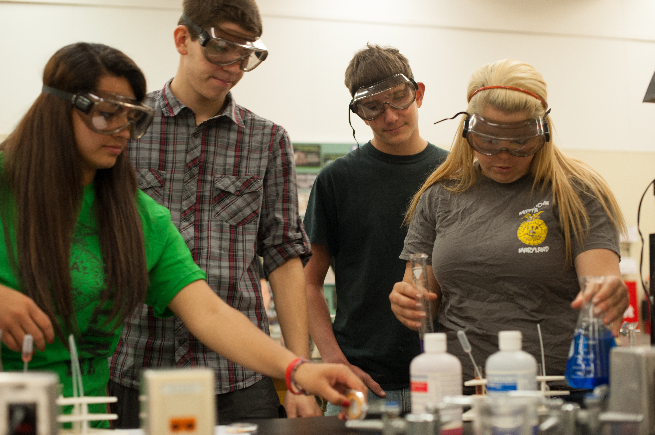

Profile Picture
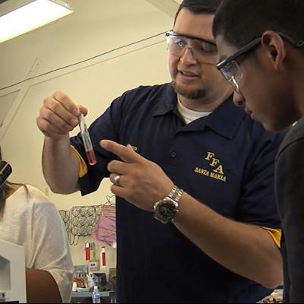

Name of Career: Agriculture Science Teacher - Secondary
Career Focus Area: Agricultural Education
Friends: (Who would I work with? What careers are related to me?)

Middle school and high school students
School administration
Extension agents
Guidance counselors
Parents
Postsecondary Educator: College/University Professor
Extension Faculty
College Recruiter
Agricultural Literacy and Advocacy Specialist
Advisor: Government/Stakeholder Relations
Agricultural Lobbyist

Interests/Groups: (What professional organizations are useful for me?)
- National Association of Agricultural Educators
- American Association for Agriculture Education
- National FFA Alumni Association

Basic Information: (Where do I work? What companies could I work for/with?)

Schools- rural, suburban or urban setting

Agriculture communications-journalist, advocacy

Agricultural education-younger students

Farm Bureau, Extension, National FFA Organization

EXAMPLE: Career Profile, Continued

Status Update: (Why is this career the coolest?)

I get to work with the future agriculturalists every day!

Schooling: (What education is needed for this career?)

Bachelor’s degree (4-year-degree) in agricultural education or other agriculturally related field plus the appropriate state teaching licensure.

About: (What do I do? What are my responsibilities?)

I teach students about all aspects of agriculture (animals, plants, mechanics, etc.).

I am an advisor for the FFA, which is the largest youth organization in the world.

I get to inspire and develop future leaders every day.

I create lesson plans and supervise the school lab and students’ SAEs. I stay informed about agriculture and agricultural literacy.

Agriscience Fair Research Project
Aligned to the following standards:
FFA.PL-A; FFA.PL-E; FFA.CS-M; CS.01; CS.02; CCSS.W.9-10.2; CCSS.SL.9-10.1; CCSS.SL.9-10.2; CRP.04

Directions:
BASF’s tagline is “We Create Chemistry,” so a lot of the company’s work goes into research and development. Design a research project following the guidelines for the agriscience fair. You can access the guidelines in the “Agriscience Fair Handbook” Refer to pages 22 through 26.

- Category:

- Issue:

- Importance/Introduction:

- Other’s Work/Literature Review:

- Materials and Methods:

- Hypothesis/Anticipated Results:

- Results:

- Discussion and Conclusions:

- References:

- Summary/Abstract:

- Acknowledgements:

- Skill Development:

