Appendix 5: How to #SpeakAg With Consumers
Aligned to the following standards:
CS.01; FFA.PL-A; FFA.PL-E; FFA.PL-F; FFA.PG-J; FFA.CS-N; AG1; CCSS.ELA.W.9-10.2; CCSS.ELA.SL.9-10.4; CRP.02; CRP.04; CRP.06; CRP.07; CRP.08

Created: Fall 2020 by the National FFA Organization
Part 1
Directions:
Read the article “How to #SpeakAg With Consumers” in the fall 2020 issue of FFA New Horizons and complete the activities below.

What are the pros and cons to consumers receiving most of their agricultural knowledge from these two sources?
Where does the article state that consumers get most of their information about agriculture?

- ________________________

- ________________________

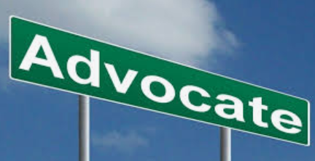

What methods have been deemed most effective in communicating with consumers about food safety and production?

1.___________________________

2. __________________________

3.___________________________

How do you determine which method will be the most effective?

How can you effectively communicate with others about agriculture?



Part 2
Directions:
Being able to advocate for agriculture is very important in the fast-paced world that we live in today. But what does advocacy even mean? Work through the following module, FFA.org/AdvocacyExperience/LetsAdvocate/#/, to learn about advocacy. Complete the activities as you go through each step.
What is an advocate?
Identify one fact and one fiction card that were most surprising to you. Describe why.

- Fact:

  - Why?

- Fiction:

  - Why?
What is advocacy?
What is literacy?

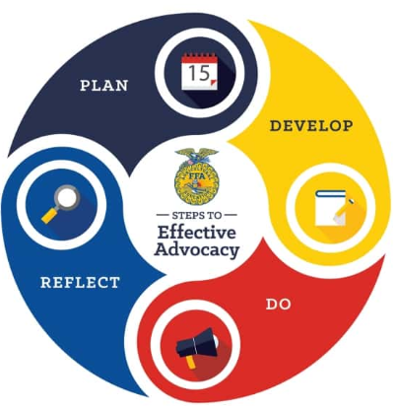
In your own words, describe what each step in the “Steps to Effective Advocacy” model means.
After you have successfully passed the quiz, select the “peers” category and complete the following questions.

- Which issue(s) did you identify that exist in your school?

- What information would be relevant to know to advocate to your peers? List them here.

It is important to have goals when you plan to advocate. Identify and describe the best components when developing goals.

S =

M =

A =

R =

T =

To practice applying what you just learned about goal setting, develop three SMART goals for yourself. The goals can be for anything in your life. Example: study skills, athletics, FFA, SAE, etc.

1.

2.

3.




Speech Rubric
Objective 3:
Objective 1:
Topic:
Objective 2:
Part 3
Directions:
Now that you understand what advocacy is, it is now your turn! Using what you have learned, develop a 2- to 3-minute speech to advocate for something important to you. Examples: agriculture, why the school should put in a different athletic turf, etc.

The speech must follow the guidelines in the attached rubric. Use the outline to help plan and compose your speech.

- What are your objectives? Identify three.
- Introduction
- Body of the speech to address your three objectives
- Conclusion
Why is it important to reflect when you complete an advocacy project?
In your own words, identify the meaning of each word below as it relates to advocating.

- Collaborate:

- Execute:

- Raise Awareness:

Qualification | Very strong evidence of skill is present  (5–4 pts) | Moderate evidence of skill is present  (3–2 pts) | Weak evidence of skill is present  (1–0 pts) | Total Points  (40 possible)
Presentation Skills | Is thorough and maintains eye contact | Somewhat professional and depends on the presentation | No evidence of preparation
Objectives | Written in SMART format and support the selected topic | Only two of the goals are written in SMART format and support the overall topic. | One or less goals are written in SMART format and/or lack support of the main topic.
Introduction | Adequately introduces each goal and their importance | Introduction lacks clarity for the rest of the speech. | Introduction is overall weak and does not adequately set up the content for the speech.
Body of Speech | Each goal is directly discussed in detail. | Only two goals were discussed, or they lacked clarity. | Less than two goals were discussed, or clarity was greatly lacking.
Conclusion | The conclusion revisited the goals and adequately summarized the main points. | The conclusion did not revisit all the main points and/or lacked strength. | The conclusion lacked clarity and strength.
Grammar/Punctuation/Spelling | Spelling, grammar and punctuation are extremely high quality with two or less errors in the document. | Spelling, grammar and punctuation are adequate with three to five errors in the document. | Spelling, grammar and punctuation are less than adequate with six or more errors in the document.
Time | Two minutes or more | Between one and two minutes | Under one minute
Overall Impression | Presentation was professional, and presenter thoroughly explained his or her plan/idea. | Presentation was complete but lacked some detail. | The presentation lacked polish and information.
 |  |  | Total | /40

KEY — Appendix 5: How to #SpeakAg With Consumers
Aligned to the following standards:
CS.01; FFA.PL-A; FFA.PL-E; FFA.PL-F; FFA.PG-J; FFA.CS-N; AG1; CCSS.ELA.W.9-10.2; CCSS.ELA.SL.9-10.4; CRP.02; CRP.04; CRP.06; CRP.07; CRP.08

Created: Fall 2020 by the National FFA Organization
Part 1
Directions:
Read the article “How to #SpeakAg With Consumers” in the fall issue of FFA New Horizons and complete the activities below.

What are the pros and cons to consumers receiving most of their agricultural knowledge from these two sources?
Answers will vary.
Where does the article state that consumers get most of their information about agriculture?

- Personal experiences

- Media

What methods have been deemed most effective in communicating with consumers about food safety and production?

- Short and informative video clips for social media

2. Shorter articles or fact posts

3. In-person conversations

How do you determine which method will be the most effective?
Know your audience and develop a plan

How can you effectively communicate with others about agriculture? Share a story/one you have a personal connection with. Personal experience is the strongest message.

Part 2
Directions:
Being able to advocate for agriculture is very important in the fast-paced world that we live in today. But what does advocacy even mean? Work through the following module, FFA.org/AdvocacyExperience/LetsAdvocate/#/, to learn about advocacy. Complete the activities as you go through each step.
What is an advocate? A person that supports
and upholds a cause
Identify one fact and one fiction card that were most surprising to you. Describe why. Answers will vary.

- Fact:

  - Why?

- Fiction:

  - Why?
What is advocacy? Providing support for a specific cause
What is literacy? Being able to understand information and share knowledge

In your own words, describe what each step in the “Steps to Effective Advocacy” model means.
Define the issue, analyze and identify the audience
Write objectives, determine the key message and develop an action plan
Monitor, review, adapt
Collaborate, execute, raise awareness
After you have successfully passed the quiz, select the “peers” category and complete the following questions.

- Which issue(s) did you identify that exist in your school?
Answers will vary.

- What information would be relevant to know to advocate to your peers? List them here.
Answers will vary.

It is important to have goals when you plan to advocate. Identify and describe the best components when developing goals.

S = Specific, clear with relevant details

M = Measurable, you can monitor the progress

A = Attainable, be sure the goal is realistic and achievable, even if challenging

R = Relevant, pertains to your overall mission

T = Timely, ensure you have adequate time to complete the advocacy project

To practice applying what you just learned about goal setting, develop three SMART goals for yourself. The goals can be for anything in your life. Example: study skills, athletics, FFA, SAE, etc. Answers will vary.

1.

2.

3.

Objective 3:
Answers will vary.

Objective 1:
Answers will vary.

Topic:
Answers will vary.

Objective 2:
Answers will vary.

Part 3
Directions:
Now that you understand what advocacy is, it is now your turn! Using what you have learned, develop a 2- to 3-minute speech to advocate for something important to you. Examples: agriculture, why the school should put in a different athletic turf, etc.

The speech must follow the guidelines in the attached rubric. Use the outline to help plan and compose your speech.

- What are your objectives? Identify three.
- Introduction
- Body of the speech to address your three objectives
- Conclusion
Why is it important to reflect when you complete an advocacy project? To be able to improve
In your own words, identify the meaning of each below as it relates to advocating.

- Collaborate: Be sure to work with the people in your school and community

- Execute: Complete the event

- Raise Awareness: Promote what you have done and learned

