Appendix 3: Ag 101: The Buzz About Honeybees
Aligned to the following standards:
CS.02; CS.05; FFA.PL-A; FFA.PL-C; FFA.PL-F; FFA.PG-I; FFA.PG-J; FFA.CS-N; AG2; AG5; CCSS.ELA.RI.9-10.2; CCSS.ELA.RI.9-10.3; CCSS.ELA.RI.9-10.8; WHST.9.10.4; MP5; MP6; CRP.02; CRP.04; CRP.05; CRP.06; CRP.07; CRP.08

Created: Fall 2020 by the National FFA Organization
Part 1
Directions:
Read the article “Ag 101:The Buzz About Honeybees” in the fall 2020 issue of FFA New Horizons and complete the following activities.
What are the three different types of honeybees?
- ________________
- _________________
- __________________

Honeybees pollinate more than ________ crops.
About how many honeybees live in a hive? ______________________

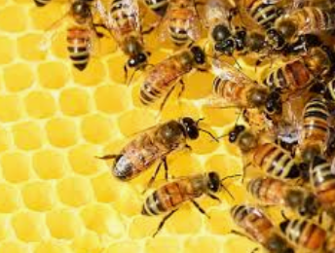
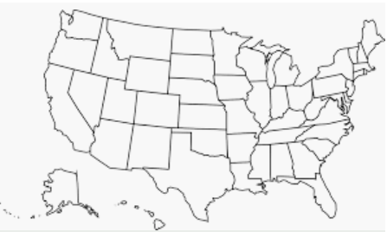
On the map, draw the path that honeybees trucked across the U.S. follow. Use a different color to identify each stop (if it is a region, color all the states in that region). Be sure to label (on the map) each location.
Using AgExplorer.ffa.org, identify two careers that are involved in the beekeeping industry besides a beekeeper.
- _______________________________

- _______________________________
What can you do to protect the honeybees?
What do bees do to indicate to other bees that they have found nectar and pollen?

__________________________
Bees are cited in the article as being “superior pollinators” for what three native crops?

- _____________
- _________________
- __________________
Part 2
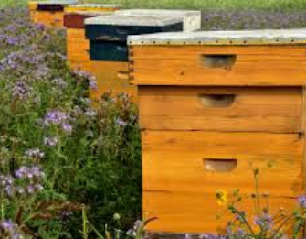
Directions:
Honeybees are crucial to food production. It is important to note that “most of the 125,000 beekeepers in the U.S. are hobbyists with fewer than 25 hives.” Knowing that hives on personal property are so important, you will price out and design a beehive or bee-friendly environment that you could have at your home or at school. Follow the steps below to help you plan.
- Where will you place your hive? Draw an aerial sketch of your home or school, and identify the location of where the hive could be placed. Remember to avoid spaces that are not bee friendly.
2. Develop a numbered list of supplies, including their cost, that you will need to build your beehive.
3. Develop a step-by-step plan of how to construct your beehive.
Why is proper hive placement so important? Give a minimum of two reasons.
Total Cost: $_______________

Part 3
Directions:
Not only are bees important for the environment and pollination, but they also produce a food product that delivers many opportunities in the food industry — honey. Read and use the information in the article “Benefits of Honey” from Michigan State University to better understand the difference between honey and white granulated sugar and why honey has recently made headlines as a great sugar substitute. Complete the Venn diagram below to organize your learning by comparing and contrasting white granulated sugar and honey.

Ingredients
Directions
In one sentence, describe the important role that bees and honey play in the agriculture industry.
Part 4
Directions:
Honey clearly has some great benefits both for our health and for our kitchen. Take one of your favorite recipes and change the recipe to include honey in place of white granulated sugar. Complete the front and back of the following recipe card to share your recipe!
Honey
White Granulated Sugar
Similar
KEY — Appendix 3: Ag 101: The Buzz About Honeybees
Aligned to the following standards:
CS.02; CS.05; FFA.PL-A; FFA.PL-C; FFA.PL-F; FFA.PG-I; FFA.PG-J; FFA.CS-N; AG2; AG5; CCSS.ELA.RI.9-10.2; CCSS.ELA.RI.9-10.3; CCSS.ELA.RI.9-10.8; WHST.9.10.4; MP5; MP6; CRP.02; CRP.04; CRP.05; CRP.06; CRP.07; CRP.08;

Created: Fall 2020 by the National FFA Organization
Part 1
Directions:
Read the article “Ag 101:The Buzz About Honeybees” in the fall 2020 issue of FFA New Horizons and complete the following activities.
What are the three different types of honeybees?
- Queen
- Female worker bees
- Male drones
Honeybees pollinate more than 100 crops.
About how many honeybees live in a hive? 50,000

Using AgExplorer.FFA.org, identify two careers that are involved in the beekeeping industry besides a beekeeper. Answers will vary.
- _______________________________

- _______________________________
Northeast: NY, PA, NJ
Southeast: AL, FL, GA, KY, MS, NC, SC, TN, MD, VA, WV
Florida
On the map, draw the path that honeybees trucked across the U.S. follow. Use a different color to identify each stop (if it is a region, color all the states in that region). Be sure to label (on the map) each location.

California
What can you do to protect the honeybees? Answers may include communicating with beekeepers, adding pollinator spaces, not treating feeding spaces with pesticides.
What do bees do to indicate to other bees that they have found nectar and pollen?

They do a waggle dance.
Bees are cited in the article as being “superior pollinators” for what three native crops?

- Blueberries
- Cherries
- Pumpkins
Part 3
Directions:
Not only are bees important for the environment and pollination, but they also produce a food product that delivers many opportunities in the food industry — honey. Read and use the information in the article “Benefits of Honey” from Michigan State University to better understand the difference between honey and white granulated sugar and why honey has recently made headlines as a great sugar substitute. Complete the Venn diagram below to organize your learning by comparing and contrasting white granulated sugar and honey.
Honey
White Granulated Sugar
Similar
- Come from natural sources
- Both contain glucose and fructose
- Both sweeteners
- Less processing
- Glucose and fructose separate
- 68 calories, 17.2g carbohydrates
- Sweeter so can use less
- Energy booster
- Immune system builder
- Antioxidant and antibacterial/anti-tumor properties
- Good glycemic index
- More processing
- Glucose and fructose hooked together
- The fact that glucose and fructose are hooked together leads to fat being stored more easily
- Empty calories due to processing
- 49 calories and 15g of carbohydrate
Ingredients
Directions
In one sentence, describe the important role that bees and honey play in the agriculture industry. Answers will vary.
Part 4
Directions:
Honey clearly has some great benefits both for our health and for our kitchen. Take one of your favorite recipes and change the recipe to include honey in place of white granulated sugar. Complete the front and back of the following recipe card to share your recipe! Answers will vary.

