Appendix 6: Urban Ag Oasis
Aligned to the following standards:
FFA.PL-A; FFA.PL-E; FFA.PL-F; FFA.PG-I; FFA.PG-J; FFA.CS-M; FFA.CS-N; FFA.CS-O; CCSS.RI.9-10.2; CCSS. RI.9-10.4; CCSS.ELA.W.9-10.2; CCSS.ELA.W.9-10.4; CCSS.SL.9-10.2; CCSS.SL.9-10.4; CRP.02; CRP.04
directions:
Part 1

Read the article “Urban Ag Oasis” in the fall 2020 issue of FFA New Horizons and complete the following activities.

- Iowa is a leader in grain production and home to innovators such as _______ ________, _________ ___________, ________ ___________, the ______ Food ________, ________ and more.

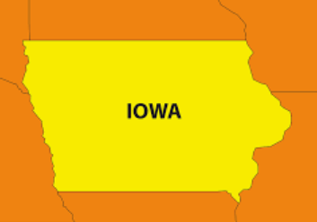
- While FFA in Iowa has commonly focused on rural communities, the _______
today is _________.

- Within the past year and into the coming year, _______ chapters have started or will start, in some of the _________ schools in the state including ________ City and _______.

- Iowa FFA Executive Director said in the past decade, FFA membership has grown __________ percent in the state.
- 35 percent
- 25 percent
- 20 percent
- 30 percent

- Iowa FFA Executive Director Scott Johnson also said current FFA participation in the state is at _____________.
  - 15,000
  - 17,000
  - 16,000
  - None of the above

6. What is the draw for urban students to take agriculture classes and become FFA members?

Are there urban FFA chapters/agriculture programs in your state? If so, what cities are those located in? Hint: Use the FFA chapter locator to help with your answer: FFA.org/chapter-locator/.

directions:
Part 2

Using the FFA chapter locator, locate FFA chapters in major cities across the United States. (Utilize this website, or one similar, to help with your search of the major cities in the U.S.: https://www.infoplease.com/us/us-cities/top-50-cities-us-population-and-rank.) The FFA chapter located can be found at https://www.ffa.org/chapter-locator/. (Locate at least 10 FFA chapters in the major U.S. cities.) See below for an example.


Los Angeles-Paul Revere Charter Middle FFA; Los Angeles, CA
Were you surprised by some of the cities that have FFA chapters? Why or why not?
What is the nearest major city closest to your town?
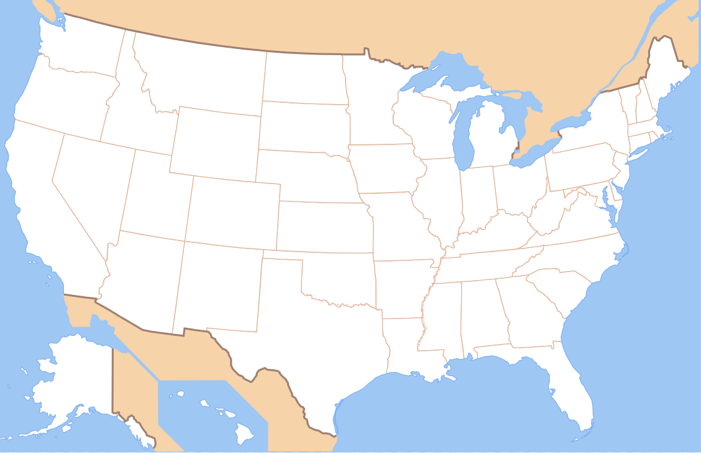

directions:
Part 3


Complete the graphic organizer below to compare the activities that Des Moines FFA Chapter does with your chapter (or school club/sports team).
What are things that you do that are the same or similar?
What is something you learned from this article that you can use in your FFA chapter (or school club or sports team)?

Summarize the article in one sentence:
What are things that the Des Moines FFA Chapter does? Write at least five things.

Outside the circle, write things that your FFA chapter and agriculture program (or club/sports team) do that are different. (Write these in any blank space outside the circle. Write at least five things.)

KEY — Appendix 4: Urban Ag Oasis
Aligned to the following standards:
FFA.PL-A; FFA.PL-E; FFA.PL-F; FFA.PG-I; FFA.PG-J; FFA.CS-M; FFA.CS-N; FFA.CS-O; CCSS.RI.9-10.2; CCSS. RI.9-10.4; CCSS.ELA.W.9-10.2; CCSS.ELA.W.9-10.4; CCSS.SL.9-10.2; CCSS.SL.9-10.4; CRP.02; CRP.04
directions:
Part 1

Read the article “Urban Ag Oasis” in the fall 2020 issue of FFA New Horizons and complete the following activities.

- Iowa is a leader in grain production and home to innovators such as John Deere, Corteva Agriscience, Kemin Industries, the World Food Prize, FarmHer and more.

- While FFA in Iowa has commonly focused on rural communities, the trend
today is urban.

- Within the past year and into the coming year, seven chapters have started or will start, in some of the largest schools in the state including Sioux City and Ames.

- Iowa FFA Executive Director said in the past decade, FFA membership has grown __________ percent in the state.
  - 35 percent
  - 25 percent
  - 20 percent
  - 30 percent

- Iowa FFA Executive Director Scott Johnson also said current FFA participation in the state is at _____________.
  - 15,000
  - 17,000
  - 16,000
  - None of the above.

The reasons are varied, but in most cases, the opportunity to learn about land and
livestock inside the city limits is too
interesting and accessible to pass up.
6. What is the draw for urban students to take agriculture classes and become FFA members?

Are there urban FFA chapters/agriculture programs in your state? If so, what cities are those located in? Hint: Use the FFA chapter locator to help with your answer: FFA.org/chapter-locator/.

Answers will vary.

directions:
Part 2

Using the FFA chapter locator, locate FFA chapters in major cities across the United States. (Utilize this website, or one similar, to help with your search of the major cities in the U.S.: https://www.infoplease.com/us/us-cities/top-50-cities-us-population-and-rank.) The FFA chapter located can be found at https://www.ffa.org/chapter-locator/. (Locate at least 10 FFA chapters in the major U.S. cities.) See below for an example.
Other chapters located in/near major cities:

-Warren Technical FFA; Atlanta, GA
-Minuteman FFA; Lexington, MA (near Boston)
-Miami FFA; Miami, FL
-Roosevelt FFA; Wyandotte, MI (near Detroit)
-H G Parkinson-Fort Cherry FFA; McDonald, PA (near Pittsburg, PA)
-Jones FFA; Orlando, FL
-Valor Christian International FFA; Beaverton, OR (near Portland, OR)
-Eastway Middle FFA; Charlotte, NC
-Alameda International FFA; Lakewood, CO (near Denver, CO)
-Gateway FFA; St. Louis, MO
-Interlake FFA; Bellevue, WA (near Seattle, WA)
-Northeast FFA; Philadelphia, PA
-Highland Park FFA; Saint Paul, MN (near Minneapolis, MN)
-James Madison-San Antonio FFA; San Antonio, TX
-Woodrow Wilson Middle FFA; Tampa, FL

Los Angeles-Paul Revere Charter Middle FFA; Los Angeles, CA
Were you surprised by some of the cities that have FFA chapters? Why or why not?
Answers will vary.
What is the nearest major city closest to your town?
Answer will vary.

Friendship Public Charter FFA; Washington, D.C.
John Bowne FFA;
Flushing, NY (near New York)
Lamar FFA; Houston, TX
Canyon Springs FFA–North; Las Vegas, NV
AAEC- South Mountain FFA; Phoenix, AZ
Glencliff FFA; Nashville, TN
OKC-Capitol Hill FFA; Oklahoma City, OK
Chicago Ag Sciences FFA; Chicago, IL
Linden-McKinley FFA;
Columbus, OH

;

directions:
Part 3

Complete the graphic organizer below to compare the activities that Des Moines FFA Chapter does with your chapter (or school club/sports team).
What is something you learned from this article that you can use in your FFA chapter (or school club or sports team)?
Answers will vary.
What are things that you do that are the same or similar?
Answers will vary.
What are things that the Des Moines FFA Chapter does?
Write at least five things.

- The Des Moines chapter participates in science fair projects where members research cognitive abilities in bonobos (the renowned Ape Cognition and Conservation Initiative is located nearby and studies bonobos), tracking consumer greenhouse trends, making a wind turbine to check energy output and analyzing egg nutritional values.
- The members also took part in a winter 2020 competition where members explored the complexities of the cattle industry through role playing such as a grower, environmentalist, etc.
- They also did meetups with state legislators and the governor where they discussed current issues and developed communication skills.
- They competed in horse judging competitions.
- They hold monthly meetings, where they talk about activities, competitions, etc.
- Members promoted pork grown by area youth by handing out samples, cookbooks, etc. from the Iowa Pork Producers at a local grocery.
- Members have packaged dry food for Meals from the Heartland and made fleece blankets for the city’s Ronald McDonald House.
- Members also raise livestock and have the opportunity for community outreach with their animals.

Summarize the article in one sentence: Answers will vary.
Outside the circle, write things that your FFA chapter and agriculture program (or club/sports team) do that are different. (Write these in any blank space outside the circle. Write at least five things.)

