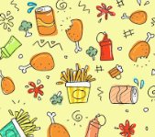
Appendix 5: Ag 101: From Farm to School
Aligned to the following standards:
FFA.PL-A; FFA.PL-C; FFA.PL-E; FFA.PL-F; FFA.PG-I; FFA.PG-J; FFA.CS-M; FFA.CS-N; CCSS.SL.9-10.2; CCSS.SL.9-10.4;CCSS.SL.9-10.5; CCSS.W.9-10.2; CCSS.W.9-10.4;CCSS.RI.9-10.4; CRP.02; CRP.04; CRP.05;CRP.06

Created: Spring 2020 by the National FFA Organization

Part 1
directions:
Read the article “Ag 101: From Farm to School” in the spring 2020 issue of FFA New Horizons and answer the questions below.

- According to the National Farm to School Network, more than _____________ in ______________ children are at _______________ for _______________.

- What is key to improving children’s health?
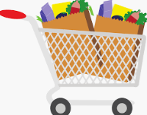

- Below are answers/facts from the article. Develop a question where these facts are the answer. Write your response in the thought bubble below.
Procurement: Schools serve foods from local farms.
School Gardens: Students participate in growing the food.
Education: School programs teach about agriculture, health, food and nutrition.



- Identify three impacts that the National Farm to School Network has had:
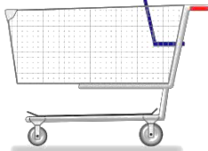

- What are examples of how FFA chapters have helped with the hunger issue? Identify two chapters and what they have done. Write your answers in the apples below.
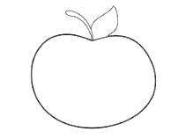

Part 2

Directions:
First, go to the website https://www.ffa.org/value-chain/, and glance at each part of the Food Value Chain (click on each icon; this will help you complete the next part). Then, select a product of your choice. Explain the development of that product throughout the value chain from research and development through consumers. Utilize the link above to help in your research.

Product: Example: Herbicides

R and D:
Example:
Find need and begin formulating herbicide
Pre-Production:
Example: Determine final formula by analyzing data

Production:
Example:
Put the components to the herbicide in production
Supply Chain:
Example:
Form final chemical
End Product:
Example:
Ship and stock
Sales, Service and Support:
Example: Advertise to homeowners and farmers

Customer:
Example: Uses product

What product did you select?

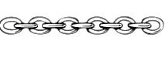


KEY — Appendix 5: Ag 101: From Farm to School
Aligned to the following standards:
FFA.PL-A; FFA.PL-C; FFA.PL-E; FFA.PL-F; FFA.PG-I; FFA.PG-J; FFA.CS-M; FFA.CS-N; CCSS.SL.9-10.2; CCSS.SL.9-10.4;CCSS.SL.9-10.5; CCSS.W.9-10.2; CCSS.W.9-10.4;CCSS.RI.9-10.4; CRP.02; CRP.04; CRP.05;CRP.06

Created: Spring 2020 by the National FFA Organization

Part 1
directions:
Read the article “Ag 101: From Farm to School” in the spring 2020 issue of FFA New Horizons and answer the questions below.

- According to the National Farm to School Network, more than one in five children are at risk for hunger.

Access to fresh, healthy foods and nutrition education is key to improving children’s health.
- What is key to improving children’s health?

- Below are answers/facts from the article. Develop a question where these facts are the answer. Write your response in the thought bubble below.
Procurement: Schools serve foods from local farms.
School Gardens: Students participate in growing the food.
Education: School programs teach about agriculture, health, food and nutrition.

What is the implementation plan for the National Farm to School Network?

- Identify three impacts that the National Farm to School Network has had:
$1 to the National Farm to School Network = $0.60 to $2.16 to the local economy

33.1% of students in schools that serve local food eat more fruits and vegetables.

One more serving of fruits and vegetables per day per kid.
(Other answers could include 44.2% of students in schools with gardens eat more fruits and vegetables; reduced food waste, emissions, screen time, diet-related diseases and health risks)
Improved ag awareness, willingness to try new foods, grades, test scores, hands-on experiences

- What are examples of how FFA chapters have helped with the hunger issue? Identify two chapters and what they have done. Write your answers in the apples below.
*Plainview/Elgin-Millville FFA: tends a raised-bed garden and supplies the produce to the school cafeteria and local food pantry.
*South Central Agri-Science Academy: hosted a Farm to School cafeteria lunch. They served pork and tomatoes raised by FFA members and led an agriculture trivia game.
Fromberg FFA: solicits donations from local beef and hog producers to provide the cafeteria with quality protein sources for lunches.

Part 2

Directions
Part 2

Directions:
First, go to the website https://www.ffa.org/value-chain/, and glance at each part of the Food Value Chain (this will help you complete the next part). Then, select a product of your choice. Explain the development of that product throughout the value chain from research and development through consumers. Utilize the link above to help in your research.
Product: Example: Herbicides

R and D:
Example:
Find need and begin formulating herbicide
Pre-Production:
Example: Determine final formula by analyzing data

Production:
Example:
Put the components to the herbicide in production
Supply Chain:
Example:
Form final chemical
End Product:
Example:
Ship and stock

Sales, Service & Support:
Example: Advertise to homeowners and farmers

Customer:
Example: Uses and applies product

What product did you select?

