Appendix 5: Making Black History Month Memorable
Aligned to the following standards:
FFA.PL-A; FFA.PL-C; FFA.PL-E; FFA.PL-F; FFA.PG-I; FFA.PG-J; FFA.CS-M; FFA.CS-N; CCSS.SL.9-10.2; CCSS.SL.9-10.4;CCSS.SL.9-10.5; CCSS.W.9-10.2; CCSS.W.9-10.4;CCSS.RI.9-10.4; CRP.02; CRP.04; CRP.06

Created: Spring 2020 by the National FFA Organization

Part 1
directions:
Read the article “Making Black History Month Memorable” in the spring 2020 issue of FFA New Horizons and answer the questions below.
- What famous person inspires the Eagle’s Landing FFA Chapter?

2. In what ways have they honored his inventions?

3. ____________ _____________, owner of

_________ __________ Blueberry Farm.


5. What are some activities the Eagle’s Landing FFA does to highlight minorities in agricultural careers?

4. What was she noted as?
Find the answers to the blanks in the article.

How many members are in the FFA chapter?

Part 2

directions:
Complete the activities below after reading the article in the spring 2020 issue of FFA New Horizons. Using the internet, research the famous African Americans in the agriculture industry listed below. Match a picture with the name by writing the correct letter next to the corresponding name.
What are the dates for Black History Month?
What percent of FFA membership is African American?

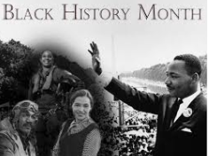
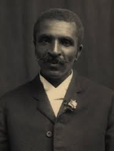
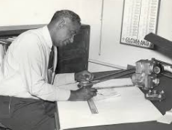
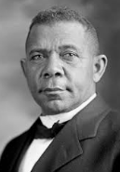
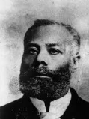


Jason Brown _________

Elijah McCoy __________

Frederick McKinley Jones __________

Booker T. Washington __________

George Washington Carver ___________

A.
B.
C.
D.
E.


Why is it important to gain an understanding of notable individuals in the agriculture industry?
Choose two of the individuals you researched and summarize their contributions to the agriculture industry. Create a social media hashtag about their contribution. For example, #CreatedCooperatives.



Individual: ____________________

What was his contribution to the agriculture industry?

Social Media Hashtag:

Summarize what you learned in one sentence:

Individual: ____________________

What was his contribution to the agriculture industry?

Social Media Hashtag:

Aligned to the following standards:
FFA.PL-A; FFA.PL-C; FFA.PL-E; FFA.PL-F; FFA.PG-I; FFA.PG-J; FFA.CS-M; FFA.CS-N; CCSS.SL.9-10.2; CCSS.SL.9-10.4;CCSS.SL.9-10.5; CCSS.W.9-10.2; CCSS.W.9-10.4;CCSS.RI.9-10.4; CRP.02; CRP.04; CRP.06

KEY — Appendix 5: Making Black History Month Memorable

Created: Spring 2020 by the National FFA Organization

Part 1
directions:
Read the article “Making Black History Month Memorable” in the spring 2020 issue of FFA New Horizons and answer the questions below.

5. What are some activities the Eagle’s Landing FFA does to highlight minorities in agricultural careers?
They host guest speakers to highlight minorities in agricultural careers, including a local beef cattle farmer, an attorney who works to protect farmers’ land and a food science researcher for Kraft Foods. They maintain a garden where the members grow vegetables, which they later cook and eat together. They also have a social media presence.
2. In what ways have they honored his inventions?
Door decorating and display case contests, food presentations and other activities.

- What famous person inspires the Eagle’s Landing FFA Chapter?
Dr. George Washington Carver

Find the answers to the blanks in the article.
3. Helen Dubose, owner of

Healing Acres Blueberry Farm.
4. What was she noted as?
The first African American to receive a degree in agriculture.
How many members are in the FFA chapter?

140

Part 2

directions:
Complete the activities below after reading the article in the spring 2020 issue of FFA New Horizons. Using the internet, research the famous African Americans in the agriculture industry listed below. Match a picture with the name by writing the correct letter next to the corresponding name.
What are the dates for Black History Month?
Feb. 1 through Feb. 29
What percent of FFA membership is African American?
4.2%

Jason Brown E.

Elijah McCoy D.

Frederick McKinley Jones B.

Booker T. Washington C.

George Washington Carver A.

A.
B.
C.
D.
E.

Why is it important to gain an understanding of notable individuals in the agriculture industry?
Answers will vary.

