Appendix 4: On the Record
Aligned to the following standards:
FFA.PL-A; FFA.PL-C; FFA.PL-E; FFA.PL-F; FFA.PG-I; FFA.PG-J; FFA.CS-M; FFA.CS-N; CS.05; AG5; AGC09.02; CCSS.SL.9-10.1; CCSS.SL.9-10.2; CRP.04; CRP.07; CRP.08; CRP.10

Created: Winter 2019 by the National FFA Organization

directions:

Part 1
Read the article “On the Record: Scott Stump” in the Winter 2019 issue of FFA New Horizons and answer the questions below.

- What is one fact that stood out to you after reading the article? Why?


- Who are your state representatives and senators? (Tip: Visit your state’s government page to locate your state leaders. For example, Indiana’s would be www.in.gov.)
State Senator
Name: ____________________________

Circle: Republican or Democrat

Hometown:

What legislature/causes do they support?

State Senator
Name: ____________________________

Circle: Republican or Democrat

Hometown:

What legislature/causes do they support?

State Representative
Name: ____________________________

Circle: Republican or Democrat

Hometown:

What legislature/causes do they support?

State Representative
Name: ____________________________

Circle: Republican or Democrat

Hometown:

What legislature/causes do they support?



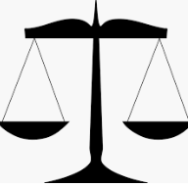

Why do you think it is important to know what the state leaders support?

Part 2

How do you sign up to vote? Visit the website Rock the Vote (https://www.rockthevote.org/voting-information/) to learn more about voting policies and how to sign up to vote.

- Click on the website link above, then on your state to learn about the specific voting policies. Identify those policies in the box below. (Utilize the checklist below to record your state’s voting policies. If there are not five policies, fill in the checklist as appropriate. If there are more than 5, add those at the bottom of the checklist.)
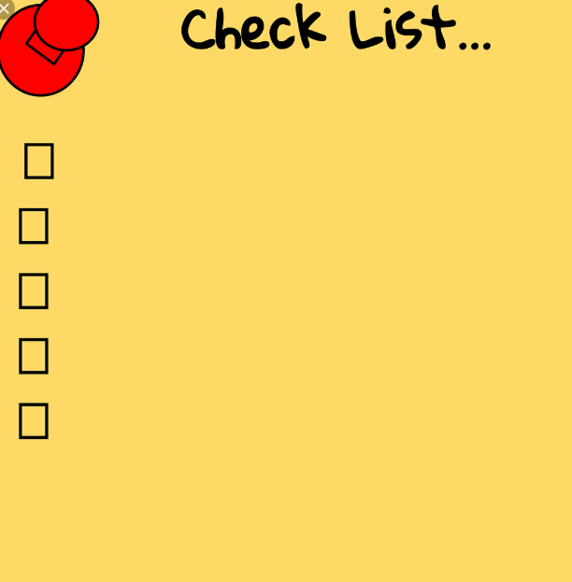
Do you think it is important to vote? Explain why or why not.

- What information should you know in order to prepare to vote? (Tip: Click on the “Prepare to Vote” tab on the left side of the page after you have selected your state. Utilize this information to answer the question.)

- What overall impact do you think voting has on our government and economy?

- Summarize, in a paragraph, what you learned after reading the article and completing the activities:

- Create a hashtag to share on social media to promote voting among your classmates.



KEY — Appendix 4: On the Record
How do you sign up to vote? Visit the website Rock the Vote (https://www.rockthevote.org/voting-information/) to learn more about voting policies and how to sign up to vote.

- Click on the website link above, then on your state to learn about the specific voting policies. Identify those policies in the box below. (Utilize the checklist below to record your state’s voting policies. If there are not five policies, fill in the checklist as appropriate. If there are more than 5, add those at the bottom of the checklist.) Answers will vary.

Do you think it is important to vote? Explain why or why not.
Answers will vary.

- What information should you know in order to prepare to vote? (Tip: Click on the “Prepare to Vote” tab on the left side of the page after you have selected your state. Utilize this information to answer the question.)
May vary by state, but could include voter identification required, absentee ballot applications must be received 7 days before Election Day, etc.

- What overall impact do you think voting has on our government and economy?
Answers may vary.

