Appendix 1: Sweet Success
Aligned to the following standards:
CS.02; CS.05; FFA.PL-A; FFA.PG-I; FFA.PG-J; FFA.CS-N; AG-PL2; AG2; AG5; CCSS.ELA.RI.9-10.2; CCSS.ELA.RI.9-10.4; MP1; MP5; MP6; CRP.02; CRP.04; CRP.06; CRP.08
Created: Winter 2019 by the National FFA Organization
Part 1
Directions:
Read the “Sweet Success” article in the Winter 2019 issue of FFA New Horizons and complete the following activities.

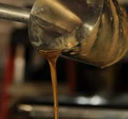
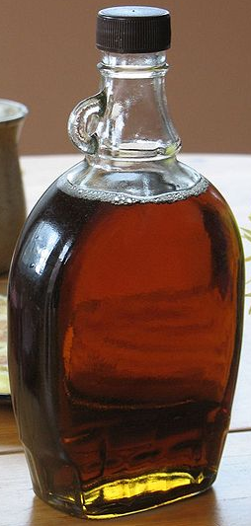
How many trees does the Wamogo FFA Chapter tap for sap on campus?

- 20
- 60
- 80
- 100
- 120
According to the United States Department of Agriculture, American __________ collected sap from _______ million taps and produced more than _______ million gallons of maple syrup last year.
What is one of the biggest challenges Paradice FFA faces in its syrup production?
Where is Henry’s family farm located?
- Worcester, MA
- Chesterfield, MA
- Framingham, MA
- Paradise, MA
Which of the following is not listed as part of Henry’s coursework?
- Sales and marketing
- Syrup production
- Fermentation science
- Forest management



Why is syrup primarily produced in the Northeastern United States??

Part 2
Aligned to the following standards:
CS.02; CS.05; FFA.PL-A; FFA.PG-I; FFA.PG-J; FFA.CS-N; AG-PL2; AG2; AG5; CCSS.ELA.RI.9-10.2; CCSS.ELA.RI.9-10.4; MP1; MP5; MP6; CRP.02; CRP.04; CRP.06; CRP.08
Directions:
Maple syrup production plays a large role within the economy. Using the information below, explore the production process for syrup in the United States.

The following table from the USDA depicts the state syrup production in the U.S. Use this table to complete the following:

- In green, underline the top five syrup-producing states in 2018.
- In red, circle the total amount of syrup produced by the United States in 2018.
- On the map below, locate, label and color the top five syrup-producing states in 2018.
- Using the outline below, create a bar graph that depicts the amount of maple syrup produced by the top five producing states. Include labels and a title.

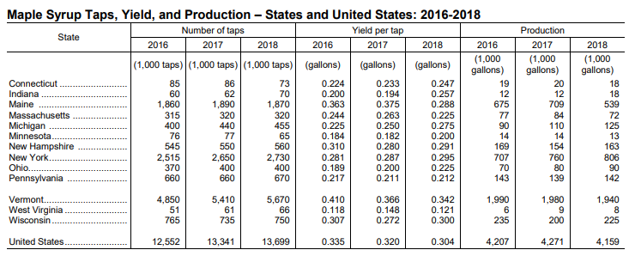

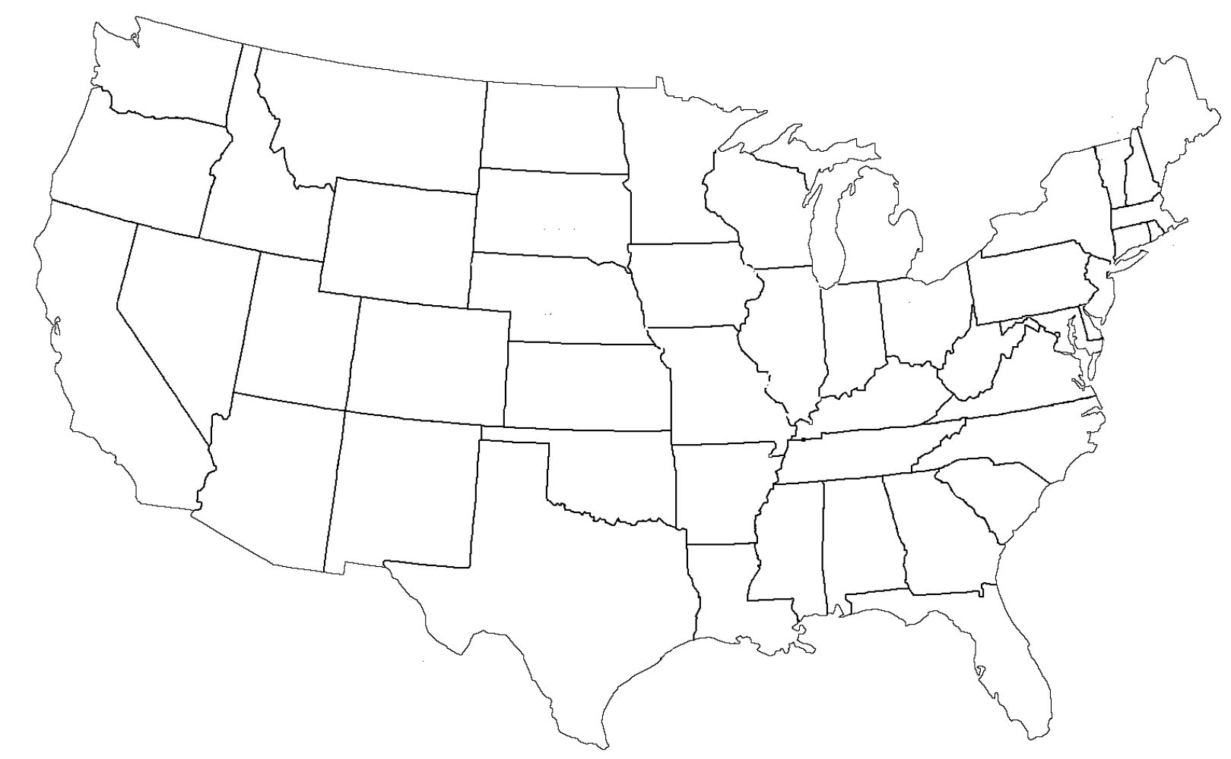
(3)

Aligned to the following standards:
CS.02; CS.05; FFA.PL-A; FFA.PG-I; FFA.PG-J; FFA.CS-N; AG-PL2; AG2; AG5; CCSS.ELA.RI.9-10.2; CCSS.ELA.RI.9-10.4; MP1; MP5; MP6; CRP.02; CRP.04; CRP.06; CRP.08
(4)
Table Title: ______________________________________

*Don’t forget to label the axes and create a legend/key!

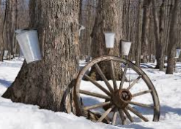

What surprises you about syrup production in the United States?

Using AgExplorer.ffa.org, identify three careers you could have within the maple syrup production industry and the education required to acquire that career.

- _______________________________
  - Education: ________________________________
2._______________________________
  - Education: ________________________________
3._______________________________
a. Education: ________________________________

What do you predict will be the future of maple syrup
production?

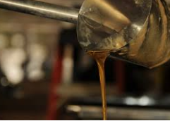

Part 3
Aligned to the following standards:
CS.02; CS.05; FFA.PL-A; FFA.PG-I; FFA.PG-J; FFA.CS-N; AG-PL2; AG2; AG5; CCSS.ELA.RI.9-10.2; CCSS.ELA.RI.9-10.4; MP1; MP5; MP6; CRP.02; CRP.04; CRP.06; CRP.08
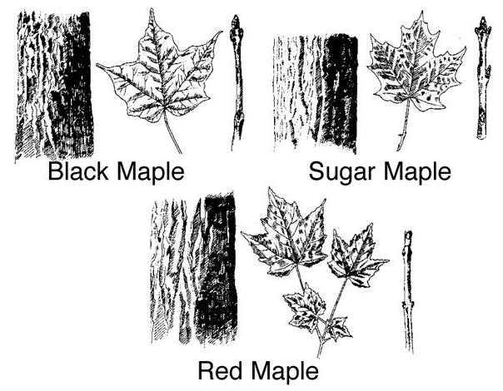
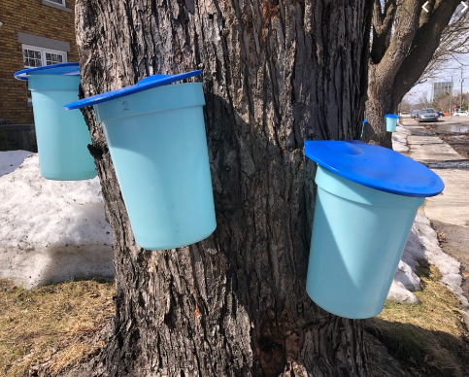
You cannot collect sap for syrup from just any tree. You must select the correct tree. Here are three different types of trees that can be used for sap collection. In this box, identify the similarities and differences between the three trees. Consider the leaves, buds and tree bark.
Go outside and select a tree that grows in your area. Take a picture or draw a picture of the leaves (if it’s not winter), buds and bark and place it here. What are the differences and similarities between the tree that grows near you and the three above used for sap?
*Image sourced from Penn State Extension.
What impact would a plant disease moving through the trees used for syrup production have on the industry?

Part 4
Aligned to the following standards:
CS.02; CS.05; FFA.PL-A; FFA.PG-I; FFA.PG-J; FFA.CS-N; AG-PL2; AG2; AG5; CCSS.ELA.RI.9-10.2; CCSS.ELA.RI.9-10.4; MP1; MP5; MP6; CRP.02; CRP.04; CRP.06; CRP.08
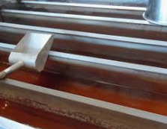
Maple syrup production is an important commodity in the United States. Surprisingly, few tools are needed in order to produce syrup at home. Using the Tractor Supply Company website, create a list of supplies you would need if you wanted to make syrup. Research the cost for each needed supply to determine your startup cost.

- ______________________________________
- ______________________________________
- ______________________________________
- ______________________________________
- ______________________________________
- ______________________________________
What are the steps in the syrup production process? List each step and draw a picture to depict the step. HINT: Use the side column in your FFA New Horizons article to find the steps with a description.
- __________________________________________
- ____________________________________________
- __________________________________________
- ____________________________________________
- __________________________________________
- ____________________________________________

What safety equipment or personal protective equipment (PPE) should be utilized during the syrup production process?

weeee
Directions:
Compose a detailed summary of the syrup production industry using 10 key words and terminology that you have learned through this lesson. Underline each of the terms in your summary.
____________________________________________________________________________________________________________________________________________________________________________________________________________________________________________________________________________________________________________________________________________________________________________________________________________________________________________________________________________________________________________________________________________________________________________________________________________________________________________________________________________________________________________________________________________________________________________________________________________________________________________________________________________________________________________________________________________________________________________________________________________________________________________________________________________________________________________________________________________________________________________________________________________________________________________________________________________________________________________________________________________________________________________________________________________________________________________________________________________________________________________________________________________________________________________________________________________________________________________________________________________________________________________________________________________________________________________________________________________________________________________________________________________________________________________________________________________________________________________________________________________________________________________________________________________________________________________________________________________________________________________________________________________________________________________________________________________________________________________________________

KEY — Appendix 1: Sweet Success
Aligned to the following standards:
CS.02; CS.05; FFA.PL-A; FFA.PG-I; FFA.PG-J; FFA.CS-N; AG-PL2; AG2; AG5; CCSS.ELA.RI.9-10.2; CCSS.ELA.RI.9-10.4; MP1; MP5; MP6; CRP.02; CRP.04; CRP.06; CRP.08
Created: Winter 2019 by the National FFA Organization
Part 1
Directions:
Read the “Sweet Success” article in the Winter 2019 issue of FFA New Horizons and complete the following activities.

How many trees does the Wimago FFA Chapter tap for sap on campus?

- 20
- 60
- 80
- 100
- 120
According to the United States Department of Agriculture, American sugar-makers collected sap from 13.3 million taps and produced more than 4.24 million gallons of maple syrup last year.
What is one of the biggest challenges Paradice FFA faces in its syrup production? The season is short, making it a rush to gather the sap. The chapter also lacks its own sugarhouse so they have to boil the sap over an open fire or transport the sap to a local sugarhouse.
Where is Henry’s family farm located?
- Worcester, MA
- Chesterfield, MA
- Framingham, MA
- Paradise, MA
Which of the following is not listed as part of Henry’s coursework?
- Sales and marketing
- Syrup production
- Fermentation science
- Forest management

Why do you think syrup is primarily produced in the Northeastern United States? Answers will vary. Examples could include climate, soil type, tree variety availability, etc.

Part 2
Aligned to the following standards:
CS.02; CS.05; FFA.PL-A; FFA.PG-I; FFA.PG-J; FFA.CS-N; AG-PL2; AG2; AG5; CCSS.ELA.RI.9-10.2; CCSS.ELA.RI.9-10.4; MP1; MP5; MP6; CRP.02; CRP.04; CRP.06; CRP.08
Directions:
Maple syrup production plays a large role within the economy. Using the information below, explore the production process for syrup in the United States.

The following table from the USDA depicts the state syrup production in the U.S. Use this table to complete the following:

- In green, underline the top five syrup-producing states in 2018.
- In red, circle the total amount of syrup produced by the United States in 2018.
- On the map below, locate, label and color the top five syrup-producing states in 2018.
- Using the outline below, create a bar graph that depicts the amount of maple syrup produced by the top five producing states. Include labels and a title.

(3)
Maine
New York
Vermont
New Hampshire
Wisconsin
(4) Example bar graph. Look and labels of graph may vary by student.
Table Title: United States Syrup Production
*Don’t forget to label the axes and create a legend/key!
What surprises you about syrup production in the United States? Answers will vary.
Aligned to the following standards:
CS.02; CS.05; FFA.PL-A; FFA.PG-I; FFA.PG-J; FFA.CS-N; AG-PL2; AG2; AG5; CCSS.ELA.RI.9-10.2; CCSS.ELA.RI.9-10.4; MP1; MP5; MP6; CRP.02; CRP.04; CRP.06; CRP.08

2,000

1,800

1,600

1,400

1,200

1,000

800

600

400

200

100

50

0

Gallons

Maine New Hampshire New York Vermont Wisconsin

States

Using AgExplorer.ffa.org, identify three careers you could have within the maple syrup production industry and the education required to acquire that career. Answers will vary.

- _______________________________
  - Education: ________________________________
- _______________________________
  - Education: ________________________________
- _______________________________
a. Education: ________________________________

What do you predict will be the future of maple syrup
production? Answers will vary.

Part 3
Aligned to the following standards:
CS.02; CS.05; FFA.PL-A; FFA.PG-I; FFA.PG-J; FFA.CS-N; AG-PL2; AG2; AG5; CCSS.ELA.RI.9-10.2; CCSS.ELA.RI.9-10.4; MP1; MP5; MP6; CRP.02; CRP.04; CRP.06; CRP.08
You cannot collect sap for syrup from just any tree. You must select the correct tree. Here are three different types of trees that can be used for sap collection. In this box, identify the similarities and differences between the three trees. Consider the leaves, buds and tree bark.
Go outside and select a tree that grows in your area. Take a picture or draw a picture of the leaves (if it’s not winter), buds and bark and place it here. What are the differences and similarities between the tree that grows near you and the three above used for sap?
Answers will vary.
*Image sourced from Penn State Extension.
What impact would a plant disease moving through the trees used for syrup production have on the industry? Plant disease would decrease sap production, which would decrease the amount of syrup produced. A decrease in overall syrup production could cause an increase in price.

Three lobed leaves, dull rounded buds, deeper bark grooves
Three lobed leaves, smooth bark that can become scaly
Five lobed leaves, sharp buds, thick long strips of bark
Part 4
Aligned to the following standards:
CS.02; CS.05; FFA.PL-A; FFA.PG-I; FFA.PG-J; FFA.CS-N; AG-PL2; AG2; AG5; CCSS.ELA.RI.9-10.2; CCSS.ELA.RI.9-10.4; MP1; MP5; MP6; CRP.02; CRP.04; CRP.06; CRP.08
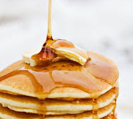
Maple syrup production is an important commodity in the United States. Surprisingly, few tools are needed in order to produce syrup at home. Using the Tractor Supply Company website, create a list of supplies you would need if you wanted to make syrup. Research the cost for each needed supply to determine your startup cost. Cost will vary.
- Drill and 5/16 in. drill bit _______________
- Stainless steel bucket spout _______________
- Hammer _______________
- Aluminum sap bucket with lid_______________
- Candy thermometer _______________
- 3-gallonstainless steel pot _______________
What are the steps in the syrup production process? List each step and draw a picture to depict the step. HINT: Use the side column in your FFA New Horizons article to find the steps with a description.

- Insert taps into sugar maple trees.

Picture will vary.
5. Bottle syrup.

Picture will vary.
2. Collect sap.

Picture will vary.
3. Boil Sap.

Picture will vary.
4. Filter syrup.

Picture will vary.
6. Pour over pancakes and enjoy!

Picture will vary.

What safety equipment or personal protective equipment (PPE) should be utilized during the syrup production process?
Answers will vary. Examples may include safety glasses, gloves, closed toe shoes, etc.

