Appendix 1: The FFA Roots of a Garden Party
Aligned to the following standards:
PS.04; CS.05; FFA.PL-A; FFA.PL-C; FFA.PL-E; FFA.PL-F; FFA.PG-J; FFA.CS-N; AG-PL4; AGPB01.04; CCSS.ELA.RI.9-10.2; CCSS.ELA.RI.9-10.3; CCSS.ELA.RI.9-10.4; MP1; MP2; MP4; MP5; MP6; CRP.02; CRP.04; CRP.06; CRP.08
Created: Spring 2020 by the National FFA Organization
Part 1
Directions:
Read the article “The FFA Roots of a Garden Party” in the spring 2020 issue of FFA New Horizons and complete the following activities.
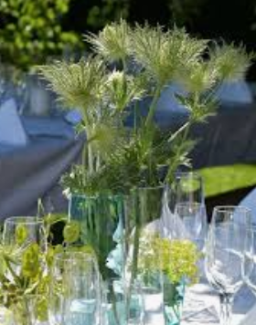
What career development event (CDE) did Mary and Dawn win that started the passion that would later become their business?

- Agricultural sales
- Marketing plan
- Nursery and landscape
- Floriculture
How long did Coombs work in a local floral shop after winning the CDE?

- One year
- Two years
- Three years
- Four years
What two passions were cultivated through her job and CDE experience?

_______________________

_______________________
What did they do in high school to help their FFA chapter grow and develop?

________________________ and ________________________________________

What did they do in college to help their business move forward?

“Success is born from hard work and staying power that comes with experience and education.” — Coombs

What does this quote mean to you? Why?



In their business, the sisters stick to their agricultural background by …

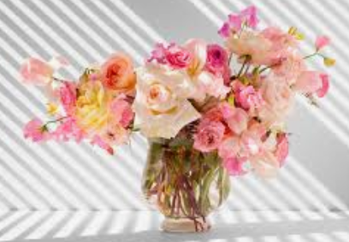
Go to AgExplorer.ffa.org and explore the florist career.

What does a florist do?

Identify five skills needed to be a successful florist.

_____________________________
_____________________________
_____________________________
_____________________________
_____________________________

What education is required to become a florist?

What would you say to someone that might be interested in being a florist?
What impact does the floral industry have on the economy?
How could the floral industry impact you now or in the future?


Part 2
Aligned to the following standards:
PS.04; CS.05; FFA.PL-A; FFA.PL-C; FFA.PL-E; FFA.PL-F; FFA.PG-J; FFA.CS-N; AG-PL4; AGPB01.04; CCSS.ELA.RI.9-10.2; CCSS.ELA.RI.9-10.3; CCSS.ELA.RI.9-10.4; MP1; MP2; MP4; MP5; MP6; CRP.02; CRP.04; CRP.06; CRP.08
Directions:
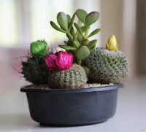
Floral shops come in all shapes and sizes but have the same basic purpose: to deliver beautiful products that meet the needs of their customers. Watch the video “Floral Shop SAE – Ashley Yanego” at https://vimeo.com/165364620 and complete the following activities.
Identify three tasks that Ashley must complete to be successful in her position.

1.

2.

3.
What services does the floral shop Ashley works for provide?
Part 3
Directions:
Thinking about a floral shop as a business, use the space below to develop a floor plan of a full-service floral shop that you could have in your community. Be sure to include the following:

- Name of your floral shop (be creative!)
- Cooler for storing flowers
- Front entry display area that includes a cooler to display completed arrangements.
- Storage closet for all supplies (Ex. vases, wreathes, wire, foam, ribbon, etc.)
- Shipping and receiving area (to receive and prepare materials, to send out arrangements)
- Cashier station
- Workstation space for two or three employees

Floral Shop Name:
______________________________

Part 4
Aligned to the following standards:
PS.04; CS.05; FFA.PL-A; FFA.PL-C; FFA.PL-E; FFA.PL-F; FFA.PG-J; FFA.CS-N; AG-PL4; AGPB01.04; CCSS.ELA.RI.9-10.2; CCSS.ELA.RI.9-10.3; CCSS.ELA.RI.9-10.4; MP1; MP2; MP4; MP5; MP6; CRP.02; CRP.04; CRP.06; CRP.08
Directions:
Floral shops can specialize in many different types of occasions and arrangements; however, all florists need to be able to price their work so they can continue their business. Complete the activities below to learn how floral arrangements can be priced.
Step 2: Determine the cost of fresh materials.

When materials are purchased for a floral shop, they are purchased in larger qualities and at a wholesale price. To determine the individual cost, you must take the total divided by the number of stems or bunches of material (Ex. baby’s breath) purchased.

Example: How much does it cost to use a stem of leatherleaf?

Leatherleaf fern
$2.95 per bunch
20 stems per bunch

Total cost/stems per bunch
$2.95/20 = $0.147
Answer (round up):
$0.15 for a stem
How much is a quarter bunch of baby’s breath?

Baby’s breath
$3.49 per bunch
Determine by amount

What is the cost per quarter bunch?
Step 1: Determine the cost of hard good materials (Ex. vases, ribbon, etc.).

When materials are purchased for a floral shop, they are purchased in larger qualities and at a wholesale price. To determine the individual cost, you must take the total divided by the number of items purchased.

Example: How much does it cost to use a yard of ribbon?

#9 satin ribbon
Cost: $4.99/roll
100 yards/roll

Total cost/yards per roll
$4.99/100 = $0.0499
Answer (round up):
$0.05 for a yard of ribbon
How much does a glass vase cost?

4-inch glass vase
Cost $19.95 per case
24 containers per case

What is the cost per vase?
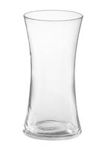
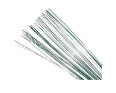

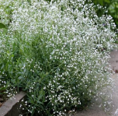
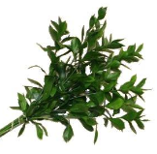
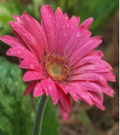
$36.75 per case of 12 vases
28-guage floral wire
50 18” strands per bag
$3.23 per bag
#9 satin ribbon (100 yards)
All colors available
$2.50/roll

Gypsophila elegans cv.
Baby’s Breath
$2.56/bunch (10 stems)

Ruscus aculeatus
Ruscus
$3.50/bunch (15 stems)

Gerbera jamesonii
Gerber Daisy
$5.50/bunch (20 stems)

Example: What is the retail price of a dozen roses in a bouquet sleeve?

Sweetheart roses $16.99 per bunch (25 stems)
Bouquet sleeve $9.95 per pack (100 sleeves)

Step 1: Determine the individual unit cost of materials.
$16.99/25 = $0.68/stem
$9.95/100 = $0.10 per sleeve

Step 2: Find the subtotal for the quantity of materials being used.
$0.68 x 12 = $8.16/dozen
$0.10 x 1 = $0.10/sleeve

Step 3: Determine the ratio needed (hard goods — 2:1; fresh goods — 3:1)
Roses: $8.16 x 3 = $24.28
Sleeve: $0.10 x 2 = $0.20

Step 4: Add up your total cost.
$24.28 + $0.20 = $24.68
Aligned to the following standards:
PS.04; CS.05; FFA.PL-A; FFA.PL-C; FFA.PL-E; FFA.PL-F; FFA.PG-J; FFA.CS-N; AG-PL4; AGPB01.04; CCSS.ELA.RI.9-10.2; CCSS.ELA.RI.9-10.3; CCSS.ELA.RI.9-10.4; MP1; MP2; MP4; MP5; MP6; CRP.02; CRP.04; CRP.06; CRP.08
Step 3: Determine the retail cost.

Materials that come into the shop are purchased at a wholesale price, which means they need to be marked up to retail. One common method in the floral industry is to use a ratio.

2:1 markup — used on hard goods
3:1 markup — used on fresh goods

You have an order placed for a $30 arrangement. Using the supplies requested below, determine how much of each material you are going to use to meet the needs of the customer. All supplies listed must be used in some amount. Please note that all prices are wholesale and will need to be marked up. SHOW ALL MATH!
Key — Appendix 1: The FFA Roots of a Garden Party
Aligned to the following standards:
PS.04; CS.05; FFA.PL-A; FFA.PL-C; FFA.PL-E; FFA.PL-F; FFA.PG-J; FFA.CS-N; AG-PL4; AGPB01.04; CCSS.ELA.RI.9-10.2; CCSS.ELA.RI.9-10.3; CCSS.ELA.RI.9-10.4; MP1; MP2; MP4; MP5; MP6; CRP.02; CRP.04; CRP.06; CRP.08
Created: Spring 2020 by the National FFA Organization
Part 1
Directions:
Read the article “The FFA Roots of a Garden Party” in the spring issue of FFA New Horizons and complete the following activities.

What career development event (CDE) did Mary and Dawn win that started the passion that would later become their business?

- Agricultural sales
- Marketing plan
- Nursery and landscape
- Floriculture
How long did Coombs work in a local floral shop after winning the CDE?

- One year
- Two years
- Three years
- Four years
What two passions were cultivated through her job and CDE experience?

- Entrepreneurship

- Floral Design
What did they do in high school to help their FFA chapter grow and develop?

Wrote grants and completed applications

What did they do in college to help their business move forward?
Drafted a business plan

“Success is born from hard work and staying power that comes with experience and education.” — Coombs

What does this quote mean to you? Why?
Answers will vary.

In their business, the sisters stick to their agricultural background by …
Emphasizing the importance of using homegrown and locally produced blooms and foraged materials in all their designs.

Go to AgExplorer.ffa.org and explore the florist career.

What does a florist do?
A florist designs and creates arrangements of flowers for us to enjoy.

Identify five skills needed to have to be a successful florist? Answers will vary. Examples:
Creativity
Detail oriented
Time management
Organization
Communication skills

What education is required to become a florist?
A high school diploma or, preferably, an associate degree in business management, floral design or plant landscaping is needed.

What would you say to someone that might be interested in being a florist?
Answers will vary.

What impact does the floral industry have on the economy? The floral industry creates revenue for the economy through the sale of their floral products. Ex. Valentine’s Day, weddings, etc.
How could the floral industry impact you now or in the future? Floral shops provide a service by helping us to present a gift or decorate for an event.
Part 2
Aligned to the following standards:
PS.04; CS.05; FFA.PL-A; FFA.PL-C; FFA.PL-E; FFA.PL-F; FFA.PG-J; FFA.CS-N; AG-PL4; AGPB01.04; CCSS.ELA.RI.9-10.2; CCSS.ELA.RI.9-10.3; CCSS.ELA.RI.9-10.4; MP1; MP2; MP4; MP5; MP6; CRP.02; CRP.04; CRP.06; CRP.08
Directions:
Floral shops come in all shapes and sizes but have the same basic purpose: to deliver beautiful products that meet the needs of their customers. Watch the video “Floral Shop SAE – Ashley Yanego” at https://vimeo.com/165364620 and complete the following activities.
Identify three tasks that Ashley must complete to be successful in her position. Answers will vary. Examples may include

- Create arrangements to customer specifications.

- Water plants.

- Prep materials as they come into the shop.
What services does the floral shop Ashley works for provide?
Floral arrangements and houseplants
Part 3
Directions:
Thinking about a floral shop as a business, use the space below to develop a floor plan of a full-service floral shop that you could have in your community. Be sure to include the following:

- Name of your floral shop (be creative!)
- Cooler for storing flowers
- Front entry display area that includes a cooler to display completed arrangements.
- Storage closet for all supplies (Ex. vases, wreathes, wire, foam, ribbon, etc.)
- Shipping and receiving area (to receive and prepare materials, to send out arrangements)
- Cashier station
- Workstation space for two or three employees
Answers will vary.
Floral Shop Name: Answers will vary.
______________________________

Part 4
Aligned to the following standards:
PS.04; CS.05; FFA.PL-A; FFA.PL-C; FFA.PL-E; FFA.PL-F; FFA.PG-J; FFA.CS-N; AG-PL4; AGPB01.04; CCSS.ELA.RI.9-10.2; CCSS.ELA.RI.9-10.3; CCSS.ELA.RI.9-10.4; MP1; MP2; MP4; MP5; MP6; CRP.02; CRP.04; CRP.06; CRP.08
Directions:
Floral shops can specialize in many different types of occasions and arrangements; however, all florists need to be able to price their work so they can continue their business. Complete the activities below to learn how floral arrangements can be priced.
Step 2: Determine the cost of fresh materials.

When materials are purchased for a floral shop, they are purchased in larger qualities and at a wholesale price. To determine the individual cost, you must take the total divided by the number of stems or bunches of material (Ex. baby’s breath) purchased.

Example: How much does it cost to use a stem of leatherleaf?

Leatherleaf fern
$2.95 per bunch
20 stems per bunch

Total cost/stems per bunch
$2.95/20 = $0.147
Answer (round up):
$0.15 for a stem
How much is a quarter bunch of baby’s breath?

Baby’s breath
$3.49 per bunch
Determine by amount

What is the cost per quarter bunch?
Total cost x 0.25 (or ¼)
$3.49 x 0.25 = $0.872

Answer:
$0.87 for a quarter bunch
Step 1: Determine the cost of hard good materials (Ex. vases, ribbon, etc.).

When materials are purchased for a floral shop, they are purchased in larger qualities and at a wholesale price. To determine the individual cost, you must take the total divided by the number of items purchased.

Example: How much does it cost to use a yard of ribbon?

#9 satin ribbon
Cost: $4.99/roll
100 yards/roll

Total cost/yards per roll
$4.99/100 = $0.0499
Answer (round up):
$0.05 for a yard of ribbon
How much does a glass vase cost?

4-inch glass vase
Cost $19.95 per case
24 containers per case

What is the cost per vase?
$19.95/24 = $0.831

Answer:
$0.83 for a glass vase

Example: What is the retail price of a dozen roses in a bouquet sleeve?

Sweetheart roses $16.99 per bunch (25 stems)
Bouquet sleeve $9.95 per pack (100 sleeves)

Step 1: Determine the individual unit cost of materials.
$16.99/25 = $0.68/stem
$9.95/100 = $0.10 per sleeve

Step 2: Find the subtotal for the quantity of materials being used.
$0.68 x 12 = $8.16/dozen
$0.10 x 1 = $0.10/sleeve

Step 3: Determine the ratio needed (hard goods — 2:1; fresh goods — 3:1)
Roses: $8.16 x 3 = $24.28
Sleeve: $0.10 x 2 = $0.20

Step 4: Add up your total cost.
$24.28 + $0.20 = $24.68

Aligned to the following standards:
PS.04; CS.05; FFA.PL-A; FFA.PL-C; FFA.PL-E; FFA.PL-F; FFA.PG-J; FFA.CS-N; AG-PL4; AGPB01.04; CCSS.ELA.RI.9-10.2; CCSS.ELA.RI.9-10.3; CCSS.ELA.RI.9-10.4; MP1; MP2; MP4; MP5; MP6; CRP.02; CRP.04; CRP.06; CRP.08
Step 3: Determine the retail cost.

Materials that come into the shop are purchased at a wholesale price, which means they need to be marked up to retail. One common method in the floral industry is to use a ratio.

2:1 markup — used on hard goods
3:1 markup — used on fresh goods

You have an order placed for a $30 arrangement. Using the supplies requested below, determine how much of each material you are going to use to meet the needs of the customer. All supplies listed must be used in some amount. Please note that all prices are wholesale and will need to be marked up. SHOW ALL MATH!
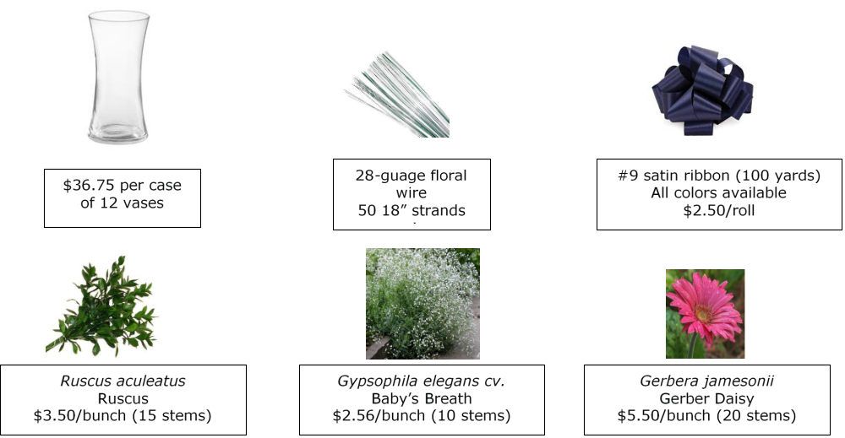

Answers will vary.

