Appendix 1: On the Record: Eric Shanks
Aligned to the following standards:
CS.02; FFA.PL-A; FFA.PL-E; FFA.PL-F; FFA.PG-J; FFA.CS-N; AG2; CRP.02; CRP.04; CRP.07; CRP.08
Created: Fall 2020 by the National FFA Organization
Part 1
Directions:
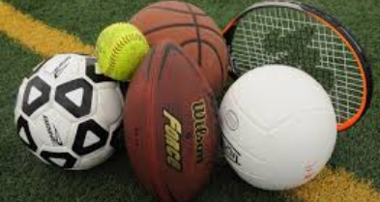
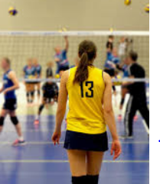
Read the article “On the Record: Eric Shanks” in the fall 2020 issue of FFA New Horizons and complete the following activities.
What does Eric Shanks do?

_________________________
Where is Eric Shanks from?

- San Francisco, CA
- Brazil, Indiana
- New Orleans, Louisiana
- Baltimore, Maryland
What major event does Shanks spend a large part of the year helping plan?

- World Series
- Stanley Cup
- Olympics
- Super Bowl
What role did FFA have in preparing Shanks for his career?
What advice does Shanks provide for FFA members?
Give a specific example of how you could use this advice in your life.
What link connects athletics and agriculture? Give an example.

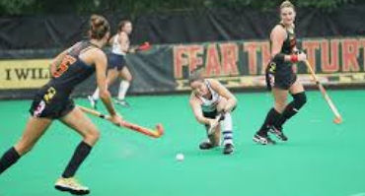
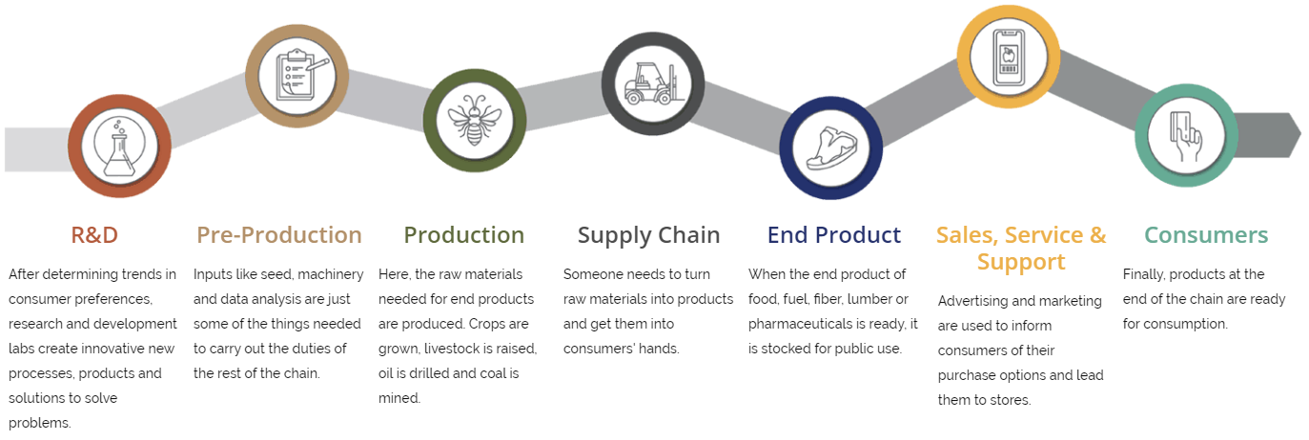
Product Selected: _____________________
Part 2
Directions:
Athletics and agriculture have a very close tie. Complete the following activities to learn how agriculture and the items we associate with athletic competitions really tie together.
- Review the Agriculture, Food and Natural Resources (AFNR) Value Chain below.
- Select a school-appropriate, product-based favorite Super Bowl commercial (ex. Doritos).
- Identify and describe how that product fits into each step of the AFNR Value Chain. Add your description to each step of the diagram. Tip: Use the following website for more information on each step in the AFNR Value Chain: FFA.org/value-chain/.
KEY — Appendix 1: On the Record: Eric Shanks
Aligned to the following standards:
CS.02; FFA.PL-A; FFA.PL-E; FFA.PL-F; FFA.PG-J; FFA.CS-N; AG2; CRP.02; CRP.04; CRP.07; CRP.08
Created: Fall 2020 by the National FFA Organization
Part 1
Directions:
Read the article “On the Record: Eric Shanks” in the fall 2020 issue of FFA New Horizons and complete the following activities.
Product Selected: _____________________
Part 2

Directions:
Athletics and agriculture have a very close tie. Complete the following activities to learn how agriculture and the items we associate with athletic competitions really tie together.
- Review the Agriculture, Food and Natural Resources (AFNR) Value Chain below.
- Select a school-appropriate, product-based favorite Super Bowl commercial (ex. Doritos).
- Identify and describe how that product fits into each step of the AFNR Value Chain. Add your description to each step of the diagram. Tip: Use the following website for more information on each step in the AFNR Value Chain: FFA.org/value-chain/.

Answers will vary.
What does Eric Shanks do?

Executive Producer of Fox Sports
Where is Eric Shanks from?

- San Francisco, CA
- Brazil, Indiana
- New Orleans, Louisiana
- Baltimore, Maryland
What major event does Shanks spend a large part of the year helping plan?

- World Series
- Stanley Cup
- Olympics
- Super Bowl
What role did FFA have in preparing Shanks for his career?

FFA taught him that you should always have respect for others.
What advice does Shanks provide for FFA members? Take on lots of different things to learn what you can really handle. “Bite off more than you can chew.”
Give a specific example of how you could use this advice in your life. Answers will vary.
What link connects athletics and agriculture? Give an example. Agricultural products make athletics possible. The turf, equipment used, etc.

